Getting Started with the TI-Nspire CX
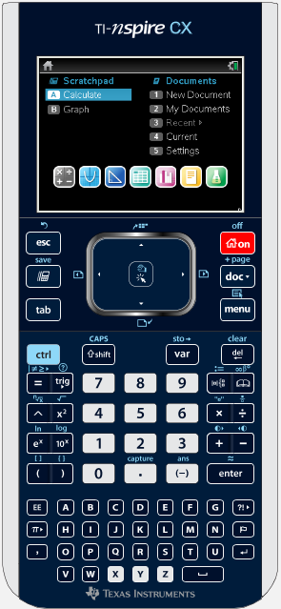
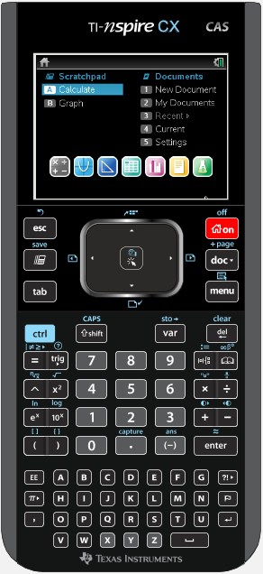

Wendy Peel
wpeel@ti.com
AR, LA, MO Educational Technology Consultant
Texas Instruments

Touchpad Swipe your finger to operate on screen mouse
Click Select menu items; Mouse Click
Undo
Like a Computer On /Home Button
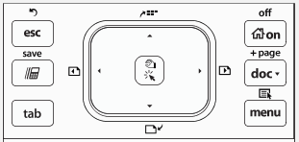
Escape
Close Menus
Release Grab
Add a Page

ScratchPad Document Key
Quick Calculator File/Edit/View/…
Quick Graph
Right Click
Tab Menu
Navigate fields Specialized by
Like a Computer App

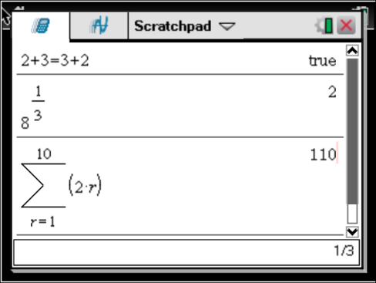
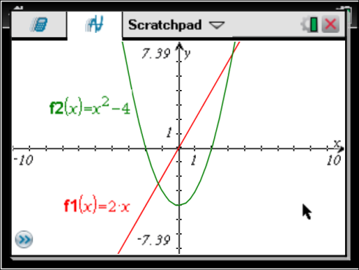
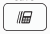
ScratchPad
Pressing the repeatedly
toggles between Calc and Graph

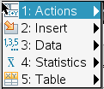
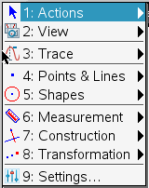
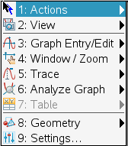
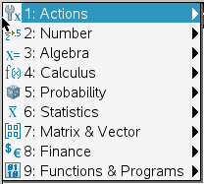
Menu
Pressing Menu will open
a menu specialized for
the current Application

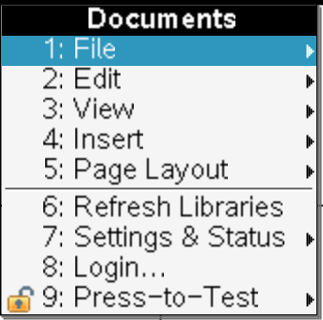

Document Key
Document Management
Very similar to Computer
Software

Shift Like on Computer;
Capitalize one Letter Set Equal to

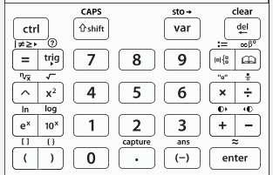
CTRL Like on Computer Delete Like on Computer
Press once, no need to
hold down Catalog find all functionality

Equal Sign
Templates Key
Trig Functions Similar to Math Type

Exponent Fraction Template

Approximate to Decimal
Parenthesis
Enter to select/evaluate/ Negative graph/ and more…

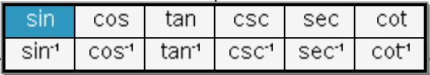
Trigonometry

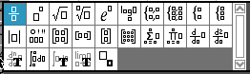
Templates Key

Different sections of Catalog; Press number associated to section

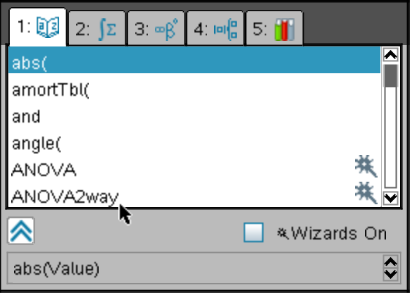
Catalog

Alphabetized
Press letter to
Jump to command

Syntax for all
commands

The Letters are arranged in an Alphabetized format opposed to the QWERTY format on a Computer due to Testing Boards not allowing QWERTY keyboards for their exams.

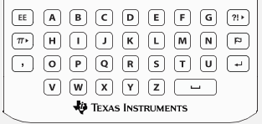

Comma

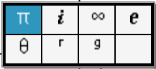
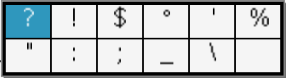

Many of the “Hot Keys” that work on a Computer carry over to the TI-Nspire handheld.
+ COPY
+ PASTE
+ CUT
+ UNDO
+ REDO However don’t try to memorize these Hot Keys as they are in the
Document menus like on your computer.
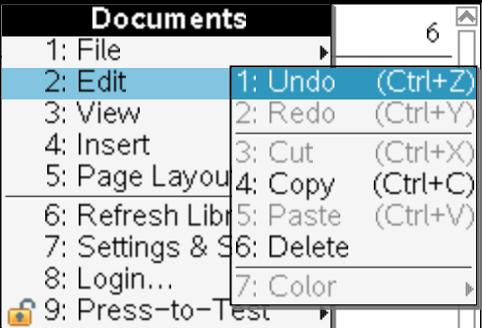
+ X-Y Function Table
+ Open Document
+ New Document
+ Close Document
+ Save Document
+ Insert Page

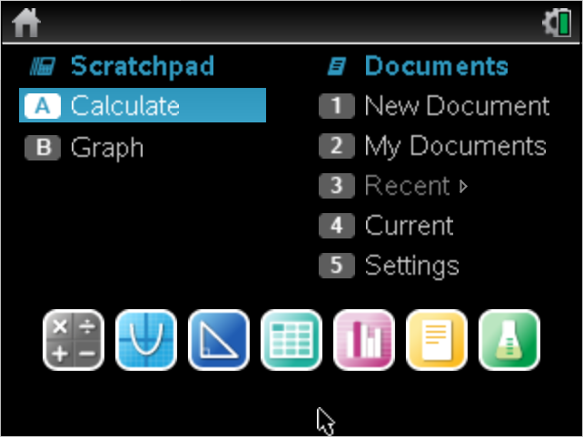
Home Screen

Calculator Graphing Geometry Spreadsheet Data/Stats Notes Data Collection
App App App App App App App

When on the Home Screen, you can select options by pressing the letter or number associated with the item.

Break Down of DOCUMENTS on the Home Screen

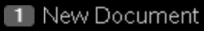
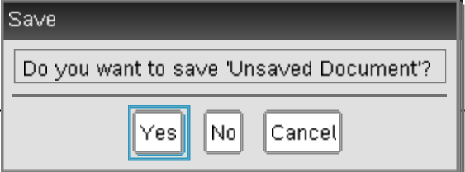
To start fresh select (1) New Document.
Only one document can be open at one time.
If another document is open,
a message like this may appear.
Unless you wish to save for later, select No.

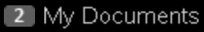
To access the Memory of the Nspire Handheld select (2) My Documents.
My Documents is a system of file folders to store lessons, activities
assessments and more.
Selecting (3) Recent, allows you to quickly access the most recent documents that were opened on the handheld.
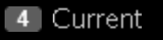
Selecting (4) Current, allows you to go back to the current document that is open.
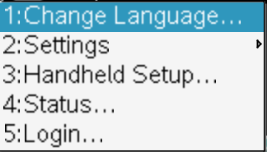
(5) Settings allows the user to change the settings of the handheld.
Radians vs Degrees, number of display digits, and more.
Check Operating System, Battery strength, and adjust power settings

Navigating Between Pages
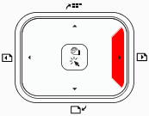
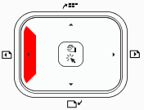
Method 1: Press + +

To move Forward a Page To move Backward a Page

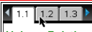
Method 2: Click on the Tabs at the Top of the Screen.

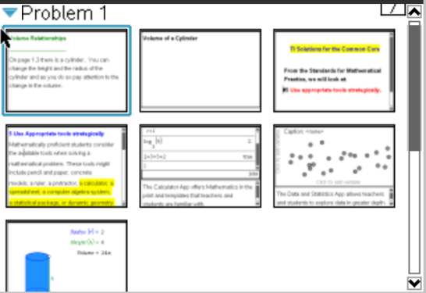
Navigating in a Document or to Manage the Pages in a Document
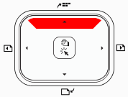
Press +

To view all the Pages in Page Sorter View

Grabbing and Dragging
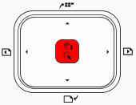

Press + OR Press and Hold

Calculator Application

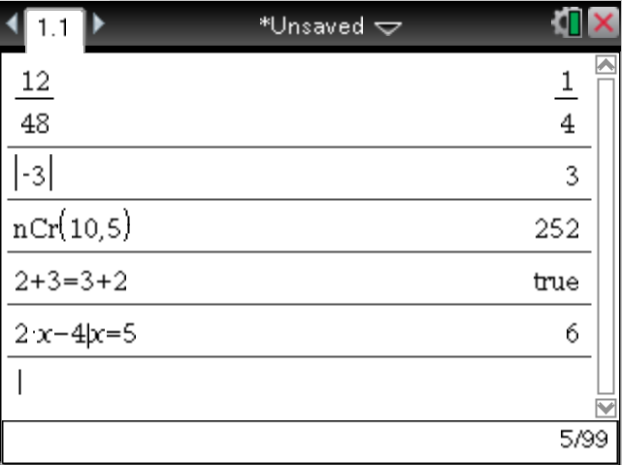

Hover to check settings
Page Number Click to make changes

Scroll Bar
Press Up on Touchpad
Note:Press Enter to Paste

Indicates the number of lines used out of possible lines

Exploring the Calculator App Menu
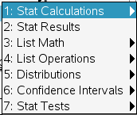
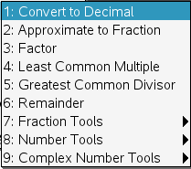
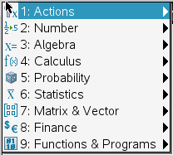

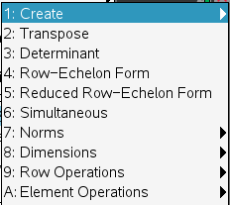

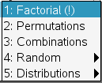
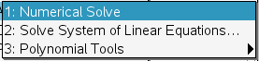

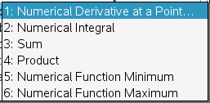

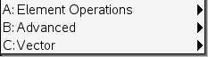

Graphing Application
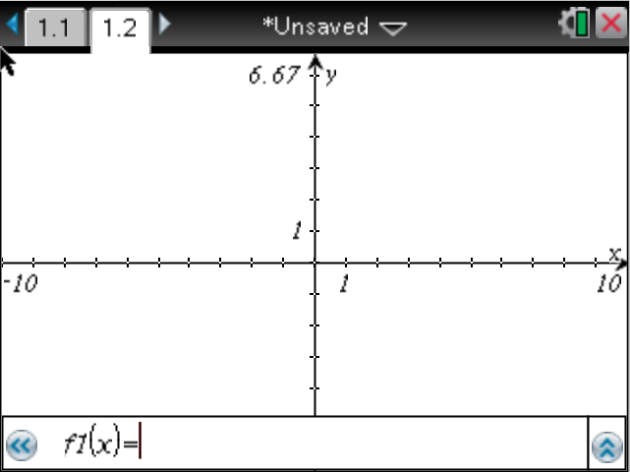

Show Multiple
Functions
Hide Entry Line
Entry Line (Press Enter after typing in Function to Graph)
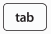
Press to open the Entry line if it is hidden

Exploring the Graphing Application Menu
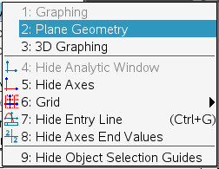
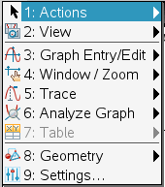

3D Graphing

Grid Lines

Analyze Graph
Similar to previous TI Models
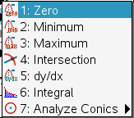
Function Templates
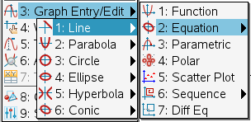

Exploring the Graphing Application

Once a Linear Equation is graphed, you can manipulate the function hands-on with the following tools.
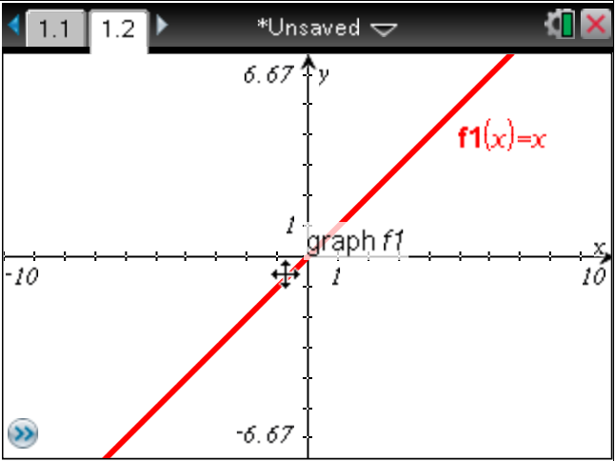
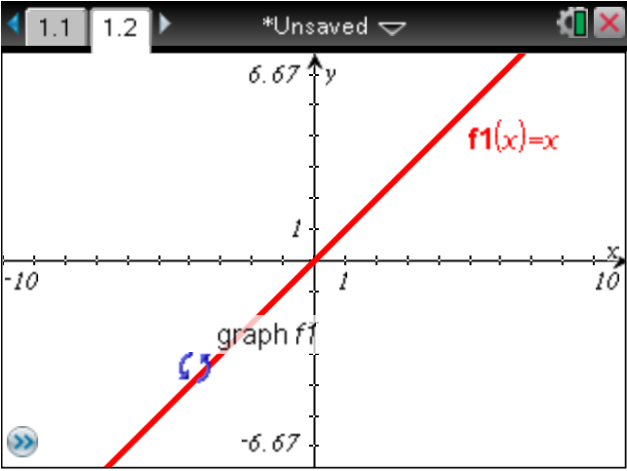

This cursor will change the Slope This cursor will change the Y-Intercept

Press + To grab the function with either of these cursors. Swipe the Touchpad to manipulate.

Press To let go. Press + To undo the changes.

Note: + To grab different things on the Graphing Page.

- Tick Marks on the Axes to Zoom in or out
- White Space to grab the Graph paper
Double on End Axes Values or Tick mark Values to open a text box and change values.

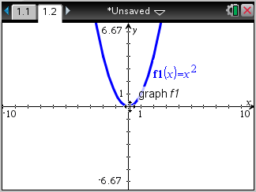
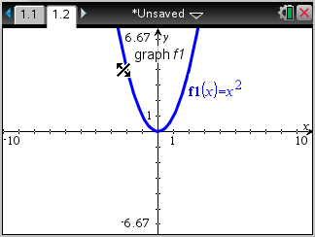

This cursor will change the Concavity This cursor will perform translations
Geometry Application

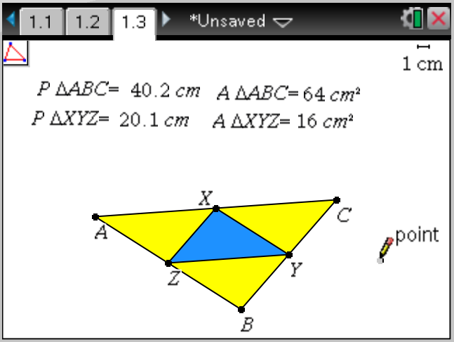

Icon indicates
current tool in use.
Hover to reveal how
to use.
Escape closes tool.

Note: grab & drag
For dynamic geometry Cursor; press enter to
drop points.

Explore the different menu options for the Geometry Application
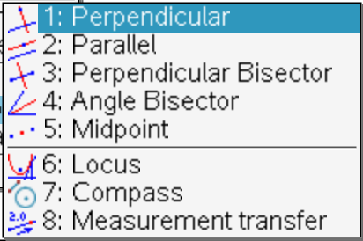
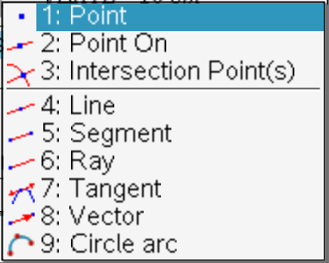
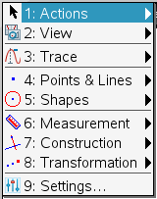

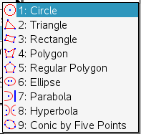
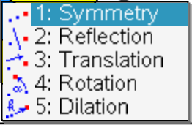

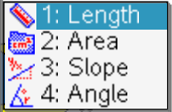

List and Spreadsheet Application
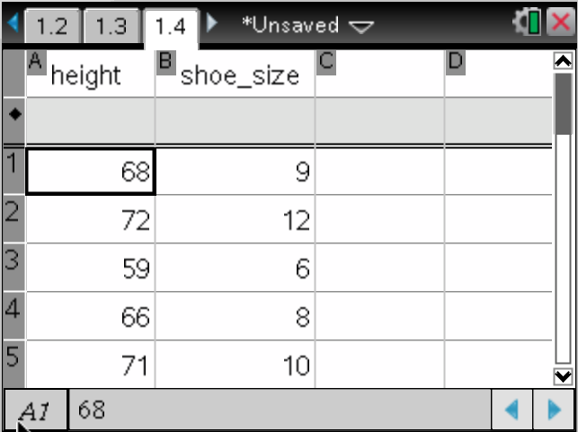

Name the lists in the title cells.

Command line for formulas.

Indicator of active cell.

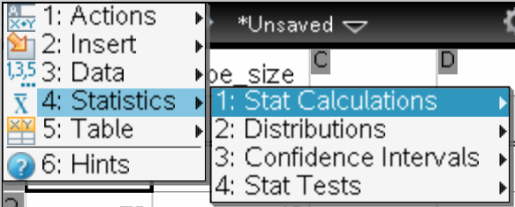
Exploring Spreadsheet Menus
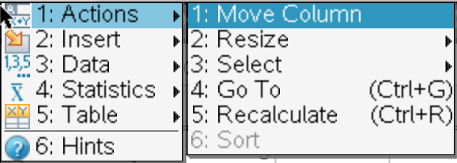

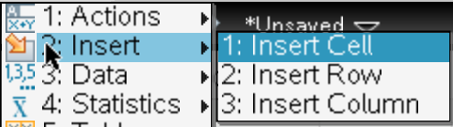

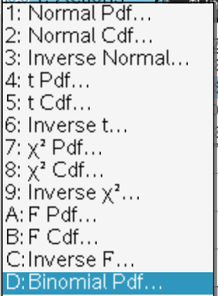
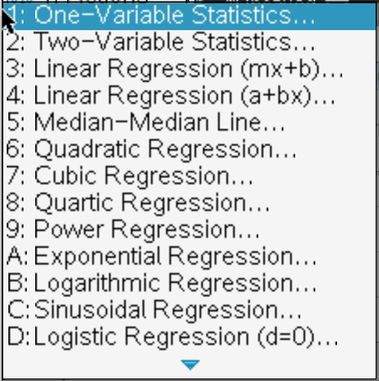

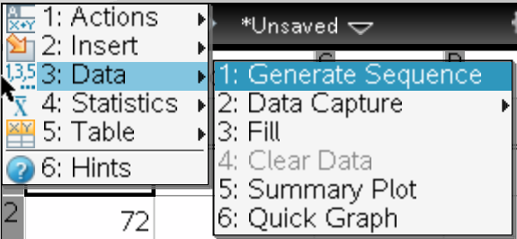
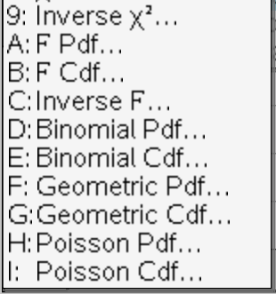

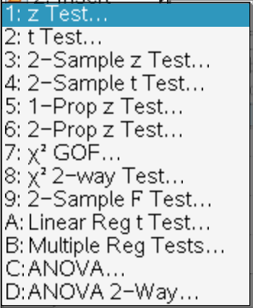

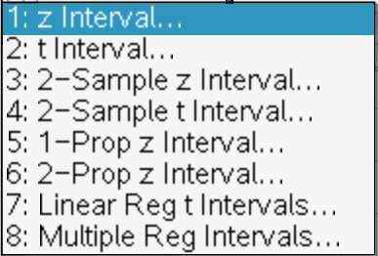

Data and Statistics Application
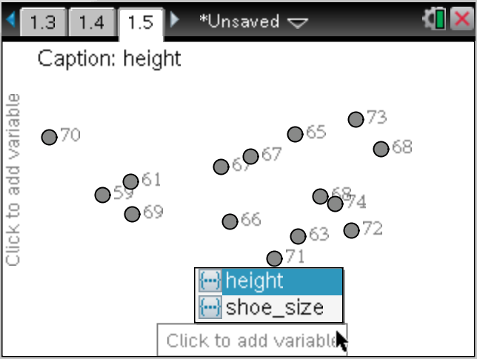
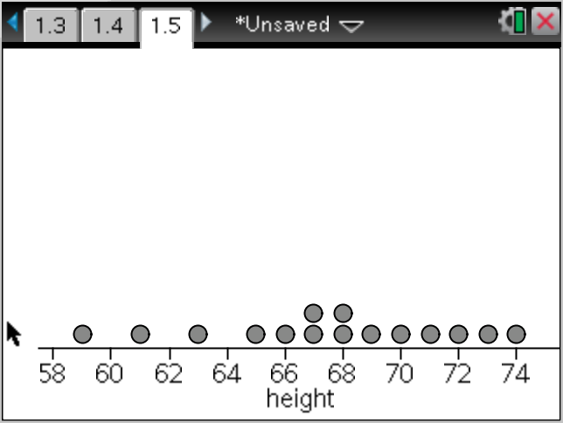
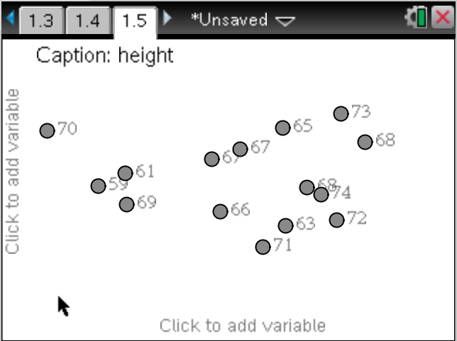

Data points are randomly positioned. Click to define variable. Points are arranged and
window is optimized.

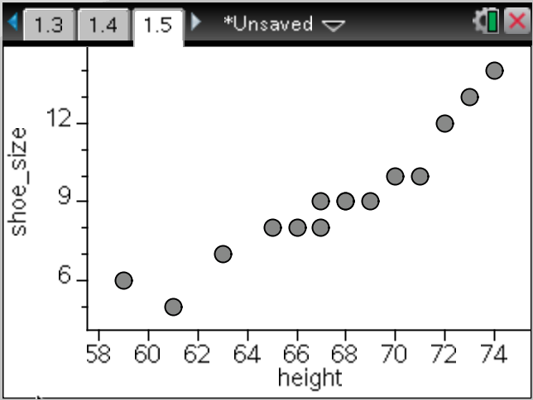
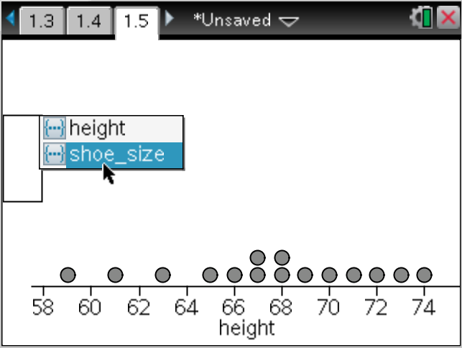

Click to define 2nd variable. Points are arranged and window is optimized.

Exploring Data and Statistics Menus
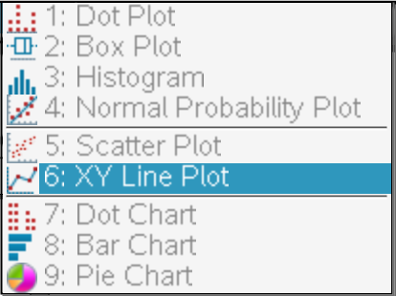
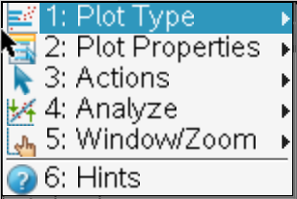
Single Variable
Statistical Plots

Two Variable
Statistical Plots

Categorical Plots
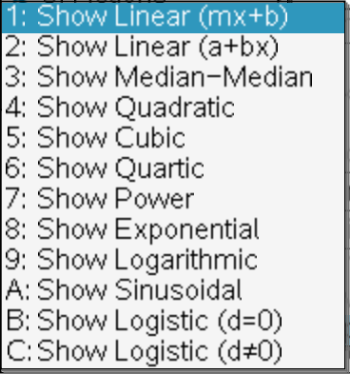

Analyze > Regressions

Notes Application

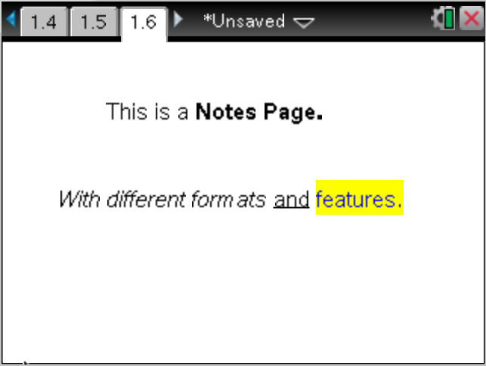

Exploring the Notes Application Menu
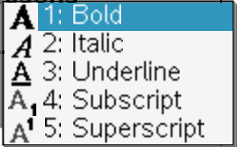
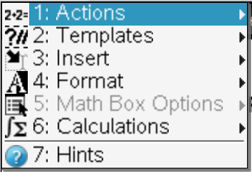

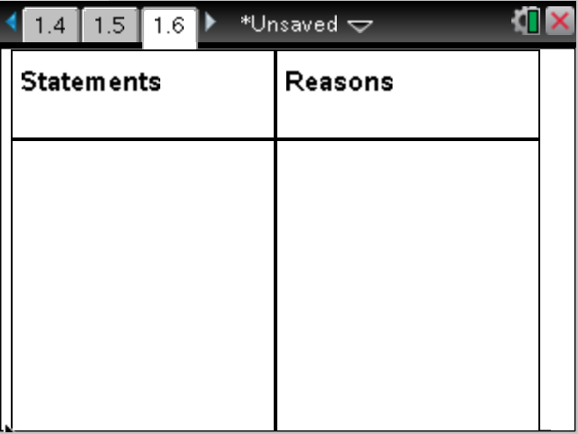

Two Column Proof Templates.

Vernier DataQuest Application

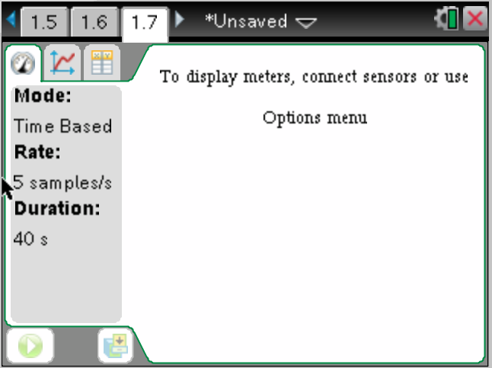
Automatically launches when a probe is connected to the TI-Nspire handheld.

3 Views:
- Meter view
- Graphical view
- Table view

Click on different tabs to
change view.

Click to start data
Collection.

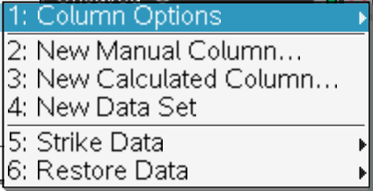
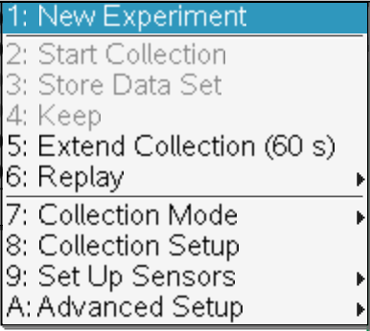
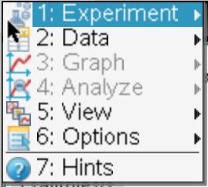
Explore Vernier DataQuest Menu

Resources for TI-Nspire Technology

Lessons aligned to CCSS for Mathematics:
www.mathnspired.com

Lessons and activities for Science Education:
www.sciencenspired.com

Activities Exchange: Lessons Created by Teachers for Teachers:
http://education.ti.com/calculators/downloads/US/Activities/

Assessments and Test Prep for Algebra, Geometry, and Algebra 2/Trig:
www.jmap.org

Free Online Tutorials for TI-Nspire:
http://www.atomiclearning.com/k12/en/ti_nspire

Free Online Tutorials for TI-Nspire:
http://media4math.com/calculator-mini-tutorials.asp

Free Online Tutorials for TI-Nspire Navigator:
http://www.atomiclearning.com/k12/en/ti_nspire_nav

Free Online Live and Archived Webinars:
http://education.ti.com/calculators/pd/US/Online-Learning/Webinars

