Open the TI-Nspire document Moving_Air.tns  Because of the spherical shape of the earth, the energy from the sun is not evenly distributed. This difference in heating causes predictable patterns in earth’s weather. In this simulation, you will discover how this uneven heating affects the patterns of circulation in our Earth’s atmosphere. |  | 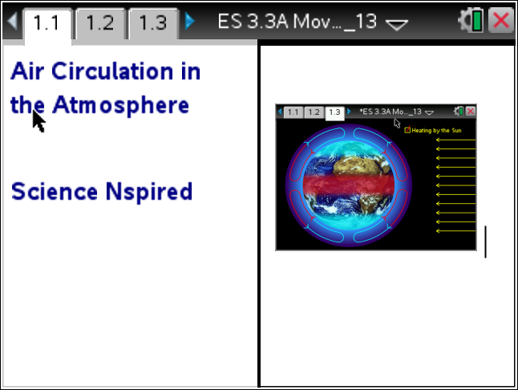
Move to page 1.2 and answer question 1 below and/or on your device.
Q1. Which region of the earth receives the most energy?

A. Poles
B. Areas between the poles and equator
C. Equator
D. all three receive the same amount of energy

Read the information below.
The sun heats the equator much more than the poles. This is caused by the spherical shape of the earth. All light moves in straight lines. The rays of the sun that strike the equator are more concentrated thus raising the temperature of this region. As you move away from the poles, the sun’s energy gets spread out over a larger area. Air warmed by the heat radiating from the Earth's surface at the equator, is less dense than the colder air near the poles. Because less dense air floats on top of cooler, more dense air, the warmer air rises. This motion of the air is called convection. If the earth didn’t rotate, this would cause two huge convection cells in the atmosphere to develop.
Earth

equator

Move to page 1.3 and read the directions.
1. After reading the directions on page 1.3, close the directions box by selecting .  2. Click on the Heating by the Sun button to start simulation. Observe the atmospheric circulation arrows.  3. The red, shaded area around the equator represents an area of warmer air.  4. Note the direction and color of the arrow in the convection cells. | 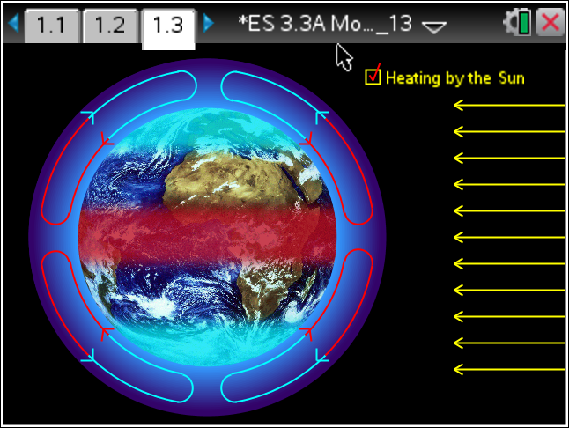
Move to pages 1.4-1.6
Q2. How did the air in the atmosphere move when there was no heating by the sun?

A. No air circulation
B. Rising air at the equator moves toward the poles.
C. Sinking air at the equator moves toward from the poles
D. Rising air at the poles moves toward the equator

Q3. How did the air in the atmosphere move when heated by the sun?

A. No air circulation
B. Rising air at the equator moves toward the poles.
C. Sinking air at the equator moves toward from the poles
D. Rising air at the poles moves toward the equator

Q4. There are two colors representing the air circulation in the convection cells. What does the red color represent?

A. warm air
B. cold air

Q5. Describe the direction of the air in a single convection cell.

Q6. What is happening to the temperature of the air as it moves north and southward towards the poles?

Move to page 1.7. Read the information and examine the diagram on page 1.8. Then answer question 7 below.
Q7. Describe the general pattern of warm and colder air circulation in any convection cell.

Move to page 1.9. Read the information and examine the diagram on page 1.10. Then answer questions 8 & 9 below.
Q8. What is the direction of the trade winds?

Q9. Where would the doldrums be located?

