Science Objectives  - Students will make observations of the effects of direct and indirect heating of the earth.  Vocabulary  - atmosphere  - circulation  - Hadley cells  About the Lesson  - In this lesson students make observations of the effect of the unequal heating of the earth on the atmospheres. Students will use their observations to describe trends in winds and weather.  - As a result, students will understand that:  - The equator receives more energy then other regions on the earth.  - The unequal heating and cooling of the atmosphere causes  TI-Nspire™ Navigator™  - Send out the .tns file.  - Monitor student progress using Class Capture.  - Use Live Presenter to spotlight student answers.  Activity Materials  - Compatible TI Technologies: TI- Nspire™ CX Handhelds,  TI-Nspire™ Apps for iPad®,  TI-Nspire™ Software | 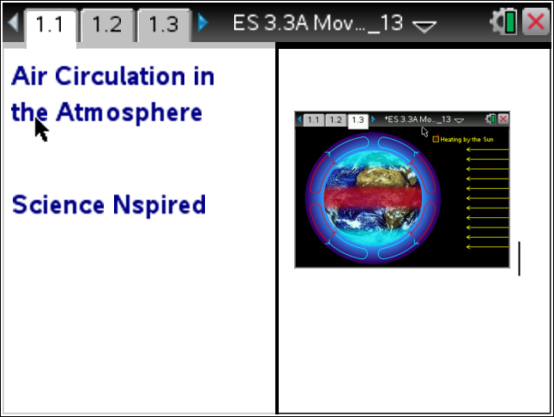  Tech Tips:  - This activity includes screen captures taken from the TI-Nspire CX handheld. It is also appropriate for use with the TI-Nspire family of products including TI-Nspire software and TI-Nspire App. Slight variations to these directions may be required if using other technologies besides the handheld.  - Watch for additional Tech Tips throughout the activity for the specific technology you are using.  - Access free tutorials at http://education.ti.com/calculators/pd/US/Online-Learning/Tutorials  Lesson Files:  Student Activity  - Moving_Air_Student.doc  - Moving_Air_Student.pdf  TI-Nspire document  - Moving_Air_.tns

Discussion Points and Possible Answers
1. Students read the information on page 1.2 in the .tns file.
Move to page 1.3.
Have students answer question 1 in the .tns file, activity sheet, or both.

Q1. Which region of the earth receives the most energy?

Answer: C. Equator

Move to page 1.4
2. After reading the instructions on page 1.4, close the directions box by selecting .  3. Click on the Heating by the Sun button to start simulation. Observe the atmospheric circulation arrows.  4. The red, shaded area around the equator represents an area of warmer air.  5. Note the direction and color of the arrow in the convection cells. |  | 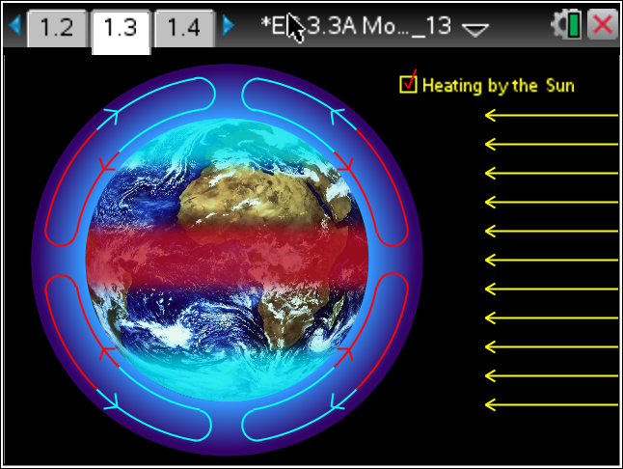
 | Tech Tip: To access the Directions again, select Menu > 1: Air Movement> 1: Directions To close the directions window, students must close box by selecting ..
Q2. How did the air in the atmosphere move when there was no heating by the sun?

Answer: A. No air circulation

Q3. How did the air in the atmosphere move when heated by the sun?

Answer: B. Rising air at the equator moves toward the poles.

Q4. Ne There are two colors representing the air circulation in the convection cells. What does the red color represent?

Answer: A. warm air

Q5. Describe the direction of the air in a single convection cell.

Sample Answer: Student answers will vary; The warm air at the equator rises then flows towards the poles. As it nears the poles it sinks and flows back towards the equator.

Q6. What is happening to the temperature of the air as it moves north and southward towards the poles?

Sample Answer: Student answers will vary; The temperature of the air decrease as it rises and moves toward the poles. The cold air at the poles sinks and moves back towards the equator where it begins to increase in temperature.

Move to page 1.7

Students read the information on page 1.7 then look at diagram on page 1.8 showing how the rotation of the earth creates 6 convection cells: Hadley cell, Ferrell or Mid-Latitude cell, and a Polar cell.

Q7. Describe the general pattern of warm and colder air circulation in any convection cell.

Sample Answer: Student answers will vary; Warm air always rises and cold air sinks. The direction of the circulation in the cell depends on its location between the equator and the poles.

Move to page 1.9

Students read the information on page 1.9 then look at diagram on page 1.10 showing the various wind patterns for convection cells: Trade winds, Westerlies. The Polar Easterlies are not shown.
Q8. What is the direction of the trade winds?

Sample Answer: Student answers will vary; In both the northern and southern hemisphere they curve toward the equator from east to west.

TI-Nspire Navigator Opportunities

Make a student a Live Presenter to illustrate show how to move the sliders. Throughout the activity, monitor student progress. At the end of the activity, collect the .tns file and save to Portfolio.

Wrap Up
When students are finished with the activity, retrieve the .tns file using TI-Nspire Navigator. Save grades to Portfolio. Discuss activity questions using Slide Show.

Assessment
- Formative assessment will consist of questions embedded in the .tns file. The questions will be graded when the .tns file is retrieved. The Slide Show will be utilized to give students immediate feedback on their assessment.
- Summative assessment could consist of questions/problems on the chapter test or a performance assessment involving students diagraming the motions of the earth’s atmosphere and the temperature changes of the air at different locations during circulation in the convection cell.

