Open the TI-Nspire document Clean_Water_Puzzle.tns  If water is clear, is it really clean? What variables are tested to see if water is clean? The water quality needed depends on it’s use. For example, water for drinking requires different standards than “clean” water for aquatic plants and animals. Knowing how environmental factors affect water quality can help predict where possible problems might be in a watershed. In this activity you will collect data from various water samples and use it to determine the location of the sample. |  | 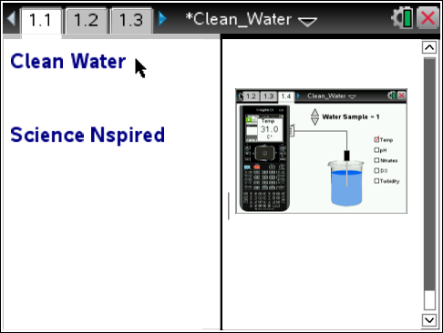
Move to page 1.2. and read the information given. Then move to page 1.3 and answer question 1 below and/or on your device.
Q1. There are many factors that affect water quality. When determining water quality

A. each factor is considered separately from the others.
B. the factors can affect each other so they are analyzed as a group.
C. only 5 factors are used to analyze water quality.

Move to page 1.4. and read the instructions.
1. After reading the instructions on page 1.4, close the directions box by selecting .  2. Begin by selecting a water sample using the clicker. Start data collection by clicking the GREEN record button on the virtual calculator screen. Drag the probe into the beaker and click the BLUE Enter button to collect a data point.  3. Check a new water quality test and click the BLUE button to record another data point.  4. Continue collecting data points for your first sample, then Press the RED stop button.  5. Repeat for Water Samples 2 and 3. | 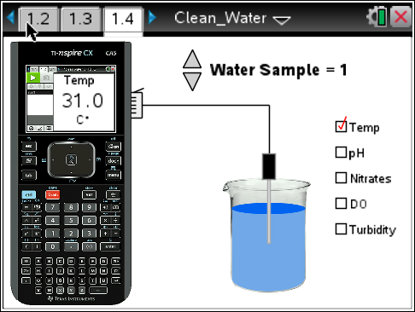
Move to pages 1.5 to 1.10
7. On page 1.5 you will find a spreadsheet containing the data points you collected, followed by graphs for each water quality test. You may want to record the data in the table on the next page.

Water Quality data for Samples

Water Sample | Temperature | pH | Nitrates | Dissolved Oxygen | Turbidity
1
2
3

8. Use the background information after the questions below to interpret your data and match each water sample with one of the three locations described in questions 2-7.

Move to page 1.11
Q2. Location A: This sample was taken from a large, fast moving river. The river’s tributaries normally drain both urban and agricultural areas with buffer strips that slow runoff and decrease the amount of sediment entering the river. Which water sample is this?

A. Water Sample 1
B. Water Sample 2
C. Water Sample 3

Q3. What evidence did you use to determine the water sample for Location A?

Q4. Location B: This sample was taken from a farm pond after a heavy rain. There is little vegetation on the banks surrounding this pond. The pond is located in the middle of a bean field that was recently fertilized. Which water sample is this?

A. Water Sample 1
B. Water Sample 2
C. Water Sample 3

Q5. What evidence did you use to determine the water sample for Location B?

Q6. Location C: This sample was taken from a shallow creek near an urban mall area. Runoff from the parking lot drains directly into this creek. Because the creek is shallow, it is very slow moving and the bottom is easy to see. There are few trees along the banks of this creek. Which water sample is this?

A. Water Sample 1
B. Water Sample 2
C. Water Sample 3

Q7. What evidence did you use to determine the water sample for Location C?

Discussion of Water Quality Factors:

Dissolved Oxygen: Dissolved oxygen (DO) is oxygen that is dissolved in water. Aquatic life requires dissolved oxygen to live. Much of the dissolved oxygen in surface water comes from the atmosphere. Moving water creates aeration so rivers and streams tend to contain more DO than ponds and lakes. Algae and aquatic plants also deliver oxygen to water through photosynthesis. When there are too many bacteria or aquatic animals in an area, they may overpopulate and use dissolved oxygen in great amounts. Also, cool water can hold more dissolved oxygen than warm water. Normal DO for freshwater is between 4-7 mg/L.

Temperature: Surface water temperature is affected by air temperature, runoff, turbidity, depth and exposure to sunlight. Increased turbidity makes water darker and increases the amount of sunlight absorbed, while shade from trees along the banks and shores can decrease heating from the sun. Shallow creeks and streams can warm up more quickly than deeper bodies of water. The warmer the water, the less dissolved oxygen carrying capacity of water. The rate of photosynthesis by aquatic plants can also decrease as the temperature increases. Some compounds are also more toxic to aquatic life at higher temperatures.

pH: Most fish can tolerate pH values of about 5.0 to 9.0. Most rivers, lakes and streams in the U.S. fall within this range, though acid rain has compromised many bodies of water in our environment. The largest variety of freshwater aquatic organisms prefer a pH range between 6.5 to 8.0

Turbidity: Turbidity is the measure of water clarity. It is an important indicator of suspended sediments and the amount of erosion. Runoff carrying silt, dirt, and chemicals from urban and agricultural areas can increase the turbidity of surface waters. Usually turbidity will increase sharply during and after it rains because sediment runs off into the water. Algal blooms can also increase turbidity. High turbidity levels can also raise water temperature, lower dissolved oxygen, prevent sunlight from reaching aquatic plants decreasing photosynthesis. The turbidity of surface water is usually between 1 NTU and 50 NTU.

Nitrates:. In water, nitrogen is present in many forms, including ammonia, nitrates, and nitrites.
As aquatic plants and animals die, bacteria break them down to form nitrites and nitrates. Excretions from aquatic organisms, ducks, geese, farm animals and other organisms contribute to the increase of nitrates in a watershed. Nitrates in water can also result from fertilizer runoff from lawns and agricultural areas. Nitrate levels in freshwater are usually less than 1mg/L but manmade sources of nitrate may increase levels to above 4mg/L.

