Science Objectives  - Students will collect and analyze water quality data to determine the location of various water samples.  Vocabulary  - Dissolved oxygen  - Turbidity  - Nitrates  - pH  - Water Quality  - Aeration  - Buffer strips  - Runoff  About the Lesson  - In this lesson students will collect water quality data for three water samples. Using this data and background information about the water quality tests, they will identify the source of the sample. As a result, students will:  - Understand how scientists use data to analyze water samples  TI-Nspire™ Navigator™  - Send out the .tns file.  - Monitor student progress using Class Capture.  - Use Live Presenter to spotlight student answers.  Activity Materials  - Compatible TI Technologies: TI- Nspire™ CX Handhelds,  TI-Nspire™ Apps for iPad®,  TI-Nspire™ Software | 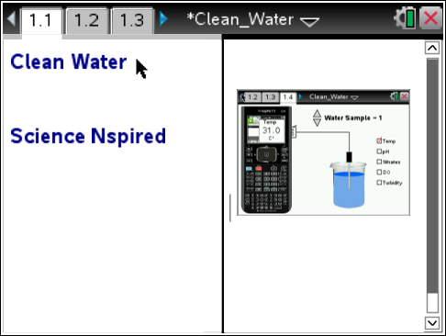  Tech Tips:  - This activity includes screen captures taken from the TI-Nspire CX handheld. It is also appropriate for use with the TI-Nspire family of products including TI-Nspire software and TI-Nspire App. Slight variations to these directions may be required if using other technologies besides the handheld.  - Watch for additional Tech Tips throughout the activity for the specific technology you are using.  - Access free tutorials at http://education.ti.com/calculators/pd/US/Online-Learning/Tutorials  Lesson Files:  Student Activity  - Clean_Water_Student.doc  - Clean_Water_Student.pdf  TI-Nspire document  - Clean_Water_.tns

Discussion Points and Possible Answers
1. Have students read the background information stated on their activity sheet and page 1.2 in the .tns file.
Move to page 1.3.
Have students answer question 1 in the .tns file, activity sheet, or both.

Q1. There are many factors that affect water quality. When determining water quality

A. each factor is considered separately from the others.
B. the factors can affect each other so they are analyzed as a group.
C. only 5 factors are used to analyze water quality.

Move to page 1.4
2. After reading the instructions on page 1.4, students should close the directions box by selecting .  3. Students begin by selecting a water sample using the clicker. Data collection is started by clicking the GREEN record button on the virtual calculator screen. Students drag the probe into the beaker and click the BLUE Enter button to collect a data point.  4. Students then check a new water quality test and click the BLUE button to record another data point.  5. They should continue collecting data points for the first sample, then Press the RED stop button.  6. Repeat for Water Samples 2 and 3. |  | 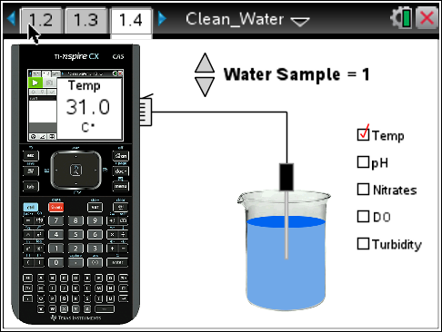
 | Tech Tip: To access the Directions again, select Menu > 1: Clean Water 1: Directions To close the directions window, students must close box by selecting ..
Tech Tip: Remind the students that the clicker in the center of the touchpad is the BLUE enter button for this simulation.
Move to pages 1.5 to 1.10
7. On page 1.5 is a spreadsheet containing the data points collected, followed by graphs for each water quality test. You can have the students record their data on their activity sheets or move between page 1.5 and the questions starting on page 1.11

Answer:

Water Sample | Temperature | pH | Nitrates | Dissolved Oxygen | Turbidity
1 | 31 C | 8 | 1 mg/L | 2 mg/L | 10 NTU
2 | 24 C | 8 | 10 mg/L | 9 mg/L | 50 NTU
3 | 24 C | 8 | 4 mg/L | 10 mg/L | 26 NTU

Q2. Location A: This sample was taken from a large, fast moving river. The river’s tributaries normally drain both urban and agricultural areas with buffer strips that slow runoff and decrease the amount of sediment entering the river. Which water sample is this?

Answer: C. Water Sample 3

Q3. What evidence did you use to determine the water sample for Location A?

Sample Answer: Student answers will vary; Moving water increases the dissolved oxygen and this sample had the highest DO level. The buffer strips help keep the sediment levels low and this one was in the middle of the normal range. It did have higher nitrate levels that might be attributed to fertilizers used on fields that are drained by it’s tributaries. The cooler water temperature could be because it’s not shallow like a creek.

Q4. Location B: This sample was taken from a farm pond after a heavy rain. There is little vegetation on the banks surrounding this pond. The pond is located in the middle of a bean field that was recently fertilized. Which water sample is this?

Answer: A. Water Sample 2

Q5. What evidence did you use to determine the water sample for Location B?

Sample Answer: Student answers will vary; Ponds can have algae that produce oxygen, but the water isn’t moving and this sample had the second highest DO level. The turbidity was very high probably because there were no buffer strips to help keep the sediment levels low it had rained. It had the highest nitrate levels that might be attributed to fertilizers used on fields. The cooler water temperature could be because it’s not shallow like a creek.

Q6. Location C: This sample was taken from a shallow creek near an urban mall area. Runoff from the parking lot drains directly into this creek. Because the creek is shallow, it is very slow moving and the bottom is easy to see. There are few trees along the banks of this creek. Which water sample is this?

Answer: C. Water Sample 1

Q7. What evidence did you use to determine the water sample for Location C?

Sample Answer: Student answers will vary; Shallow water with no shade can cause water temperature to increase. Warmer water holds less oxygen and this sample had the highest temperature and lowest DO readings. The turbidity was low probably because there wasn’t any soil that the water was running over. It also had the lowest nitrate levels that might be attributed to the fact that fertilizers aren’t used on parking lots.

TI-Nspire Navigator Opportunities

Make a student a Live Presenter to illustrate show how to move the sliders. Throughout the activity, monitor student progress. At the end of the activity, collect the .tns file and save to Portfolio.

Wrap Up
When students are finished with the activity, retrieve the .tns file using TI-Nspire Navigator. Save grades to Portfolio. Discuss activity questions using Slide Show.

Assessment
- Formative assessment will consist of questions embedded in the .tns file. The questions will be graded when the .tns file is retrieved. The Slide Show will be utilized to give students immediate feedback on their assessment.
- Summative assessment could consist of questions/problems on the chapter test or a performance assessment involving students using data collection sensors to collect data from local bodies of water and analyzing the water quality.

