Open the TI-Nspire document Rock_Formations.tns  Many processes are at work on the earth’s surface. Weathering, erosion, and deposition work together to shape the landscape. The movement of water is an example of all three processes occurring at the same time. Water can dissolve and carry away minerals in the rock. Rock particles in the water can abrade rock (wear down or rub away by friction). In this simulation, you will observe the effects of wave action on a rock cliff. |  | 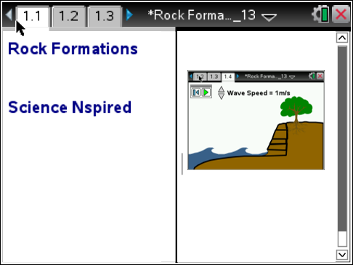
Move to page 1.2. and read the information given. Then move to pages 1.3-1.4 and answer questions 1 and 2 below and/or on your device.
Q1. When water waves pound on the face of a rock cliff, which of the following occurs?

A. Weathering
B. Erosion
C. Deposition
D. all three occur

Q2. What happens to the size of the bottom layer of rock during the simulation?

True or False

Move to page 1.5. and read the instructions.
1. After reading the instructions on page 1.5, close the directions box by selecting .  2. Click on the play button to start simulation. Observe what is happening to the rocks at the base of the cliff.  3. Use the wave speed clicker to change the speed of the waves.  4. Run the simulation until the bottom layer of the cliff has eroded. | 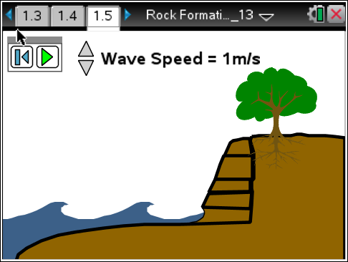
Move to pages 1.6-1.12
Q3. What happens to the size of the bottom layer of rock during the simulation?

A. increases.
B. decreases.
C. stays the same.

Q4. As the waves hit the rock, some of the minerals in the rock dissolve and are carried away. Which process or processes does this demonstrate?

A. Weathering
B. Erosion
C. Deposition

Q5. The waves also carry small particles that smash into the rock knocking off more particles and then carrying them away. This abrasion of rock demonstrates which of the following process or processes?

A. Weathering
B. Erosion
C. Deposition

Q6. What force caused the upper rock layers to fall into the ocean?

- Waves
- Gravity
- Water

Q7. Which of the following process or processes best categorizes the action of the upper rock layers on the cliff falling into the ocean?

A. Weathering
B. Erosion
C. Deposition

Q8. Which action best demonstrates erosion and weathering over a long period of time?

A. Wave action dissolving and abrading the lowest rock layer
B. Gravity causing the unstable upper rock layers to fall

Q9. What would eventually happen to the upper rock layers that fell into the ocean?

