Science Objectives  - Students will make observations of weathering and erosion due to wave action and gravity.  Vocabulary  - weathering  - erosion  - gravity  - abrasion  - geoscience processes  About the Lesson  - In this lesson students make observations of weathering and erosion by waves and gravity. Students will use their observations to match the actions of the waves to the processes that shape the earth.  - As a result, students will understand that:  - Weathering is the physical or chemical breakdown of rock  - Erosion is the process of carrying rock away  - Geoscience processes can change the Earth’s surface at varying time and spatial scales.  TI-Nspire™ Navigator™  - Send out the .tns file.  - Monitor student progress using Class Capture.  - Use Live Presenter to spotlight student answers.  Activity Materials  - Compatible TI Technologies: TI- Nspire™ CX Handhelds,  TI-Nspire™ Apps for iPad®,  TI-Nspire™ Software | 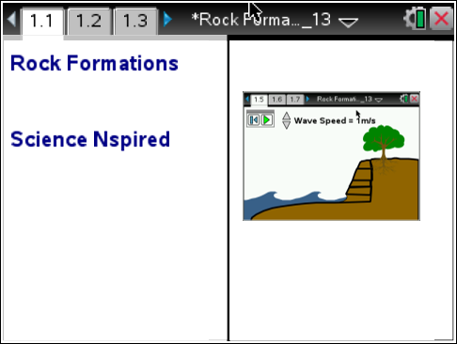  Tech Tips:  - This activity includes screen captures taken from the TI-Nspire CX handheld. It is also appropriate for use with the TI-Nspire family of products including TI-Nspire software and TI-Nspire App. Slight variations to these directions may be required if using other technologies besides the handheld.  - Watch for additional Tech Tips throughout the activity for the specific technology you are using.  - Access free tutorials at http://education.ti.com/calculators/pd/US/Online-Learning/Tutorials  Lesson Files:  Student Activity  - Rock_Formations_Student.doc  - Rock_Formations_Student.pdf  TI-Nspire document  - Rock_Formations_.tns

Discussion Points and Possible Answers
1. Students read the information on page 1.2 in the .tns file.
Move to page 1.3.
Have students answer questions 1 and 2 in the .tns file, activity sheet, or both.

Q1. When water waves pound on the face of a rock cliff, which of the following occurs?

Answer: D. all three occur

Q2. Geoscience processes can change the Earth’s surface at varying time scales: quickly or slowly over time.

Answer: True

Move to page 1.5
2. After reading the instructions on page 1.5, students should close the directions box by selecting .  3. After clicking on the play button to start simulation, student will observe what is happening to the rocks at the base of the cliff.  4. Students can use the wave speed clicker to change the speed of the waves.  5. Have students run the simulation until the bottom layer of the cliff has eroded. |  | 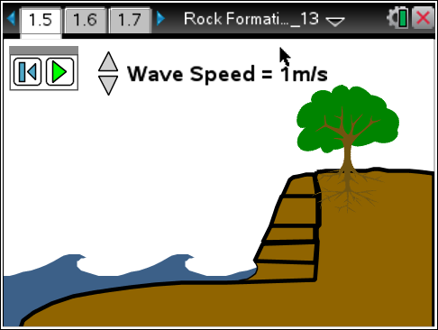
 | Tech Tip: To access the Directions again, select Menu > 1: Rock Formations> 1: Directions To close the directions window, students must close box by selecting ..
Q3. What happens to the size of the bottom layer of rock during the simulation?

Answer: B. decreases

Q4. As the waves hit the rock, some of the minerals in the rock dissolve and are carried away. Which process or processes does this demonstrate?

Answer: A & B Weathering and Erosion

Q5. The waves also carry small particles that smash into the rock knocking off more particles and then carrying them away. This abrasion of rock demonstrates which of the following process or processes?

Answer: A & B Weathering and Erosion

Q6. What force caused the upper rock layers to fall into the ocean?

Answer: B. Gravity

Q7. Which of the following process or processes best categorizes the action of the upper rock layers on the cliff falling into the ocean?

Answer: B. Erosion

Q8. Which action best demonstrates erosion and weathering over a long period of time?

Answer: A. Wave action dissolving and abrading the lowest rock layer

Q9. What would eventually happen to the upper rock layers that fell into the ocean?

Sample Answer: Student answers will vary; The rocks will continue to be weathered by abrasion and dissolving of minerals. Wave action will erode the rocks over time.

TI-Nspire Navigator Opportunities

Make a student a Live Presenter to illustrate show how to move the sliders. Throughout the activity, monitor student progress. At the end of the activity, collect the .tns file and save to Portfolio.

Wrap Up
When students are finished with the activity, retrieve the .tns file using TI-Nspire Navigator. Save grades to Portfolio. Discuss activity questions using Slide Show.

Assessment
- Formative assessment will consist of questions embedded in the .tns file. The questions will be graded when the .tns file is retrieved. The Slide Show will be utilized to give students immediate feedback on their assessment.
- Summative assessment could consist of questions/problems on the chapter test or a performance assessment involving students identifying the processes of weathering, erosion, and deposition around the school, community or at home. Try and emphasize geoscience processes that shape local geographic features, where appropriate.

