Open the TI-Nspire document Ocean_Currents.tns  Ocean water is in constant motion throughout an Earth-wide system of currents known as the “oceanic conveyor belt.” These currents move at much slower speeds (around a few centimeters a second) when compared to surface, or wind driven currents which can travel anywhere from tens to hundreds of cm a second. It is estimated that it can take around 1,000 years for a cubic meter of water to travel through the entire system. In this simulation you will take a closer look at the oceanic conveyor belt and investigate what environmental factors drive the current system. |  |  | 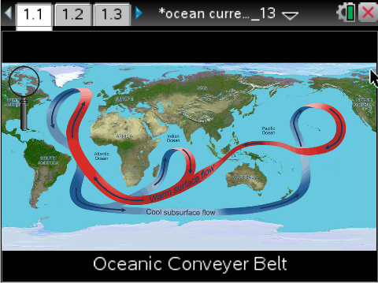
Move to page 1.3. Read the directions below and/or on your device.
On the following page you will see a magnifying glass in the top left corner of the screen. Select the magnifying glass and then hover over the Indian Ocean. When doing so a question mark will appear. As this happens, click to zoom in on the selected area. Doing so will bring up a series of buoys on your screen. Using the same process as before, select the magnifying glass and click on each of the buoys that appear on the screen. As you click on the selected buoy, a series of information will pop up displaying key data points. All of the data you collect from these buoys will be stored on spreadsheet page 1.5. Be sure to gather all of the information from all of the buoys. As you are conducting your data collection, look for patterns in the different data points. Be sure to collect the information for all of the buoys in the Indian Ocean.
Move to page 1.4.
1. After reading the instructions on page 1.4, close the directions box by selecting .  2. To begin researching, select the magnifying glass. Place the magnifying glass over the Indian Ocean until a question mark appears on the screen. Once this icon is displayed, click to bring to zoom in on the selected area.  3. A series of buoys will appear on the screen. Using the same process as before, selected your magnifying glass and hover over the areas of interest. Once again, click on the selected area to display the data the buoy has collected.  4. As you select buoys, all of the data viewed will be stored on a spreadsheet, located on page 1.5.  5. Record your data on the table. | 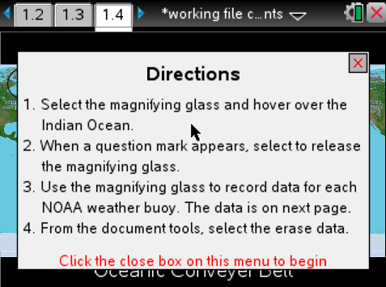
Buoy | Temp | Salinity | pH | Wind | Place the number next to each buoy.
1 |  |  |  |  | 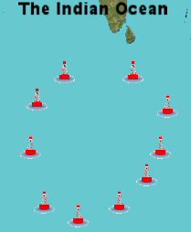
2
3
4
5
6
7
8
9
10

After examining the data in the spreadsheet on page 1.5, the graph on page 1.6 and the graphic representation above, answer questions 1 – 13 below and/or in your .tns file.

Tech Tip: To scroll through data in the spreadsheet on screen 1.4, press your finger anywhere on the screen and drag it up or down.

Q1. On page 1.3, set the y axis to temperature and the x axis to buoy. What pattern do you notice?

Q2. When looking at the current located towards the west, closer to the coast of Africa, we can determine that this is a ___ water current.

A. warm
B. cold

Q3. As you increase the temperature of water, what happens to its density?

A. The density increases.
B. The density decreases.
C. The density stays the same.

Q4. Why would temperature have an effect on the current system?

Q5. Upwelling is the process where deep water returns to the surface and then becomes a shallow current. At which buoy is this process most likely to occur at?

A. Buoy 2
B. Buoy 5
C. Buoy 8
D. Buoy 10

Q6. Is there any observable pattern with the pH numbers from the different buoys?

A. Yes
B. No

Q7. Where is the cold water directly coming from before it gets close to the equator?

A. From the North.
B. From the East, near Australia.
C. From the South, near Antarctica.

Q8. Does the wind pattern match the overall flow of the current?

A. Yes
B. No

Q9. What type of current is guided by wind?

A. Deep water current.
B. Surface current.
C. Surface and deep water current.

Q10. When comparing buoys 1 and 2 with 3 and 4, which values in the data appear to be lower for buoys 3 and 4?

A. Temperature.
B. Wind
C. pH
D. Salinity

Q11. Why would there be more salt coming from Antarctica than from the equator?

A. Gravity is stronger by the poles, which causes more of the salt to culminate there.
B. Water by the poles freeze and create ice caps, leaving tons of salty water behind.
C. The salt keeps the water colder over a longer period of time.
D. There are more currents by the south pole, causing tons salt to gather there.

Q12. Which factors have an effect on the density of water? (select ALL that apply)

A. pH.
B. Temperature.
C. Wind.
D. Salinity.

Q13. The current system is driven by a process known as "Thermohaline Circulation." Using what you have learned throughout this simulation, explain what is meant by that term.

