Science Objectives  - Students will investigate and discover relationships between temperature and salinity as the driving force behind the global conveyor belt.  - Students will differentiate the differences between surface currents and deep water currents.  Vocabulary  - Thermohaline circulation  - Upwelling  - Density  - Oceanic Conveyor Belt  About the Lesson  - As a result of this lesson, students will:  - Discover that we have an interconnected oceanic current system, tied together by temperature and salinity variations causing changes in density.  - Explain the process of upwelling and what effect it has on the current system.  - Understand the impact thermal energy from the sun has on the current system.  TI-Nspire™ Navigator™  - Send out the .tns file.  - Monitor student progress using Class Capture.  - Use Live Presenter to spotlight student answers.  Activity Materials  - Compatible TI Technologies: TI- Nspire™ CX Handhelds,  TI-Nspire™ Apps for iPad®,  TI-Nspire™ Software | 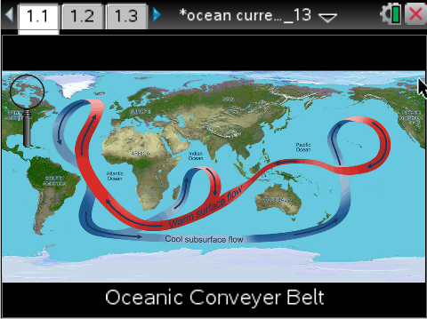  Tech Tips:  - This activity includes screen captures taken from the TI-Nspire CX handheld. It is also appropriate for use with the TI-Nspire family of products including TI-Nspire software and TI-Nspire App. Slight variations to these directions may be required if using other technologies besides the handheld.  - Watch for additional Tech Tips throughout the activity for the specific technology you are using.  - Access free tutorials at http://education.ti.com/calculators/pd/US/Online-Learning/Tutorials  Lesson Files:  Student Activity  - Ocean_Currents_Student.doc  - Ocean_Currents_Student.pdf  TI-Nspire document  - Ocean_Currents.tns

Discussion Points and Possible Answers
Have students read the background information stated on their activity sheet.
Move to page 1.4.
1. After reading the instructions on page 1.4, students should then close the directions box by selecting .  2. Students should select the magnifying glass and then hover over the Indian Ocean. When doing so a question mark will appear. As this happens, click to zoom in on the selected area. Doing so will bring up a series of buoys on their screen. Using the same process as before, select the magnifying glass and click on each of the buoys that appear on the screen. As the students click on a selected buoy, a series of information will pop up displaying key data points. Students will record the data they collect onto their student activity sheet. | 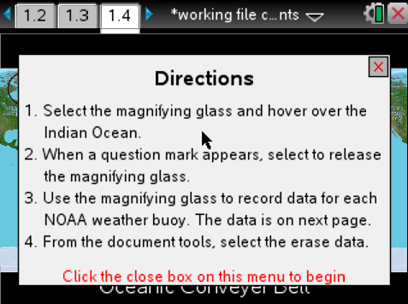
Tech Tip: To access the Directions again, select > Directions
The buoy data will be captured on the spreadsheet on page 1.5 and will also be graphed on page 1.6. If students select the reset button on page 1.3, the data will be cleared from the spreadsheet and the graph.
Tech Tip: To scroll through data in the spreadsheet on screen 1.4, students can press their finger anywhere on the screen and drag it up or down.
Buoy | Temp | Salinity | pH | Wind | Place the number next to each buoy.
1 | 30° | 35.4 ppt | 8.06 | SSE | 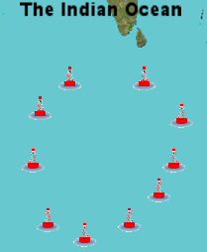  1  10  2  9  3  8  4  7  5  6
2 | 30° | 35.2 ppt | 8.08 | ESE
3 | 30° | 34.4 ppt | 8.07 | ESE
4 | 30° | 34.4 ppt | 8.02 | ESE
5 | 28° | 34.4 ppt | 8.08 | ESE
6 | 24° | 34.8 ppt | 8.10 | ESE
7 | 22° | 33.8 ppt | 8.08 | ESE
8 | 22° | 33.8 ppt | 8.10 | SSW
9 | 24° | 35 ppt | 8.12 | SSE
10 | 26° | 35 ppt | 8.09 | SSE

Move to page 2.1.
Have students answer questions 1-12 in the .tns file, the activity sheet, or both.

Q1. On page 1.3, set the y axis to temperature and the x axis to buoy. What pattern do you notice?

Sample Answer: As you get closer to the equator, the temperature of the water increases. The further south you go, the temperature decreases.

Q2. When looking at the current located towards the west, closer to the coast of Africa, we can determine that this is a ___ water current.
Answer: B. Cold

Q3. As you increase the temperature of water, what happens to its density?

Answer: B. The density decreases.

Q4. Why would temperature have an effect on the current system?

Sample Answer: Cold water will sink due to it being denser, while warm water will rise to it being less dense.

Q5. Upwelling is the process where deep water returns to the surface and then becomes a shallow current. At which buoy is this process most likely to occur at?

Answer: A. Buoy 2

Q6. Is there any observable pattern with the pH numbers from the different buoys?

Answer: B. No

Q7. Where is the cold water directly coming from before it gets close to the equator?

Answer: C. From the south, near Antarctica

Q8. Does the wind pattern match the overall flow of the current?

Answer: B. No

Q9. What type of current is guided by wind?

Answer: B. Surface Current

Q10. When comparing buoys 1 and 2 with 3 and 4, which values in the data appear to be lower for buoys 3 and 4?

Answer: D. Salinity

Q11. Why would there be more salt coming from Antarctica than from the equator?

Answer: B. Water by the poles freeze and create ice caps, leaving tons of salty water behind.

Q12. Which factors have an effect on the density of water? (select ALL that apply)

Answer: temperature and salinity

Q13. The current system is driven by a process known as "Thermohaline Circulation." Using what you have learned throughout this simulation, explain what is meant by that term.

Sample Answer: Ocean currents are driven by changes in ocean temperature and salt concentration.

TI-Nspire Navigator Opportunities

Make a student a Live Presenter to illustrate show how to move use the magnifying glass. Throughout the activity, monitor student progress. At the end of the activity, collect the .tns file and save to Portfolio.

Wrap Up
When students are finished with the activity, retrieve the .tns file using TI-Nspire Navigator. Save grades to Portfolio. Discuss activity questions using Slide Show.

Assessment
- Formative assessment will consist of questions embedded in the .tns file. The questions will be graded when the .tns file is retrieved. The Slide Show will be utilized to give students immediate feedback on their assessment.
- Summative assessment could consist of questions/problems on the chapter test or a performance assessment involving collecting local, buoy data online and analyzing it.

