Science Objectives  - Students will predict the locations of the continents in the ancient supercontinent Pangaea based on coastlines and various lines of evidence.  Vocabulary  - fossil  - plates  - plate tectonics  - Pangaea  - theory  - evidence  About the Lesson  - In this lesson students will move the continents from their present day locations on the earth’s surface to their location in the supercontinent Pangaea. As a result, students will:  - Understand how scientists use evidence to formulate theories  - Determine past locations of the continents.  TI-Nspire™ Navigator™  - Send out the .tns file.  - Monitor student progress using Class Capture.  - Use Live Presenter to spotlight student answers.  Activity Materials  - Compatible TI Technologies: TI- Nspire™ CX Handhelds,  TI-Nspire™ Apps for iPad®,  TI-Nspire™ Software | 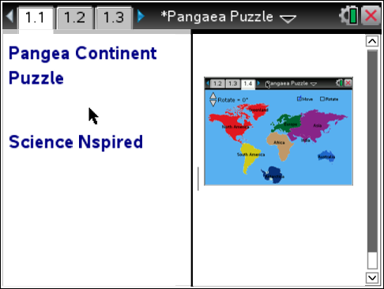  Tech Tips:  - This activity includes screen captures taken from the TI-Nspire CX handheld. It is also appropriate for use with the TI-Nspire family of products including TI-Nspire software and TI-Nspire App. Slight variations to these directions may be required if using other technologies besides the handheld.  - Watch for additional Tech Tips throughout the activity for the specific technology you are using.  - Access free tutorials at http://education.ti.com/calculators/pd/US/Online-Learning/Tutorials  Lesson Files:  Student Activity  - Pangea_Continent_Puzzle_  Student.doc  - Pangea_Continent_Puzzle_  Student.pdf  TI-Nspire document  - Pangea_Continent_Puzzle.tns

Discussion Points and Possible Answers
1. Have students read the background information stated on their activity sheet and page 1.2 in the .tns file.
Move to page 1.3.
Have students answer question 1 in the .tns file, activity sheet, or both.

Q1. What evidence can be used to determine past locations of the continents?

Answer: All of the choices given are correct.

Move to pages 1.4-1.5.
2. After reading the instructions on page 1.4, students should close the directions box by selecting .  3. Student use the a to grab and drag a continent to the desired location. (Student Hint: Assume Africa has not moved much in the last 200 million years and use that as the starting point) |  | 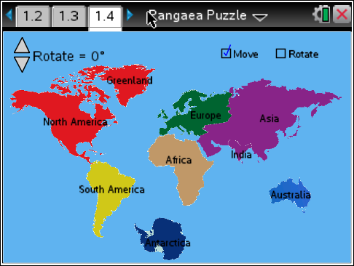
 | Tech Tip: To access the Directions again, select Menu > 1: Pangea Continent Puzzle > 1: Directions To close the fossil type picture window, students must close box by selecting ..
Tech Tip: To rotate a continent, click the Rotate box in the upper right of the screen, then on the continent. Use the Rotate slider on the left to rotate clockwise or counterclockwise
Move to pages 1.6-1.8
Have students answer questions 2-4 on the device, the activity sheet, or both using their maps.

Q2. What characteristic did you find most useful in determining how to arrange the continents?

Answer: B. shape of the coastlines
Q3. Which two continents have the best matching coastlines?

Sample Answer: Student answers may vary, but the best answer is South America and Africa

Q4. Which two continents have coastlines that match the least?

Sample Answer: Student answers will vary

4. When students are satisfied with their hypothetical maps, they will sketch their configuration. Students’ evidence maps will vary (see sample on the right). |  | 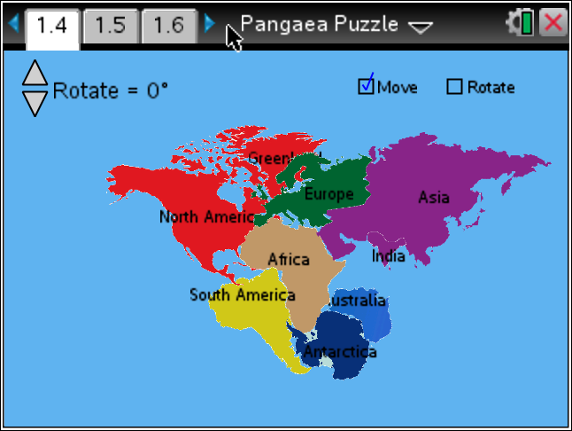
5. Students will analyze other pieces of evidence for the existence of Pangaea, then return to page 1.4 to make adjustments to their maps.

- Geologist Alexander du Toit observed rock layers on the western coast of Africa were almost identical to a sequence of rock layers on the eastern coast of South America.
- The Indian continent has fossils in common with the horn of Africa and the northern half of Antarctica.
- Antarctica and Australia have fossils in common with Africa and South America.
- When the direction of grooves formed by large glaciers are aligned, an ancient ice sheet expanding outward in all directions is formed across Africa, South America, Australia, Antarctica, and India.
- An Alpine Mountain range is found along the east coast of North America, Northern Africa, Greenland, and Europe
- European plant fossils have been found in Canada and Greenland.
- In 1965, Geologist Edward Bullard used computers to match the underwater coastlines of South America and Africa. At an ocean depth of about 1,000 meters they matched very well.

6. When students are satisfied with changes to their hypothetical maps, they will sketch their configuration. Students’ evidence maps will vary (see sample on the right). |  | 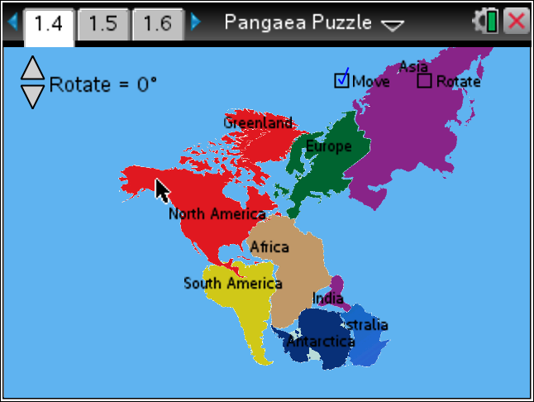
Have students answer questions 5-11 on their activity sheet using their new maps.

Q5. Why is the fact that similar fossils have been found on different continents considered evidence for the existence of Pangaea?

Sample Answer: It would be hard for land animals to survive a swim across the open ocean. For the to be on the same continents, they would have needed to be able to walk there.

Q6. What might be the reason why the sea level outlines of the continents don’t fit perfectly into a supercontinent but they do under water?

Sample Answer: Erosion and weathering have removed parts of the coastline while volcanoes could have added land.

Q7. Remember that in order for a theory to be accepted as the best explanation for a natural phenomena, it must do the best job of explaining all evidence. Theories can sometimes be made stronger as new pieces of evidence are discovered. What do you think is the most convincing piece of evidence for the existence of Pangaea? Why?

Sample Answer: Student answers will vary. They should provide valid reasoning for their answers. Rock layers are the best evidence because they are too large and heavy to be moved by the wind to different places around the world (like a seed that could travel across the ocean and grow on a new continent). Animals could have moved between continents by a land bridge.

Q8. India and Eurasia are on different plates. Separating India from Eurasia is the Himalayan Mountain range which continues to increase in height every year. What implication does the increasing height of the Himalayas have on plate movement?

Answer: A. The Indian and Eurasian plates are colliding.

Q9. The Himalayas are the tallest mountains in the world. Interestingly, fossils of seashells can be found in these mountains, far from the ocean. How do you think they got there?

Sample Answer: They were in the ocean between India and Eurasia. When the Indian plate moved northward, the ocean floor bunched up to create the mountains as India collided with Eurasia.

Q10. Based on the evidence we have to reconstruct the history of the earth, it seems that Earth is always changing. What evidence to we have today that supports this idea? (HINT: Think about natural disasters.)

Sample Answer: Earthquakes happen when the plates move. They change the shapes of the continents and their locations. Volcano also make new land that changes the shapes and heights of the continents.

Q11. In 100 years, do you think the continents will still be where they are today, or will they be in a different location? Why do you think this?

Sample Answer: They will be in different locations because the plates are still moving.

TI-Nspire Navigator Opportunities

Make a student a Live Presenter to illustrate show how to move the sliders. Throughout the activity, monitor student progress. At the end of the activity, collect the .tns file and save to Portfolio.

Wrap Up
When students are finished with the activity, retrieve the .tns file using TI-Nspire Navigator. Save grades to Portfolio. Discuss activity questions using Slide Show.

Assessment
- Formative assessment will consist of questions embedded in the .tns file. The questions will be graded when the .tns file is retrieved. The Slide Show will be utilized to give students immediate feedback on their assessment.
- Summative assessment could consist of questions/problems on the chapter test or a performance assessment involving students re-creating Pangaea from hands-on puzzle pieces and sketching evidence that would support their arrangement of the continents.

