Science Objectives  - Students will analyze and interpret data on the distribution of fossils to provide evidence of the past plate motions.  Vocabulary  - fossil  - plates  - plate tectonics  - Pangea  About the Lesson  - In this lesson students use a magnifying glass to discover fossils at various locations on the earth’s continents. As a result, students will:  - Understand how scientiists use fossil evidence to infer past plate motions.  - Determine past locations of continents.  TI-Nspire™ Navigator™  - Send out the .tns file.  - Monitor student progress using Class Capture.  - Use Live Presenter to spotlight student answers.  Activity Materials  - Compatible TI Technologies: TI- Nspire™ CX Handhelds,  TI-Nspire™ Apps for iPad®,  TI-Nspire™ Software | 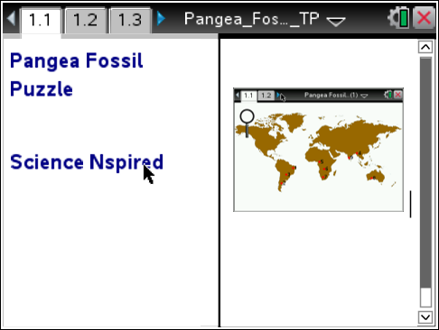  Tech Tips:  - This activity includes screen captures taken from the TI-Nspire CX handheld. It is also appropriate for use with the TI-Nspire family of products including TI-Nspire software and TI-Nspire App. Slight variations to these directions may be required if using other technologies besides the handheld.  - Watch for additional Tech Tips throughout the activity for the specific technology you are using.  - Access free tutorials at http://education.ti.com/calculators/pd/US/Online-Learning/Tutorials  Lesson Files:  Student Activity  - Pangea_Fossil_Puzzle_  Student.doc  - Pangea_Fossil_Puzzle_  Student.pdf  TI-Nspire document  - Pangea_Fossil_Puzzle.tns

Discussion Points and Possible Answers
Have students read the background information stated on their activity sheet and page 1.2 in the .tns file.
Move to page 1.3.
Have students answer question 1 in the .tns file, activity sheet, or both.

Q1. What evidence can be used to determine past locations of the continents?

Answer: All of the choices given are correct.

Move to pages 1.4-1.5.
1. After reading the information on page 1.4 and the instructions on page 1.5, students should then close the directions box by selecting .  2. Students should begin by moving the magnifier to the numbered fossil dig locations on the map. Students should record the fossil types found at each location on their student activity sheet. |  | 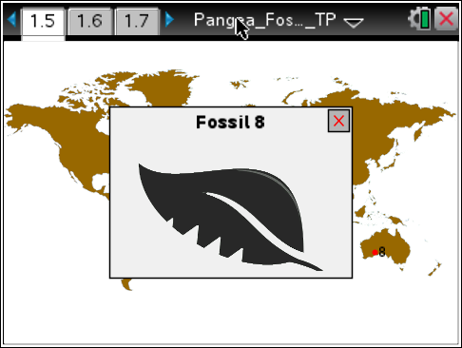
 | Tech Tip: To access the Directions again, select Menu > 1: Pangea Fossil Puzzle > 1: Directions
Tech Tip: To close the fossil type picture window, students must close box by selecting .. The magnifier will reappear in the upper right hand box of the screen for them to grab, drag, and drop at a new site.
Move to page 1.6

3. Students’ evidence maps should look like this:

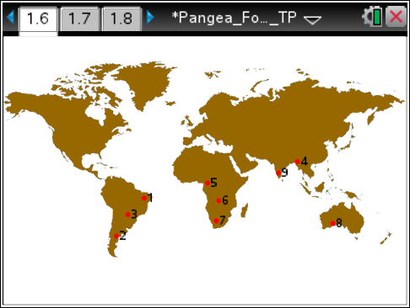
C
B
D
D
B
C
C
A
A

Place the letter corresponding to the fossil types below next to the fossil dig site where it was found on the map.
 A  B





C D
Move to page 1.8
Have students answer questions 2-12 on the device, the activity sheet, or both using their maps.

Q2. Which two continents have the most matching fossils between them?

Answer: South America and Africa

Q3. What do you notice about the coastlines of South America and Africa?

Sample Answer: They seem to fit together like parts of a jigsaw puzzle.

Q4. India has 2 fossils in common with (Check all that apply):

Answer: Australia, Africa, and South America

Q5. Based on the fossil evidence, to which continent was Australia most likely connected?

Answer: India

Q6. What evidence do you have that India may not have always been attached to Eurasia?

Sample Answer: The fossils on India match the fossils on the southern half of Africa.

Move to page 1.13

Separating India from Eurasia is the Himalayan Mountain range. These mountains increase in height by 1 cm per year as the Indian plate and the Eurasian plate collide. This is because the Indian Plate is moving north.
Move to page 1.14

Q7. Based on the fossil evidence and the motions of the plates, what might be the arrangement of the following continents:

Answer: India between Africa and Australia

Q8. Based on your fossil evidence how would the discovery of fossils on continents separated by miles of ocean support Wegener’s continental drift hypothesis?

Sample Answer: If the fossils where of animals that could not swim, then it would be logical to think the continents would have to be connected in some way for the animals to move between them.

Q9. Look at the picture of Fossil A. Does it look like it would be a good swimmer?

Answer: No

Q10. Look at the picture of Fossil A. Does it look like it would be a good swimmer?

Answer: No

Q11. Why would the fossil of an ocean fish found on two different continents NOT be good evidence of continental drift?

Sample Answer: .

Q12. Why would finding similar fossils on different continents be considered evidence for continental drift?
Sample Answer: When fossils of similar plants and animals can be found on continents separated by an ocean, it seems likely that the continents may have been joined so the plants and animals could migrate.

TI-Nspire Navigator Opportunities

Make a student a Live Presenter to illustrate show how to move the sliders. Throughout the activity, monitor student progress. At the end of the activity, collect the .tns file and save to Portfolio.

Wrap Up
When students are finished with the activity, retrieve the .tns file using TI-Nspire Navigator. Save grades to Portfolio. Discuss activity questions using Slide Show.

Assessment
- Formative assessment will consist of questions embedded in the .tns file. The questions will be graded when the .tns file is retrieved. The Slide Show will be utilized to give students immediate feedback on their assessment.
- Summative assessment could consist of questions/problems on the chapter test or a performance assessment involving collecting actual water quality data and analyzing it.

