Open the TI-Nspire document Pangea_Fossil_Puzzle.tns  Are the continents moving? Were all of the continents once joined together in one big “supercontinent”? What evidence do we have to support that idea? These were some of the questions Alfred Wegener, a German meteorologist, tried to answer in the early 1900s. He proposed the theory of Continental Drift in which the supercontinent, Pangaea, split apart. By visiting various fossil dig sites, you will collect one type of evidence he used to recreate Pangaea. |  | 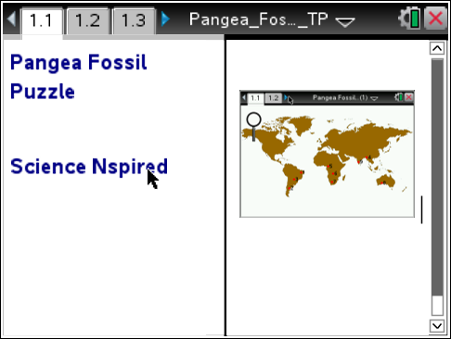
Move to page 1.2. and read the information given. Then move to page 1.3 and answer question 1 below and/or on your device.
Q1. What evidence can be used to determine past locations of the continents?

A. Fossil types and locations
B. Continental boundaries
C. Rock types and locations

Move to page 1.4. and read the information given. Then move to page 1.5
1. After reading the instructions on page 1.5, close the directions box by selecting .  2. Begin by moving the magnifier to each numbered fossil dig locations on the map. Do this by clicking and dragging the magnifier to one numbered location and releasing it when the “?” mark appears.  3. Record the fossil types found at each location on the map below. | 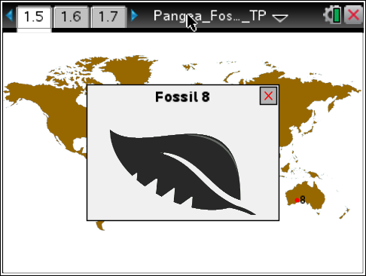
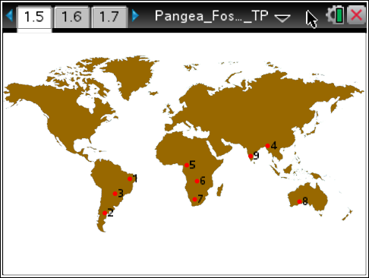

Place the letter corresponding to the fossil types below next to the fossil dig site where it was found on the map.

 A  B

 C  D

Move to pages 1.7-1.20.

After examining the evidence in your map above answer questions 4 – 14 below and/or in your .tns file.
Q2. Which two continents have the most matching fossils between them?

South America and Africa
Africa and India
Africa and Australia
Australia and India

Q3. What do you notice about the coastlines of South America and Africa?

Q4. India has 2 fossils in common with (Circle all that apply):

Africa, South America, Australia, North America, Greenland, Eurasia

Q5. Based on the fossil evidence, to which continent was Australia most likely connected?

Africa, South America, Australia, North America, Greenland, Eurasia

Q6. What evidence do you have that India may not have always been attached to Eurasia?

Move to page 1.13

Separating India from Eurasia is the Himalayan Mountain range. These mountains increase in height by 1 cm per year as the Indian plate and the Eurasian plate collide. This is because the Indian Plate is moving north.
Move to page 1.14

Q7. Based on the fossil evidence and the motions of the plates, what might be the arrangement of the following continents:

Australia between Africa and India
India between Africa and Australia
Africa between Australia and India

Q8. Based on your fossil evidence how would the discovery of fossils on continents separated by miles of ocean support Wegener’s continental drift hypothesis?

Q9. Look at the picture of Fossil A. Does it look like it would be a good swimmer?

Yes or No

Q10. Look at the picture of Fossil A. Does it look like it would be a good swimmer?

Yes or No

Q11. Why would the fossil of an ocean fish found on two different continents NOT be good evidence of continental drift?

Q12. Why is the fact that similar fossils have been found on different continents considered evidence for continental drift?

