Open the TI-Nspire document Light and Distance.tns  The distance from the Earth to the Sun is known as 1 Astronomical Unit, or 1 AU which is equal to about 150 million kilometers. Using this information, we established a baseline that the relative solar intensity of our sun is 1 when viewing from Earth. During this simulation, you will have to explore our solar system to discover planets, asteroids and comets. Using the solar intensity, you will have to identity a pattern and discover the distance provided objects are from the sun. |  |  | 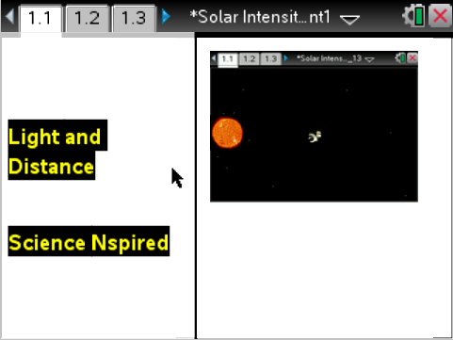
Move to page 1.3. Answer question 1 below and/or on your device.
Q1. 1 AU is the distance from what two celestial bodies?

A. The Sun and Neptune.
B. Earth and the Moon.
C. The Sun and Earth.
D. Earth and the edge of the Solar System

Move to page 1.4.
1. After reading the instructions on page 1.4, students should then close the directions box by selecting .  2. Scroll your mouse over the probe that appears on the screen. Once you place your mouse over the left side of the probe, a hand will appear. You should then click to grab the probe. The space probe can then be dragged across the screen through the solar system. As you move their probe, you will discover several “hotspots” on the page. These hotspots are located at the several dots across the screen, which represent objects in the solar system. When you click on any of these hotspots, another box will appear. Here, a box displaying the object, light intensity and distance will appear. There are 2 unknown objects to discover, along with the 8 planets. | 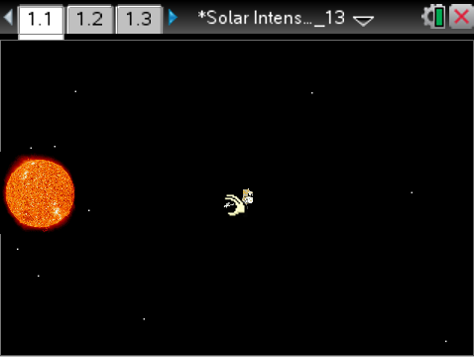
Move to pages 1.5 – 1.6.

After examining the data in the spreadsheet on page 1.4 and the graphic representation on page 1.5, fill in the table below. Do not solve for the asteroid or the comet yet.

Celestial Body | Distance (AU) | Light Intensity
Mercury
Venus
Earth
Mars
Jupiter
Saturn
Uranus
Neptune
Asteroid | ?
Comet | ?

Move to pages 1.7 – 1.10.
Answer questions 2-5 in the .tns file, the activity sheet, or both

Q2. As the objects get further away from the sun, what happens to the intensity of the light?

A. The light intensity stays the same.
B. The light intensity goes down.
C. The light intensity goes up.
D. There is no pattern with the light intensity.

Q3. While Earth is 1 AU away from the sun, Venus is only .723 AU away. Knowing this, how much more intense is the sunlight on Venus than it is on Earth?

A. Both Earth and Venus have the same light intensity.
B. The sunlight on Venus is close to .25 times as intense as it is on Earth.
C. The sunlight on Venus is close to .75 times as intense as it is on Earth.
D. The sunlight on Venus is close to 2 times as intense as it is on Earth.

Q4. On page 1.6, a line graph is displayed showing the data. If you have not done so already, set the y-axis to distance and the x-axis to intensity. A linear graph is a straight line which is often used to show a series of consistent data points. Is the graph linear on page 1.6?

A. Yes.
B. No.

Q5. Explain your reasoning for the question you just answered on the previous page 1.9.

Move to pages 1.11 – 1.12.
3. On page 1.11, a graph will appear with an equation. You will need to use this equation in figuring out the distance of your unknown objects from the sun. Take a moment to reflect and compare this graph to the graph on page 1.6. |  | 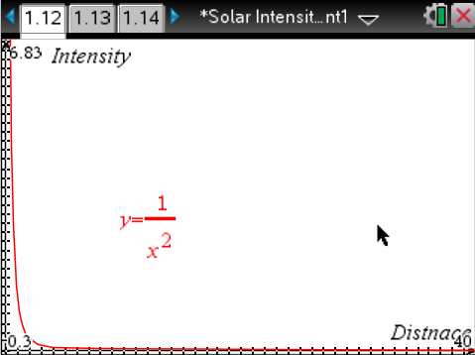
Move to pages 1.13 – 1.19. Answer questions 6 – 11 below and/or in your .tns file.

Q6. How does the graph on page 1.12 compare to the graph on page 1.6?

Q7. What equation is used on the graph located on page 1.12?

Q8. What does x represent in the equation on page 1.12?

A. Distance.
B. Intensity.
C. The celestial object.
D. It varies.

Q9. As an object moves further away from the sun, what happens to the intensity of the light? Choose the best answer.

A. It changes according to the inverse square of the distance.
B. Squaring the total distance to the object provides you with the light intensity.
C. You convert the distance from AU to Kilometers and then multiply by 2.
D. It changes according to the inverse of the distance X 2.

Q10. Find the asteroid on page 1.4. Using your formula calculate the distance in AU the asteroid is from the sun. Use up to 4 decimal points in your answer and only include numbers, no letters in your response.

Q11. Find the comet on page 1.4 of your simulation. Using the light intensity provided, what is the distance in AU the comet is from the sun? Use up to 4 decimal points in your answer and only include numbers, no letters in your response.

Move to page 1.20
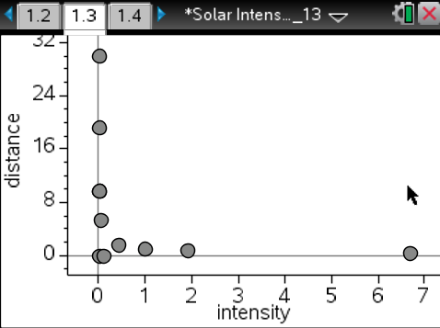
Check your answers from page 1.17 and 1.18

1. Go back to page 1.5
2. On the spreadsheet, plug in the distances you calculated on pages 1.17 and 1.18 under either comet or asteroid.
3. View the graph on page 1.6
4. The "dots" on the graph representing the comet and asteroid should all be lined up properly according to the equation, just as the line looks on page 1.12.
5. If the line does not look correct on page 1.6, correct your answers on pages 1.17 and 1.18.

