Science Objectives  - Students will investigate and discover relationships between light and distance.  - Students will create and use a mathematical formula to determine a celestial body’s unknown distance to the sun.  - Students will recognize the large distances between objects in our solar system.  Vocabulary  - Astronomical Unit  - Celestial Body  - Light Intensity  - Inverse  About the Lesson  - As a result of this lesson, students will:  - Understand how to determine the distance an object is from the sun by measuring its light intensity.  - Calculate an objects distance by using the inverse square law.  - Analyze the distances of multiple objects while creating a mathematical formula to represent a pattern.  TI-Nspire™ Navigator™  - Send out the .tns file.  - Monitor student progress using Class Capture.  - Use Live Presenter to spotlight student answers.  Activity Materials  - Compatible TI Technologies: TI- Nspire™ CX Handhelds,  TI-Nspire™ Apps for iPad®,  TI-Nspire™ Software | 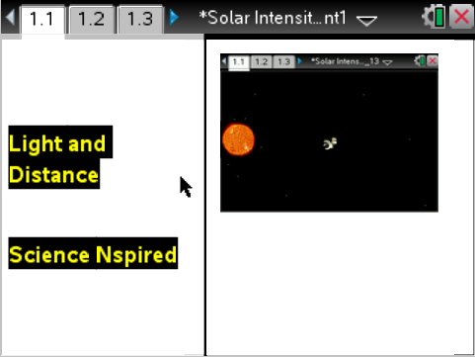  Tech Tips:  - This activity includes screen captures taken from the TI-Nspire CX handheld. It is also appropriate for use with the TI-Nspire family of products including TI-Nspire software and TI-Nspire App. Slight variations to these directions may be required if using other technologies besides the handheld.  - Watch for additional Tech Tips throughout the activity for the specific technology you are using.  - Access free tutorials at http://education.ti.com/calculators/pd/US/Online-Learning/Tutorials  Lesson Files:  Student Activity  - Light and Distance_  Student.doc  - Light and Distance_  Student.pdf  TI-Nspire document  - Light and Distance.tns

Discussion Points and Possible Answers
Have students read the background information stated on their activity sheet or their handheld.
Move to page 1.3
Have students answer question 1 in the .tns file, activity sheet, or both.

Q1. 1 AU is the distance from what two celestial bodies?

Answer: C. The Sun and the Earth.

Move to page 1.4.
1. After reading the instructions on page 1.4, students should then close the directions box by selecting .  2. Students should then scroll the mouse over the probe that appears on the screen. Once they place their mouse over the left side of the probe, a hand will appear. Students should then click to grab the probe. The space probe can then be dragged through the solar system. As the students move their probe, they will discover several “hotspots” on the page. These hotspots are located at the several dots across the screen, which represent objects in the solar system. When a student clicks on any of these hotspots, another box will appear. Here, a box displaying the object, light intensity and distance will appear. There are 2 unknown objects for the students to discover, along with the 8 planets. | 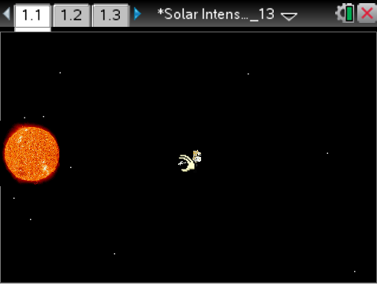
Tech Tip: To access the Directions again, select > Directions
The celestial bodies distance and light intensity data will be captured on the spreadsheet on page 1.5 and will also be graphed on page 1.6. If students select the reset button on page 1.4, the data will be cleared from the spreadsheet and the graph. Have students copy their data down onto the student worksheet.
Tech Tip: To scroll through data in the spreadsheet on screen 1.5, students can press their finger anywhere on the screen and drag it up or down.
Celestial Body | Distance (AU) | Light Intensity
Mercury | 0.387 | 6.6769
Venus | 0.723 | 1.913
Earth | 1. | 1.
Mars | 1.524 | 0.431
Jupiter | 5.203 | 0.0369
Saturn | 9.539 | 0.01098
Uranus | 19.189 | 0.0027
Neptune | 30.06 | 0.0011066
Asteroid | ? | .092
Comet | ? | .002

Move to page 1.7.
Have students answer questions 2-5 in the .tns file, the activity sheet, or both.

Q2. As the objects get further away from the sun, what happens to the intensity of the light?

Answer: B. The light intensity goes down.

Q3. While Earth is 1 AU away from the sun, Venus is only .723 AU away. Knowing this, how much more intense is the sunlight on Venus than it is on Earth?

Answer: D. The sunlight on Venus is close to 2 times as intense as it is on Earth.

Q4. On page 1.6, a line graph is displayed showing the data. If you have not done so already, set the y-axis to distance and the x-axis to intensity. A linear graph is a straight line which is often used to show a series of consistent data points. Is the graph linear on page 1.6?

Answer: B. No.

Q5. Explain your reasoning for the question you just answered on the previous page 1.9.

Sample Answer: Student answers will vary. However, it is an exponential line; specifically the inverse square law.

Move to pages 1.10 – 1.11.
3. On page 1.11, a graph will appear with an equation representing the inverse square law. Students will be asked to use this equation in figuring out the distance their unknown objects are from the sun. Students should take a moment to reflect and compare this graph to the graph on page 1.6. | 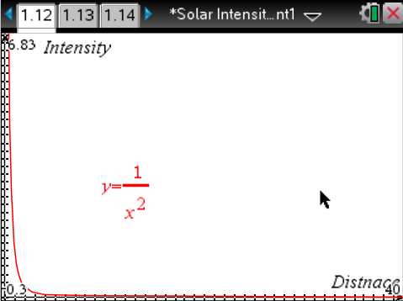
Move to pages 1.12 - 1.19.
Have students answer questions 6 - 11 on the device, the activity sheet, or both.

Q6. How does the graph on page 1.12 compare to the graph on page 1.6?

Sample Answer: Both graphs are identical.

Q7. What equation is used on the graph located on page 1.12?

Sample Answer: y=1/x².

Q8. What does x represent in the equation on page 1.12?

Answer: A. Distance.

Q9. As an object moves further away from the sun, what happens to the intensity of the light? Choose the best answer.

Answer: A. It changes according to the inverse square of the distance.

Q10. Find the asteroid on page 1.4. Using your formula calculate the distance in AU the asteroid is from the sun. Use up to 4 decimal points in your answer and only include numbers, no letters in your response.

Answer: 3.2969

Q11. Find the comet on page 1.4 of your simulation. Using the light intensity provided, what is the distance in AU the comet is from the sun? Use up to 4 decimal points in your answer and only include numbers, no letters in your response.

Answer: 22.3607

Move to page 1.20.

4. After answer all of the questions in the simulation, students should go back to the lists and spreadsheets page 1.5 and plug in the distances they calculated for the asteroid and the comet. Students should then compare the line to the placement of the dots in the graph on page 1.6. If their anticipated values are located along the line, they would have the correct answer. However, if their values do not fall on the line, the students should then go back and recalculate their response.

TI-Nspire Navigator Opportunities

Make a student a Live Presenter to illustrate show how to move the probe around the screen. Throughout the activity, monitor student progress. At the end of the activity, collect the .tns file and save to Portfolio.

Wrap Up
When students are finished with the activity, retrieve the .tns file using TI-Nspire Navigator. Save grades to Portfolio. Discuss activity questions using Slide Show.

Assessment
- Formative assessment will consist of questions embedded in the .tns file. The questions will be graded when the .tns file is retrieved. The Slide Show will be utilized to give students immediate feedback on their assessment.
- Summative assessment could consist of questions/problems on the chapter test or an assessment where you give students a series of unknown distances/light intensities and they have to solve for the missing variable.

