Open the TI-Nspire document WhatMakesaPlanet.tns  How much do you know about objects in the solar system? Do you know the difference between an asteroid, moon and planet? In this simulation you will discover relationships between multiple celestial bodies in our solar system. You will be given an object along with what it revolves around. Using that information, you will have to identify several characteristics for each object. |  | 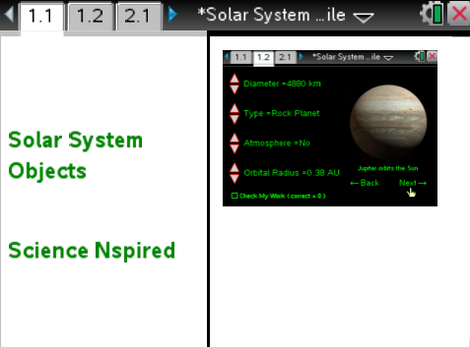
Move to pages 1.2 – 1.3. Answer questions 1-2 below and/or on your device.
Q1. The "orbital radius" of an object represents what?

A. The average distance from any two points of an objects orbit.
B. The distance of a planet to its closest moon.
C. The revolution period of any celestial body.
D. The distance an object is from its orbiting body.

Q2. The IAU (International Astronomical Union) has developed rules in order for a celestial body to gain planetary status. Which of the following are these rules? (Select all that apply)

A. The object orbits a star.
B. Has sufficient mass to assume a round shape under its own gravity.
C. Has an atmosphere
D. Has at-least one moon.
E. Has cleared its orbital zone.

Move to page 1.3.
1. After reading the instructions on page 1.3, close the directions box by selecting .  2. You will see an image of a celestial body stating what it orbits on the right hand side of the screen, along with various facts about the object on the left. By clicking on the up and down arrows (¤ and £) on the extreme left of the screen, you will be able to change the values for diameter, type, atmosphere, and orbital radius. Once you feel the answer is correct, click the check my work box on the lower left hand corner of the screen, Once the check my work box has been selected, either a happy alien or a sad alien will appear over the planet indicating if you got the response correct. Once you have a correct response, you should move on to the next planet by clicking on the word next in the lower right corner of the screen. | 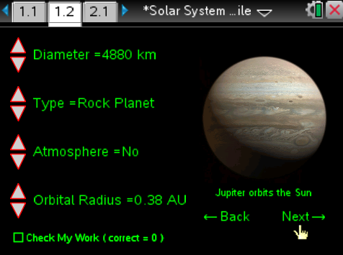
3. As you gather data from the simulation, fill in the data table below.

Object | Diameter of Object (km) | Orbital Radius (AU) | Type of Object | Atmosphere?

Move to pages 2.1 – 2.10.

After examining the data in the simulation and your data table above, answer questions 3 – 12 below and/or in your .tns file.

Q3. Which of the following is an accurate statement when you compare the gas planets to the rock planets?

A. Gas planets have a larger diameter and a smaller orbital radius.
B. Gas planets have a larger diameter and a larger orbital radius.
C. Rock planets have a larger diameter and a larger orbital radius.
D. Rock planets have a larger diameter and a smaller orbital radius.

Q4. Why is a moon's orbital radius much smaller than a planet?

Q5. Which of the following reasons is the best explanation for why an asteroid is not classified as a moon?

A. An asteroid does not orbit a planet.
B. An asteroid is not spherical in shape.
C. An asteroid is not large enough in diameter to be considered a moon.
D. An asteroid does not have an atmosphere.
E. All of the above are correct reasons.

Q6. Which of the following planets do not have an atmosphere? (Select all that apply)

A. Mercury
B. Mars
C. Jupiter
D. Saturn
E. Uranus
F. All of the above planets have an atmosphere.

Q7. Is it possible for a moon to have an atmosphere?

Yes
No

Q8. W Pallas has an orbital radius of 2.77 AU. Knowing this, what two planets does it orbit in-between? (___ and ___)

Q9. Earlier, you were asked what a celestial body "needs" in order to gain planetary status. Using your answers from page 1.5, which of these rules does Pallas violate?

A. Pallas does not orbit a star.
B. Pallas does not have sufficient mass to assume a round shape under its own gravity.
C. Pallas does not have an atmosphere.
D. Pallas does not have a moon.
E. Pallas has not cleared its orbital zone.

Q10. How is a moon different from a planet? (Choose the best answer)

A. It orbits a planet, not a star.
B. It does not have a clear orbital zone.
C. All moons do not have an atmosphere.
D. Not enough info was provided.

Q11. Titan has an atmosphere, is round and is larger than the planet Mercury. Why is Titan not considered a planet?

Q12. Using the information you gathered throughout the simulation, place the planets in order of increasing distance from the sun.

