Science Objectives  - Students will investigate and differentiate between planets, moons and asteroids.  - Students will manipulate the characteristics of celestial bodies to discover how planets are classified.  Vocabulary  - orbital radius  - astronomical unit  - asteroid  - orbital zone  About the Lesson  - As a result of this lesson, students will:  - Understand that in order to classify an object as a planet; it must be in orbit around the sun, have sufficient mass to assume a nearly round shape under its own gravity, and have a clear orbital zone free of any other objects.  - Identify similarities and differences among objects in the solar system including diameter, orbital radius, presence of atmosphere, type of object, and what the object revolves around.  TI-Nspire™ Navigator™  - Send out the .tns file.  - Monitor student progress using Class Capture.  - Use Live Presenter to spotlight student answers.  Activity Materials  - Compatible TI Technologies: TI- Nspire™ CX Handhelds,  TI-Nspire™ Apps for iPad®,  TI-Nspire™ Software | 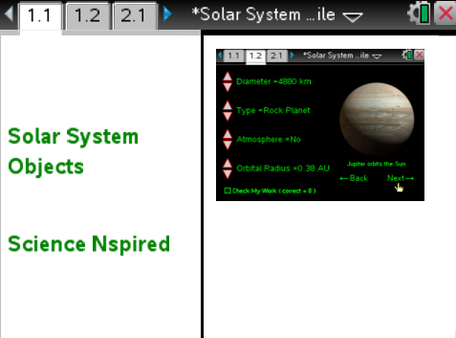  Tech Tips:  - This activity includes screen captures taken from the TI-Nspire CX handheld. It is also appropriate for use with the TI-Nspire family of products including TI-Nspire software and TI-Nspire App. Slight variations to these directions may be required if using other technologies besides the handheld.  - Watch for additional Tech Tips throughout the activity for the specific technology you are using.  - Access free tutorials at http://education.ti.com/calculators/pd/US/Online-Learning/Tutorials  Lesson Files:  Student Activity  - WhatMakesaPlanet  Student.doc  - WhatMakesaPlanet  Student.pdf  TI-Nspire document  - WhatMakesaPlanet.tns

Discussion Points and Possible Answers
Have students read the background information stated on their activity sheet and the information on page 1.2 of their handheld.

Move to pages 1.3 – 1.4.
Have students answer questions 1 and 2 in the .tns file, activity sheet, or both.

Q1. The "orbital radius" of an object represents what?

Answer: D. The distance an object is from its orbiting body.

Q2. The IAU (International Astronomical Union) has developed rules in order for a celestial body to gain planetary status. Which of the following are these rules? (Check all that apply)

Answer: The object orbits a star and has sufficient mass to assume a round shape under its own gravity

Move to page 1.5.
1. After reading the instructions on page 1.4, students should then close the directions box by selecting .  2. Students will see an image of a celestial body stating what it orbits on the right hand side of the screen, along with various facts about the object on the left. By clicking on the up and down arrows (¤ and £) on the extreme left of the screen, the students will be able to change the values for diameter, type, atmosphere, and orbital radius. Once the student feels they have a correct answer they can click the check my work box on the lower left hand corner of the screen, Once the check my work box has been selected, either a happy alien or a sad alien will appear over the planet indicating if the student got the response correct. Once the student has a correct response, they should move on to the next planet by clicking on the word next in the lower right corner of the screen. | 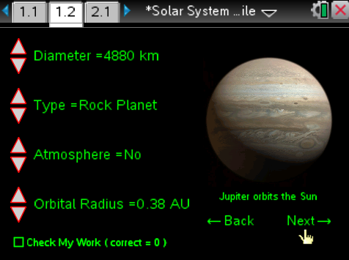
Tech Tip: To access the Directions again, select > Directions
3. As the students gather data from the simulation on page 1.5 they should be filling in the table on their student worksheet.

Object | Diameter of Object (km) | Orbital Radius (AU) | Type of Object | Atmosphere?
Mercury | 4,880 | 0.38 | Rock Planet | Yes
Venus | 9,738 | 0.72 | Rock Planet | Yes
Earth | 12,742 | 1 | Rock Planet | Yes
Mars | 6,800 | 1.6 | Rock Planet | Yes
Jupiter | 142,984 | 5.4 | Gas Planet | Yes
Saturn | 116,464 | 9.53 | Gas Planet | Yes
Uranus | 50,724 | 19.19 | Gas Planet | Yes
Neptune | 49,346 | 30.07 | Gas Planet | Yes
Pallas | 1088 | 2.77 | Asteroid | No
Amalthea | 167 | .001 | Moon | No
Titan | 5150 | .008 | Moon | Yes
Luna | 3472 | .0025 | Moon | No

Move to pages 2.1 – 2.10.
Have students answer questions 3-12 in the .tns file, the activity sheet, or both.

Q3. Which of the following is an accurate statement when you compare the gas planets to the rock planets?

Answer: B. Gas planets have a larger diameter and a larger orbital radius.

Q4. Why is a moon's orbital radius much smaller than a planet?

Sample Answer: Because a moon orbits a planet, whereas a planet orbits a star.

Q5. Which of the following reasons is the best explanation for why an asteroid is not classified as a moon?

Answer: A. An asteroid does not orbit a planet.

Q6. Which of the following planets do not have an atmosphere? (Select all that apply)

Answer: All of the above planets have an atmosphere.

Q7. Is it possible for a moon to have an atmosphere?

Answer: Yes.

Q8. Pallas has an orbital radius of 2.77 AU. Knowing this, what two planets does it orbit in-between? (___ and ___)

Answer: Mars and Jupiter

Q9. Earlier, you were asked what a celestial body "needs" in order to gain planetary status. Using your answers from p1.4, which of these rules does Pallas violate?

Answer: Pallas does not have sufficient mass to assume a round shape under its own gravity

Q10. How is a moon different from a planet? (Choose the best answer)

Answer: A. It orbits a planet, not a star.

Q11. Titan has an atmosphere, is round and is larger than the planet Mercury. Why is Titan not considered a planet?

Sample Answer: Titan orbits Jupiter, which is a planet, not a star.

Q12. Using the information you gathered throughout the simulation, place the planets in order of increasing distance from the sun.

Answer: Mercury, Venus, Earth, Mars, Jupiter, Saturn, Uranus, Neptune

TI-Nspire Navigator Opportunities

Make a student a Live Presenter to illustrate show how to move the sliders. Throughout the activity, monitor student progress. At the end of the activity, collect the .tns file and save to Portfolio.

Wrap Up
When students are finished with the activity, retrieve the .tns file using TI-Nspire Navigator. Save grades to Portfolio. Discuss activity questions using Slide Show.

Assessment
- Formative assessment will consist of questions embedded in the .tns file. The questions will be graded when the .tns file is retrieved. The Slide Show will be utilized to give students immediate feedback on their assessment.
- Summative assessment could consist of questions/problems on the chapter test or a performance assessment having students make a scale model of our solar system.

