Science Objectives  - Students will investigate the interaction that occur in specific organs of the human body during a “fight or flight” nervous reaction to fear or stress  - Students will relate each organ to its specific organ system  - Students will justify the response for each organ  - Students will relate the “fight or flight” response to a real-life situation  - Students will compare/contrast the “rest and digest” nervous response  Vocabulary  - organs: stomach, muscles, heart, eyes, sweat glands, liver, lungs, kidneys, arteries  - organ systems: nervous, circulatory, digestive, muscular, urinary respiratory  - “fight or “flight” nervous system response  - “rest and digest” nervous system response  About the Lesson  - In this lesson students result, students will:  - Explore body specific reactions to the nervous system’ “fight or flight” response system  - Run a simulation of a baseball player. With each advance of the simulation, they will use a magnifying glass to locate specific organs and their responses to the situation.  - Students will record their data and apply this data to answer questions.  TI-Nspire™ Navigator™  - Send out the It_Takes_Guts_.tns file.  - Monitor student progress using Class Capture.  - Use Live Presenter to spotlight student answers.  Activity Materials  - Compatible TI Technologies: TI- Nspire™ CX Handhelds,  TI-Nspire™ Apps for iPad®,  TI-Nspire™ Software | 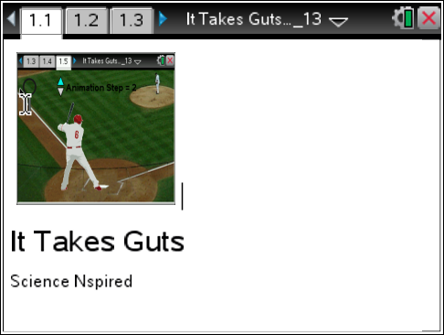  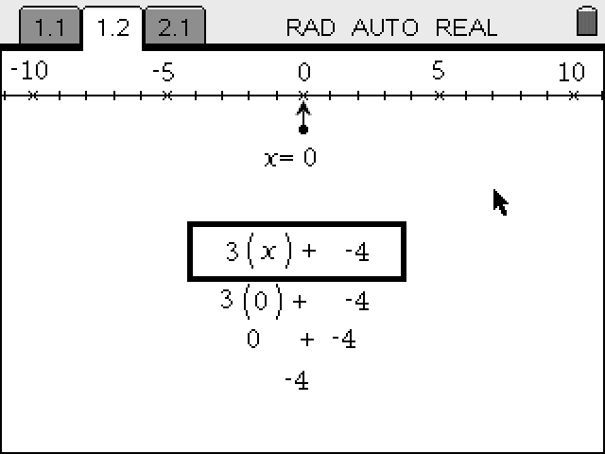  Tech Tips:  - This activity includes screen captures taken from the TI-Nspire CX handheld. It is also appropriate for use with the TI-Nspire family of products including TI-Nspire software and TI-Nspire App. Slight variations to these directions may be required if using other technologies besides the handheld.  - Watch for additional Tech Tips throughout the activity for the specific technology you are using.  - Access free tutorials at http://education.ti.com/calculators/pd/US/Online-Learning/Tutorials  Lesson Files:  Student Activity  - It_Takes_Guts_Student.doc  - It_Takes_Guts_Student.pdf  TI-Nspire document  - It_Takes_Guts_.tns

Questions:
Q1. Data chart

Animation step | Hot Spot | Images
1 | Mouth  Stomach | Salivary Glands ↓ Saliva Production  Stomach ↓ Digestive Juice Production
2 | Under arm  Eye | Sweat Glands↑ Sweat Production  Eye ↑ Pupil Opening
3. | Muscles  Artery | Arm Muscles↑ Contractions  Arm Arteries↑ Blood Flow
4 | Muscles  Heart | Upper Body Muscles ↑Contractions  Heart ↑ Contractions
5 | Kidney | Kidneys ↓ Urine Production
6 | Lungs  Liver | Lungs ↑ Air Flow  Liver ↑ Glucose Production
7 | Muscles  Artery | Leg Muscles↑ Contractions  Leg Arteries ↑ Blood Flow

TI-Nspire Navigator Opportunities
Make a student a Live Presenter to demonstrate how they are recording their data.

Q2. Which organ(s) decreased in activity? Choose all that apply.

Answer: stomach, kidneys, salivary glands

Q3. Which system(s) decreased in activity? Choose all that apply.

Answer: digestive, urinary

Q4. Which two organs had opposite responses to maintain water
balance?

Answer: kidneys, sweat glands

Q5. This activity focused on the "fight or flight" response; you either face the challenge or run from it. Briefly describe a situation when you experienced this response.
Sample Answer: Accept any relevant response. Answers may include speaking in front of the class, watching a scary movie, witnessing an accident, etc.

Q6. Your nervous system has an opposite response called “rest and digest” to calm the body down. Which of the following organs would increase in activity in this situation?
Answer: stomach

Wrap Up
- Discuss the body’s ability to maintain homeostasis. For example, how processes like digestion and urine formation are “put on hold” to conserve energy. How arteries leading to capillary beds near digestive and urinary organs constrict; those leading to muscles dilate.
- Discuss how it really isn’t healthy to “eat on the run.”
- Tape a large outline of the body and have students match the organ with its organ system. Then place up and down arrows to simulation activity during each type of nervous response.

Assessment
- Students can design a graphic organizer, i.e.; concept map or compare/contrast to illustrate the responses that occur during a “fight or flight” vs a “rest and digest” nervous system reaction.

