Open the TI-Nspire document Team_Effort.tns. | 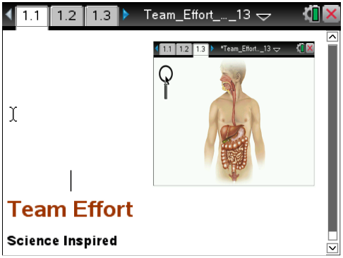

When you are sitting in the cafeteria eating that "delicious" school lunch, have you ever wondered what happens to that slice of pepperoni pizza you just ate? Probably not! But hopefully after you complete this activity, you will know how the organs inside you have specific jobs to make sure your food gets broken down to give you nourishment and energy.
Your digestive system is an amazing group of organs that work as a team. Each organ is made up of tissues which are made up of cells. Not just any kind of cells--but specific cells that give the tissues the right structure so the organ can carry out the right function.
So let's get started!
Move to page 1.4 Complete the table below as you find the information on the simulation.
Digestive Organ | Tissue Type | Function
Mouth
Pharynx and Upper ½ of Esophagus
Bottom ½ of Esophagus
Stomach
Small Intestine

Move to pages 1.5 – 1.11. Answer the questions here or on the .tns file.
Q1. What tissue type forms the lining of the mouth?

- Skeletal muscle
- Smooth muscle
- Stratified squamous epithelial

Q2. Stratified squamous epithelium means

- Layers of flat cells upper layer
- Single layer of flat cells upper layer
- Layers of square cells bottom layer

Q3. How does the structure of the tissue lining the mouth relate to its function?

Q4. What tissue type helps you chew and swallow your food?
- Smooth muscle
- Stratified squamous epithelium
- Skeletal muscle

Q5. What tissue type pushes your food down to your stomach?
- Skeletal muscle
- Stratified squamous epithelium
- Smooth muscle

Q6. What tissue type in your stomach adds juices to chemically break down your food?
- Smooth muscle
- Stratified squamous epithelium
- Skeletal muscle

Q7. What is the function of the microvilli that line the small intestine?
- Sweep the digested food to the large intestine
- Absorb nutrients into the blood
- Add more chemicals to the food

