Science Objectives  - Students will discover that groups of cells work together to form tissues and organs that are specialized for particular body functions.  - Students will relate the connection between structure and function to specific organs of the digestive system.  - Student will learn how organs of the digestive system work as a team to digest food.  Vocabulary  - mouth  - pharynx  - esophagus  - stomach  - stratified squamous epithelial tissue  - skeletal muscle tissue  - smooth muscle tissue  - simple columnar epithelial tissue  - microvill  About the Lesson  - This simulation illustrates the specific tissues of digestive organs that work as a team to digest food.  - As a result, students will:  - Understand how structure relates to function.  - Understand the relationship among cells, tissues, organs and organ systems, using the digestive system as an example.  TI-Nspire™ Navigator™  - Send out the Team_Effort.tns file.  - Monitor student progress using Class Capture.  - Use Live Presenter to spotlight student answers.  Activity Materials  - Compatible TI Technologies: TI- Nspire™ CX Handhelds,  TI-Nspire™ Apps for iPad®,  TI-Nspire™ Software | 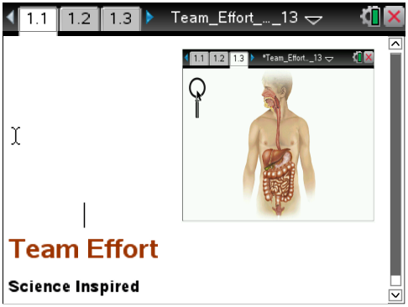  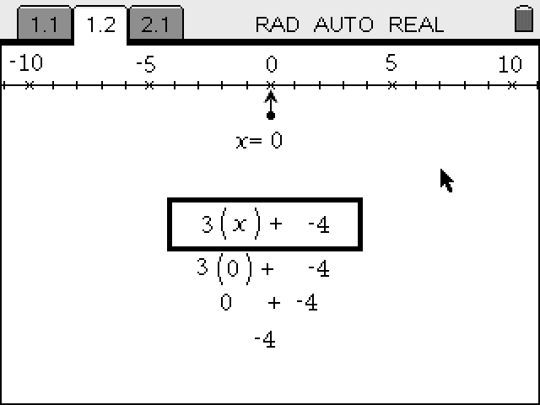  Tech Tips:  - This activity includes screen captures taken from the TI-Nspire CX handheld. It is also appropriate for use with the TI-Nspire family of products including TI-Nspire software and TI-Nspire App. Slight variations to these directions may be required if using other technologies besides the handheld.  - Watch for additional Tech Tips throughout the activity for the specific technology you are using.  - Access free tutorials at http://education.ti.com/calculators/pd/US/Online-Learning/Tutorials  Lesson Files:  Student Activity  - Team_Effort  _Student.doc  - Team_Effort  _Student.pdf  TI-Nspire document  - Team_Effort.tns

Discussion Points and Possible Answers

Move to pages 1.5-1.11
Have students answer the questions on pages 1.5-1.11 after they fill in the chart. You can have them answer the questions on either the device, on the activity sheet, or both.
Q1. What tissue type forms the lining of the mouth?

Answer: C. stratified squamous epithelium

Q2. Stratified squamous epithelium means

Answer: A. layers of flat cells upper layer

Q3. How does the structure of the mouth lining relate to its function?

Answer: many layers for protection; flat cells to form a smooth lining

Q4. What tissue type helps you chew and swallow your food?

Answer: C. skeletal muscle

Q5. What tissue type pushes your food down the esophagus to the stomach?

Answer: C. smooth muscle

Q6. What tissue type in the stomach adds juices to chemically break down your food?

Answer: B. simple columnar epithelium

Q7. What is the function of the microvilli that line the small intestine?

Answer: B. absorb nutrients into the blood

TI-Nspire Navigator Opportunities
To quickly assess student understanding, use Quick Poll to gather answers to any of the questions through the lesson.

TI-Nspire Navigator Opportunities
Use TI-Nspire Navigator to capture screen shots of student progress and to retrieve the file from each student at the end of the class period. The student questions can be electronically graded and added to the student portfolio.

Wrap Up
When students are finished with the activity, pull back the .tns file using TI-Nspire Navigator. Save grades to Portfolio. Discuss activity questions using Slide Show.

Assessment
- Formative assessment will consist of questions embedded in the .tns file. The questions will be graded when the .tns file is retrieved by TI-Nspire Navigator. The TI-Nspire Navigator Slide Show can be utilized to give students immediate feedback on their assessment.
- Summative assessment will consist of questions/problems on the chapter test, inquiry project, performance assessment, or an application/elaborate activity.

