Science Objectives  - Students will describe how…..  - the substitution of one nucleic acid sequence  results in the production of a faulty protein.  - a translation mutation can results in a genetic  disease.  Vocabulary  - genotype  - phenotype  - gene  - amino acid  - protein  - hemoglobin  - mutation  - sickle-cell anemia  About the Lesson  - This lesson is an exploration by students of how gene mutations located on chromosomes result in harmful effects.  - Students will run a simulation that demonstrates each step: nucleic acid substitution, amino acid substitution, protein shape, genetic disease.  TI-Nspire™ Navigator™  - Send out the Translation_Mutation_.tns file.  - Monitor student progress using Class Capture.  - Use Live Presenter to spotlight student answers.  Activity Materials  - Compatible TI Technologies: TI- Nspire™ CX Handhelds,  TI-Nspire™ Apps for iPad®,  TI-Nspire™ Software | 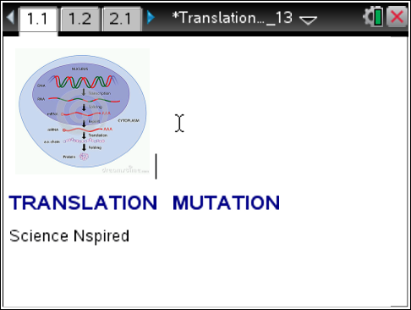  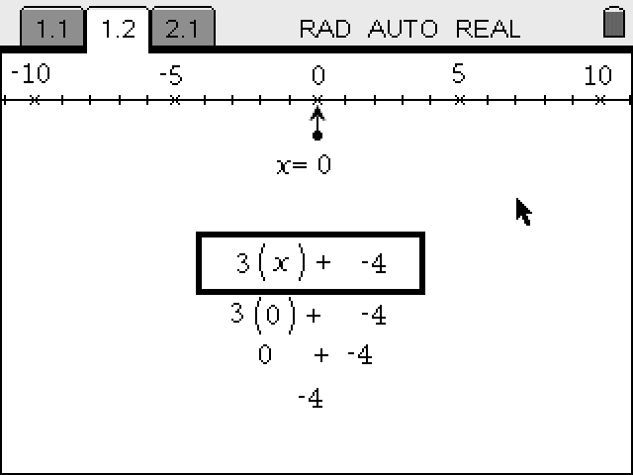  Tech Tips:  - This activity includes screen captures taken from the TI-Nspire CX handheld. It is also appropriate for use with the TI-Nspire family of products including TI-Nspire software and TI-Nspire App. Slight variations to these directions may be required if using other technologies besides the handheld.  - Watch for additional Tech Tips throughout the activity for the specific technology you are using.  - Access free tutorials at http://education.ti.com/calculators/pd/US/Online-Learning/Tutorials  Lesson Files:  Student Activity  - Translation_Mutation_Student.doc  - Translation_Mutation_Student.pdf  TI-Nspire document  - Translation_Mutation_.tns
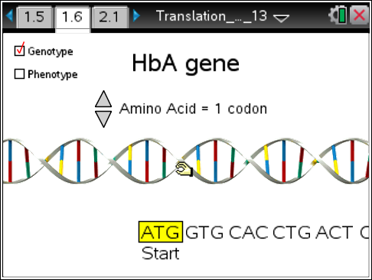
Directions: Students will read the background information on pages 1.2 – 1.5. They will advance to page 1.6 and run the simulation. As they answer the following questions, it may be necessary for them to return to the simulation.

Q1. Red blood cells are bags of hemoglobin so the shape of hemoglobin determines their shape. What is the normal shape of RBC's?
- round
- sickle
ans. A. round

Q2. What letter substitution caused the translation mutation?

- A for a T
- T for an A
- C for a G
- G for a C
ans. B. T for an A

Q3. What amino acid subsitution caused the translation mutation?
- val (valine) for glu (glucine)
- glu (glu) for val (valine)
ans. A. val (valine) for glu (glucine)

Q4. Q4. Mutated hemoglobin is sticky and clumps together. What is the shape of the red blood cell containing mutated hemoglobin protein?
- round
- sickle
ans. B. sickle

Q5. Hemoglobin transports oxygen in the blood. What symptom would a person with sickle-cell anemia experience?
- hunger
- thirst
- fatigue
ans. C. fatigue

TI-Nspire Navigator Opportunities
Make a student a Live Presenter to demonstrate how they are recording their data.

Wrap Up
- Use the graphic on the title page to reinforce each step of protein synthesis.

Assessment
- Students can design a “Foldable” that begins with the DNA helix and “unfolds” for each step of protein synthesis. One side will illustrate the normal sequence and the other side will illustrate the mutation.

