Open the TI-Nspire document Translation_Mutation.tns. | 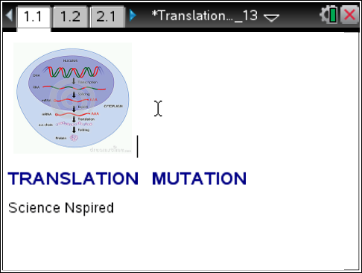
Move to pages 1.2 –1.5 and read the background information for this activity.
Have you ever received a text message that didn't make sense? You just sent a joke to a friend and the response was BOL - Be on Later- instead of LOL - laughing out loud! Or the mix up between CTC - Care to chat? and CTN - Can't talk now? Or BBL - Be back later and BBS - Be back soon? Can a single letter substitution really make that much difference?
Well in the world of making proteins, the answer is YES. Proteins have many important jobs in your body, so it's important that they are made correctly. They determine the color or your skin and hair. They also speed up reactions in your body, like how quickly you digest the pizza you ate at lunch. Your body makes special proteins called antibodies that fight off disease and keep you healthy.
Proteins are really large molecules made up of long chains of amino acids. Each amino acid has its own 3 letter code, just like the text abbreviations you use every day. Sometimes, if just one letter is substituted for another, a translation error occurs, and either the protein is made incorrectly or sometimes not at all! This error is called a mutation. In this activity you will learn how a gene mutation of just one letter causes an error in the production of the protein hemoglobin.

Move to page 1.6. Read the directions for the simulation.
- Select and drag the DNA helix to view the normal gene. The HbA gene codes for normal hemoglobin.

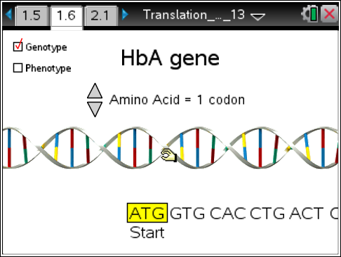
- Select the clicker to view the amino acid  for each codon.  - Select the Phenotype checkbox to view the red blood cell.  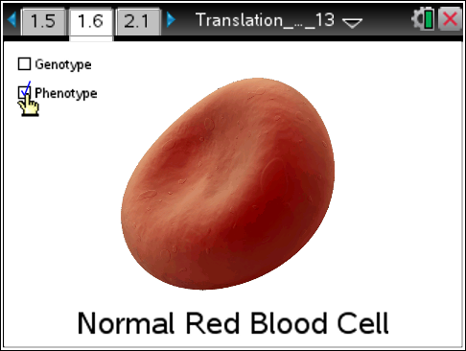  - Select the Genotype checkbox.  - Find the mutation site. Place the  cursor below the site and a pencil  pointer will appear. Use the pointer  to mutate the gene. As you toggle  back and forth, note the specific  letter substitution and the switch from  HbA to HbS at the top.  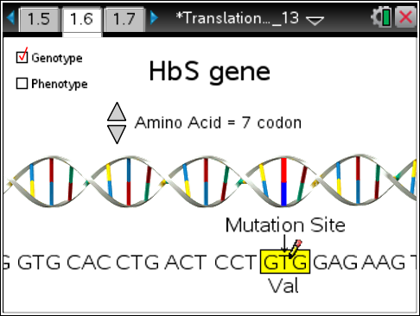  - Select the Phenotype checkbox.Compare this red blood cell to the normal blood cell in step 3.  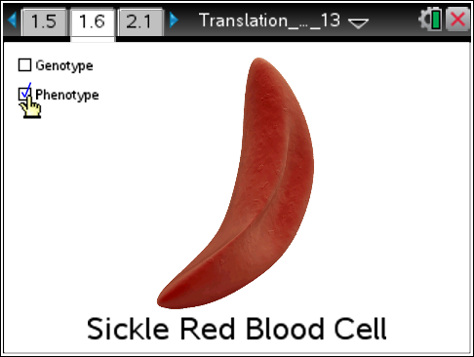 |  | 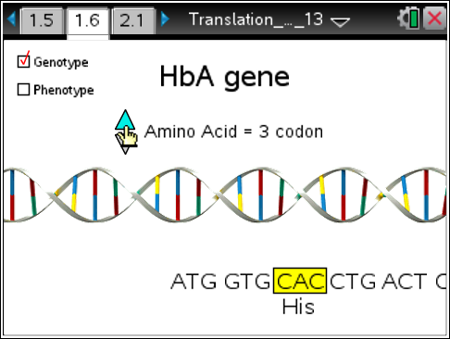
Move to pages 1.7 -1.11. Answer questions 1 – 5 below and/or in the .tns file. You may need to return to page 1.6 to review the simulation.

Q1. Red blood cells are bags of hemoglobin so the shape of hemoglobin determines their shape. What is the normal shape of RBC's?
- round
- sickle

Q2. What letter substitution caused the translation mutation?

- A for a T
- T for an A
- C for a G
- G for a C

Q3. What amino acid subsitution caused the translation mutation?
- val (valine) for glu (glucine)
- glu (glu) for val (valine)

Q4. Mutated hemoglobin is sticky and clumps together. What is the shape of the red blood cell containing mutated hemoglobin protein?
- round
- sickle

Q5. Hemoglobin transports oxygen in the blood. What symptom would a person with sickle-cell anemia experience?
- hunger
- thirst
- fatigue

