Open the TI-Nspire document Newton and THE Law.tns.  In this activity you will explore one of Newton’s Laws. Using the simulated collisions between cars with different masses and velocities you will predict the reaction of each. | 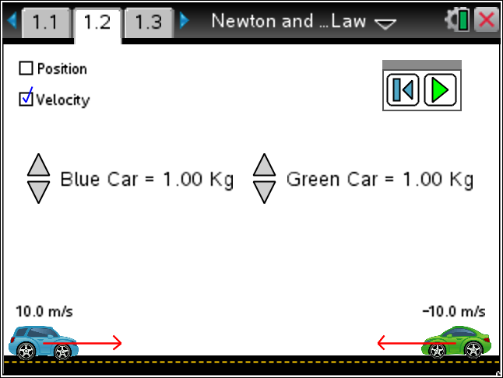

Materials
- TI-Nspire (handheld, APP, software)
- Ruler or some way to measure on the Nspire screen.

Procedure
1. Open the Newton and THE Law.tns file. If prompted to save the current file, use your discretion or ask your teacher what she would do.

2. Partner with another student and explore the simulation. Read the Directions. If the Directions are missing, press Menu and select Directions.
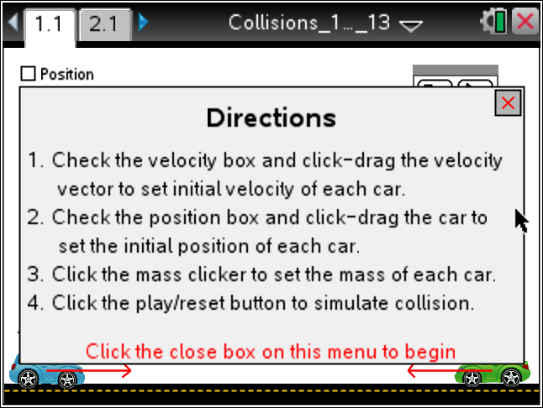
3. What is the range of toy car masses?

Tech Tip: To change the mass of a toy car click on the 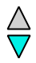 icon to increase or decrease.
4. How do you change the starting position of the toy cars?
Tech Tip: Using escape (d) to release the car will not work in this simulation.
5. How do you set the velocity of each toy car?
6. What does the negative mean on the velocity vector (arrow)?
7. What happens when you Play the simulation?
8. Do the cars always change direction after they collide? Explain.

9. Create an interesting collision to share with the class. One that you think will impress.

10. Look at Newton’s Three Laws of Motion
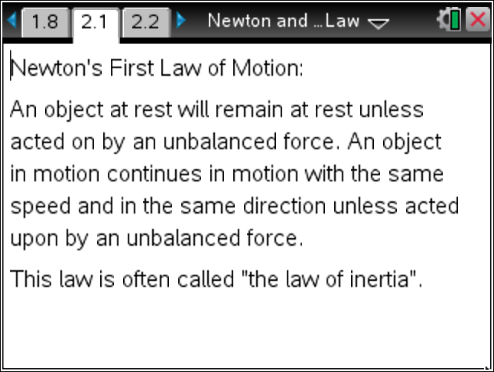 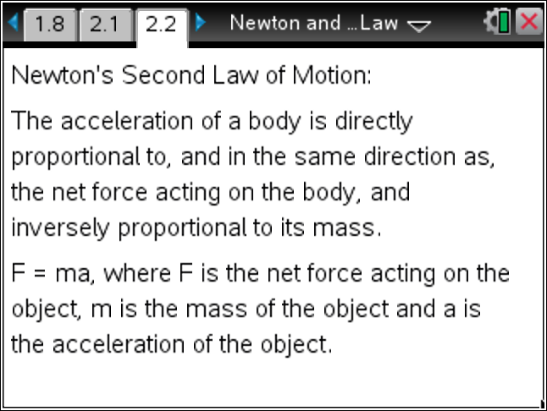 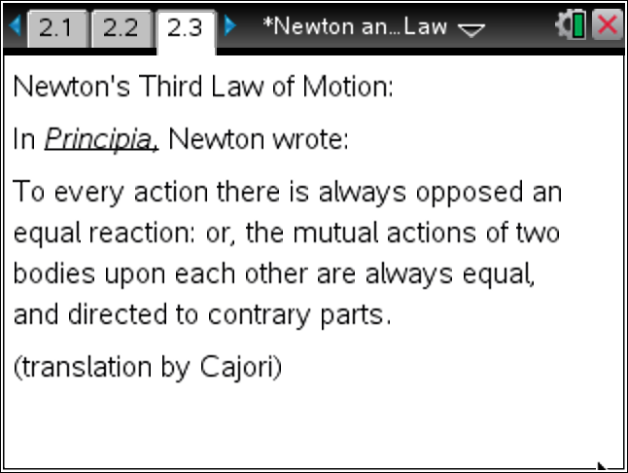
11. How does this simulation represent Newton’s Third Law of Motion?

12. State Newton's Third Law of Motion in your own words.

Analysis

1. Return to the page with the toy car simulation and reset it using the  icon.  Set both cars with a mass of 2.00 kilograms and move them closer together and measure this value. Don’t forget to set the Position radio button before you move them. Both toy cars should have the same speed. Adjust this by selecting the Velocity radio button and then stretching the arrow.  Report the mass and velocity before and predict what you think these values will be after the collision.  Distance the cars are apart at start: ________________  Run the simulation. How well did you predict? |  | 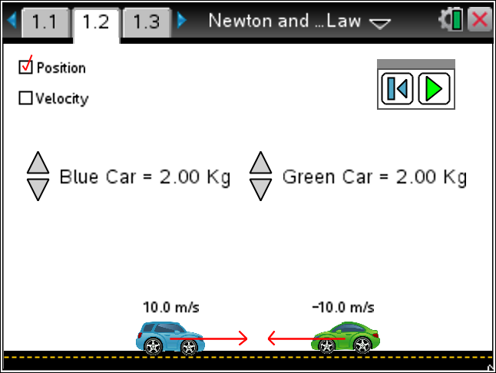  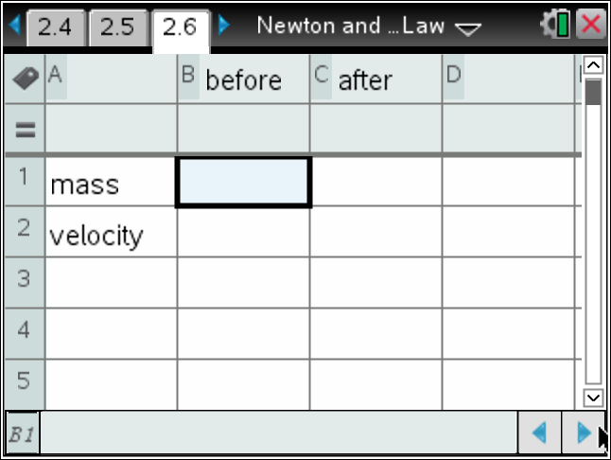
   | Before Measures | After Predictions
  mass
  velocity
Tech Tip: To move between several pages press /£ and move to select the desired pages using £¤¢ ¡ to get where you are going and then ·.
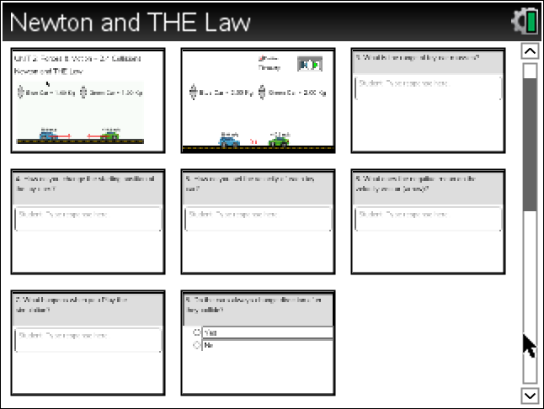
2. Repeat this experiment with various distances and different but equal speeds and masses.
3. What pattern do you see with the conditions you have been using?
4. Now let’s collect some data to see if there is a pattern in the data. Discuss with the class and/or you partner what variables you have control of in the simulation. List them below.
5. Explore different collisions holding all but one variable constant.
Variable to explore: __________________
Fill in the table. Place this information on the Nspire as needed in a List & Spreadsheet. Extend the number of trials as needed.
 | Blue Mass | Green Mass | Distance | Blue Velocity | Green Velocity
Before
After |  |  | x
Before
After |  |  | x
Before
After |  |  | x
Before
After |  |  | x
Before
After |  |  | x

 | Tech Tip: You may add words to a spreadsheet by placing them in quotes.
6. Share your results with the class. What patterns do you see? Look at the sum product of the mass and the velocity before the collision and then after. How about the sum of the square of the velocity and the mass (before and after)?
 | Tech Tip: To insert a calculator press /I and select Calculator.

