Science Objectives  - Students will explore the collision of two toy cars to explore the action-reaction forces in pure Elastic Collisions.  - Studnets will vary the mass of the toy cars, the distance between the two cars, and the speed and direction of each, including having one car at rest.  - Students will discover Newton’s Third Law as they design scenarios for the interaction of two cars.  Vocabulary  - Speed  - Velocity  - Vector  - Mass  - Momentum  - Inertia  - Elastic Collision  - Kinetic Energy  - Action-Reaction Forces  About the Lesson  For any pair of interacting objects, the force exerted by the first object on the second object is equal in strength to the force that the second object exerts on the first, but in the opposite direction (Newton’s third law).  These collisions are all Elastic so both Kinetic energy and Momentum are conserved.  TI-Nspire™ Navigator™  - Send out the Newton and THE Law.tns file. Tthe questions are Self-Check which you might want to change to Exam.  - Monitor student progress using Class Capture.  - Use Student Live Presenter to spotlight student answers and presentation of solutions..  NGSS  MS.Forces and Interactions  Students who demonstrate understanding can:  MS-PS2-1. Apply Newton’s Third Law to design a solution to a problem involving the motion of two colliding objects.  Science and Engineering Practices  Asking Questions and Defining Problems (MS-PS2-3)  Plan an investigation individually and collaboratively, and in the design: identify independent and dependent variables and controls, what tools are needed to do the gathering, how measurements will be recorded, and how many data are needed to support a claim. (MS-PS2-2)  Conduct an investigation and evaluate the experimental design to produce data to serve as the basis for evidence that can meet the goals of the investigation. (MS-PS2-5)  Constructing Explanations and Designing Solutions (MS-PS2-1) Engaging in Argument from Evidence (MS-PS2-4)  Connections to Nature of Science Scientific Knowledge is Based on Empirical Evidence (MS-PS2-2),(MS-PS2-4)  Disciplinary Core Ideas  PS2.A: Forces and Motion:  For any pair of interacting objects, the force exerted by the first object on the second object is equal in strength to the force that the second object exerts on the first, but in the opposite direction (Newton’s third law). (MS-PS2-1)  The motion of an object is determined by the sum of the forces acting on it; if the total force on the object is not zero, its motion will change. The greater the mass of the object, the greater the force needed to achieve the same change in motion. For any given object, a larger force causes a larger change in motion. (MS-PS2-2)  Crosscutting Concepts  Cause and Effect (MS-PS2-3),(MS-PS2-5)  Systems and System Models. (MS-PS2-1),(MS-PS2-4),  Activity Materials  - Compatible TI Technologies: TI- Nspire™ CX Handhelds,  TI-Nspire™ Apps for iPad®,  TI-Nspire™ Software |  | 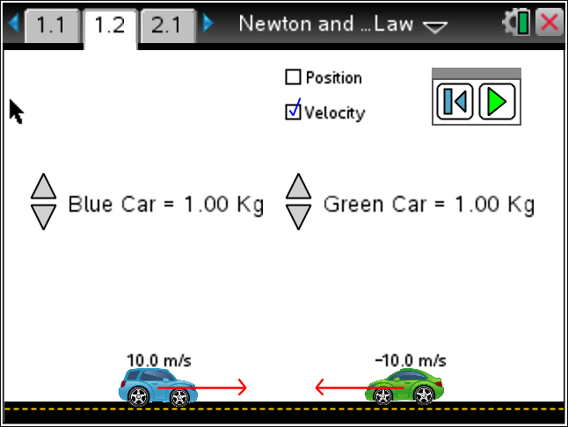  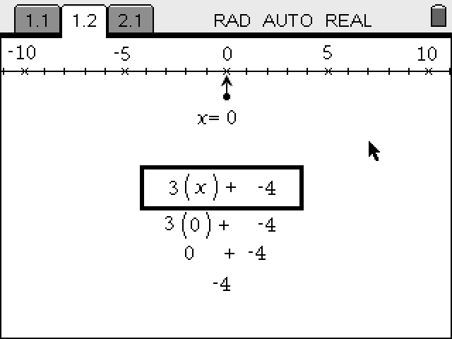  Tech Tips:  - This activity includes screen captures taken from the TI-Nspire CX handheld. It is also appropriate for use with the TI-Nspire family of products including TI-Nspire software and TI-Nspire App. Slight variations to these directions may be required if using other technologies besides the handheld.  - Watch for additional Tech Tips throughout the activity for the specific technology you are using.  - Access free tutorials at http://education.ti.com/calculators/pd/US/Online-Learning/Tutorials  Lesson Files:  Student Activity  - Newton_and_THE_Law_Teacher.doc  - Newton_and_THE_Law_Student.doc  TI-Nspire document  - Newton and THE Law.tns
Materials
- TI-Nspire (handheld, APP, software)
- Ruler or some way to measure on the Nspire screen.

Procedure
1. Open the Newton and THE Law.tns file. If prompted to save the current file, use your discretion or ask your teacher what she would do.

2. Partner with another student and explore the simulation. Read the Directions. If the Directions are missing, press Menu and select Directions.
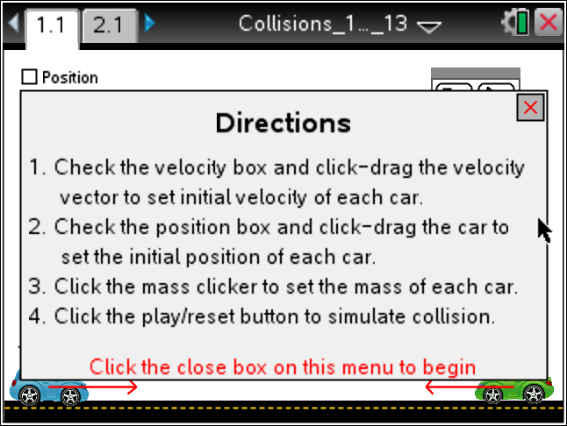
3. What is the range of toy car masses?
[1.00 kg to 10.00 kg]

 | Tech Tip: To change the mass of a toy car click on the  icon to increase or decrease.
4. How do you change the starting position of the toy cars?
[Click on the Position radio box and then with the hand ({) on the car of interest press click (x), to release press click again.]
Tech Tip: Using escape (d) to release the car will not work in this simulation.
5. How do you set the velocity of each toy car?
[With the Velocity radio box clicked, grab the vector (red arrow) and stretch to the desired length.]
6. What does the negative mean on the velocity vector (arrow)?
[That the car is moving to the left.]
7. What happens when you Play the simulation?
[The cars start to move in the direction indicated at the speed set. They usually collide, and then their velocity changes.]
8. Do the cars always change direction after they collide? Explain.
[No, it depends on the initial mass, position, and velocity of the cars.]

9. Create an interesting collision to share with the class. One that you think will impress.
[Use Student Live Presenter, or have the student set up the simulation of interest on the teacher software.]

10. Look at Newton’s Three Laws of Motion
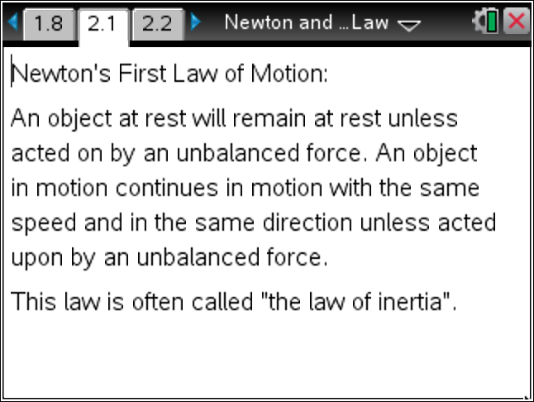 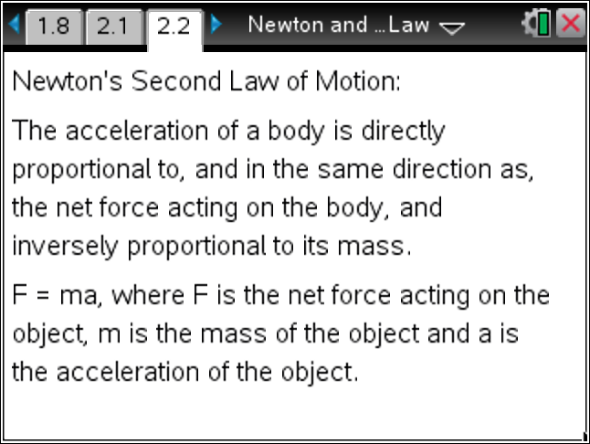 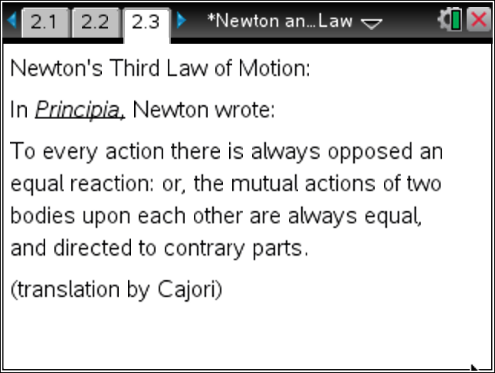
[Note: Have the students “interact with the text” by identifying key words, words they know, words that they don’t know, etc. They can color, or otherwise highlight the word and with the Navigator screenshots display what the class selected, and discuss patterns.]
11. How does this simulation represent Newton’s Third Law of Motion?
[As the cars collide, when all things are equal, they respond with equal and opposite motion.]

12. State Newton's Third Law of Motion in your own words.
[For every action, there is an equal and opposite reaction.]
Analysis

1. Return to the page with the toy car simulation and reset it using the  icon.  Set both cars with a mass of 2.00 kilograms and move them closer together and measure this value. Don’t forget to set the Position radio button before you move them. Both toy cars should have the same speed. Adjust this by selecting the Velocity radio button and then stretching the arrow.  Report the mass and velocity before and predict what you think these values will be after the collision.  Distance the cars are apart at start: ________________  Run the simulation. How well did you predict? |  | 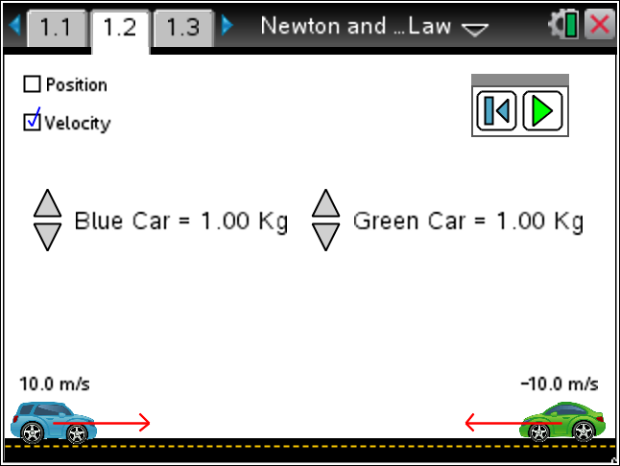  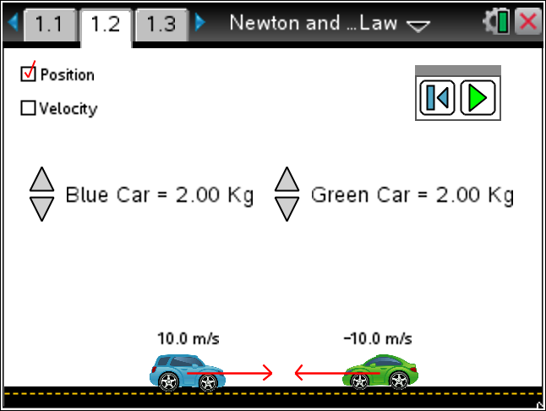  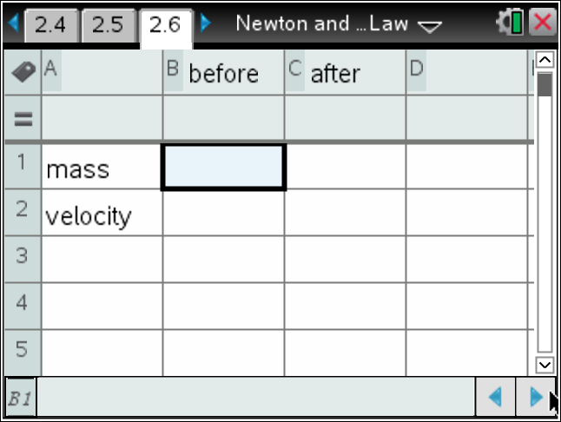
   | Before Measures | After Predictions
  mass
  velocity
Tech Tip: To move between several pages press /£ and move to select the desired pages using £¤¢ ¡ to get where you are going and then ·.
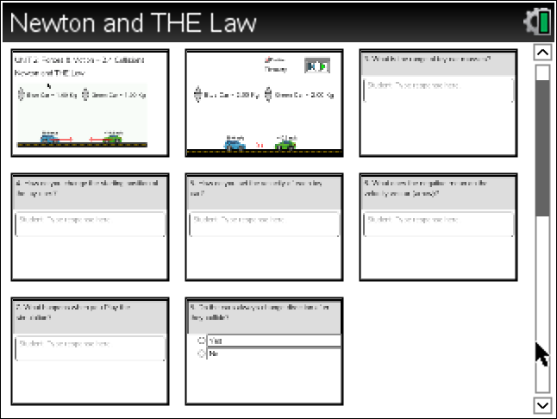
2. Repeat this experiment with various distances and different but equal speeds and masses.
3. What pattern do you see with the conditions you have been using?
[After the cars collide they always change direction but keep the same speeds and mass.]
Teacher Note: What can you conclude about the effective friction between the toy car wheels and the road?
4. Now let’s collect some data to see if there is a pattern in the data. Discuss with the class and/or you partner what variables you have control of in the simulation. List them below.
[Green car’s mass, initial speed and direction, and distance from the other car. Same variables for the Blue car.]
5. Explore different collisions holding all but one variable constant.
Variable to explore: __________________
Fill in the table. Place this information on the Nspire as needed in a List & Spreadsheet. Extend the number of trials as needed.
[Teacher Note: Assign groups different variables to explore to make sure you cover all the possibilities. To differentiate, assign Distance to some groups to vary. Also note that both cars could have a speed in the same direction and whole number velocities might make the comparisons easier.]
 | Blue Mass | Green Mass | Distance | Blue Velocity | Green Velocity
Before
After |  |  | x
Before
After |  |  | x
Before
After |  |  | x
Before
After |  |  | x
Before
After |  |  | x

 | Tech Tip: You may add words to a spreadsheet by placing them in quotes.
6. Share your results with the class. What patterns do you see? Look at the sum product of the mass and the velocity before the collision and then after. How about the sum of the square of the velocity and the mass (before and after)?
[Both momentum and kinetic energy is conserved.]
[Teacher Note: Use Student Live Presenter to have scenarios displayed to class.]
 | Tech Tip: To insert a calculator press /I and select Calculator.

TI-Nspire Navigator Opportunities
Make a student a Live Presenter to demonstrate what they discover along the way.
Use Quick Poll as Formative Assessment.

Wrap Up
Students should compose a lab report, which includes their data, analysis, and a discussion of the results of their test. Students may choose to use the TI-Nspire™ Student Edition software to convert their .tns files to PublishView Documents.

Assessment
- Use the questions in the Nspire document as Quick Polls during the lesson as needed.
- The questions in the Nspire document are Self-Check, so students can check their answers.
- Use Ranking Task as shown below.
Moving Car and Boat Trailer—Force Difference 29
Rank, from greatest to least, on the basis of the difference between the strength (magnitude) of the force the car exerts on the boat trailer, and the strength of the force the boat trailer exerts on the car. All the boat trailers and cars are identical, but the boat trailers have different loads, so the boat trailers masses vary.
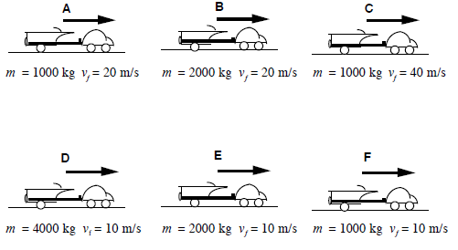
Greatest 1_______ 2________ 3________ 4________ 5________ 6________ Least
Or, the differences between the two forces are the same in each situation. _______
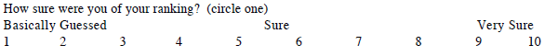

Reference Links:
- The Physics Classroom: http://www.physicsclassroom.com/Class/newtlaws/U2L4a.cfm
- PhET - Lunar Lander:
http://phet.colorado.edu/en/simulation/lunar-lander
- PhET - Forces and Motion: Basics:
http://phet.colorado.edu/en/simulation/forces-and-motion-basics
- PhET - Forces and Motion:
http://phet.colorado.edu/en/simulation/forces-and-motion
- Wikipedia, the free encyclopedia - Newton's third law:
http://en.wikipedia.org/wiki/Newton%27s_laws_of_motion#Newton.27s_third_law
- Ranking Task Exercises in Physics: Student Edition / Edition 1 by T L O'Kuma, D P Maloney, C J Hieggelke. ISBN: 013144851X, ISBN-13: 9780131448513, October 2003, Addison-Wesley
- Topical Arrangements of Standards | Next Generation Science Standards:
http://www.nextgenscience.org/msps-fi-forces-interactions
- Mastering Physics:
http://masteringphysicsanswers.blogspot.com/2013/05/mastering-physics-chapter-5-section-4.html

