Use the TI-Nspire document Matter Conservation.tns file.  A fundamental principle of classical physics is that matter cannot be created or destroyed in an isolated system. In this investigation, you will explore a reaction in an open and closed system, looking at the mass of the system before and after the reaction. | 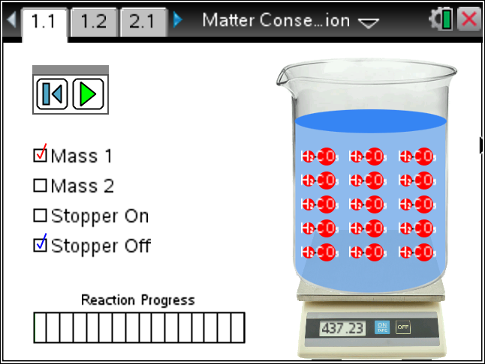

Materials
- TI-Nspire (handheld, APP, software)

Procedure
1. With your partner, explore the simulation. Read the Directions. If the Directions are missing, press Menu and select Directions.
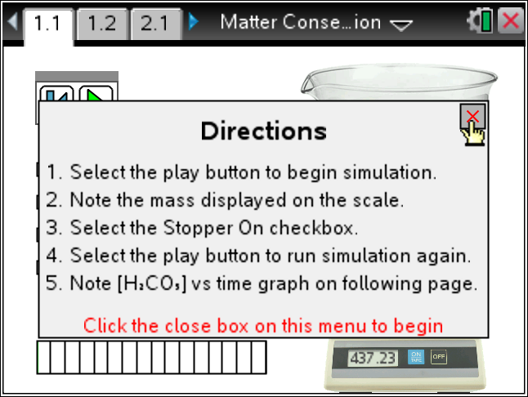
Tech Tip: To Play the simulation, Pause, or Reset click on the appropriate icon.  .
Change the initial settings by clicking on the radio boxes.
2. In this simulation you have the opportunity to start with two different amounts of Carbonic Acid (H₂CO₃) in water (H₂O). In addition, you can have the system open (Stopper Off) or closed (Stopper On). Explain what appears to happen with your assigned scenario.
3. Why does the initial mass change when the Stopper is changed?

4. How does the simulation deal with the mass of the extra water in the beaker?

5. What do you normally do with a digital balance to account for the empty beaker and stopper?
6. Run the simulation with the system closed and examine the plot shown on the following page. How does this plot reflect what you visualize during the simulation?
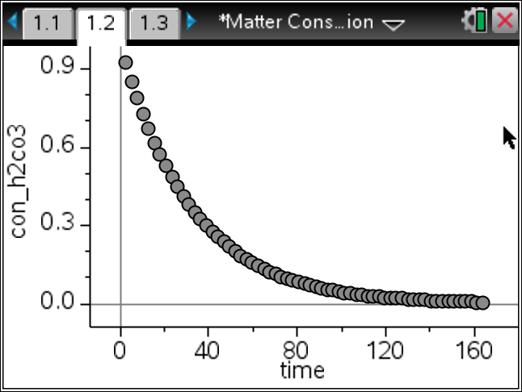
Tech Tip: To move between several pages press /£ and move to select the desired pages using £¤¢ ¡ to get where you are going and then ·.
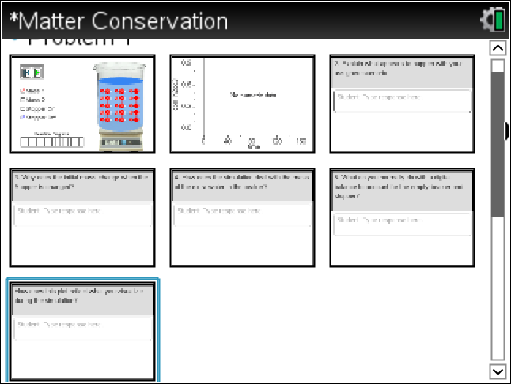

7. Look at the Periodic Table and find all of the elements involved in this reaction. Fill in the table below.
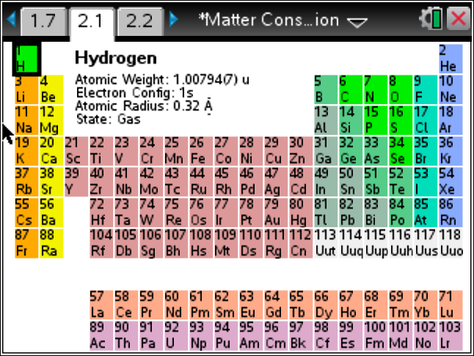 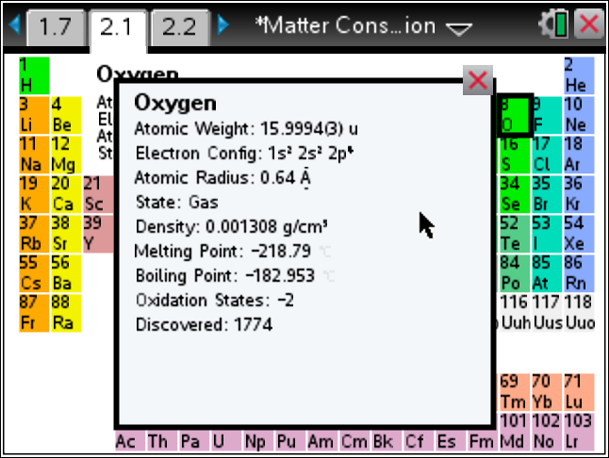
Element | Symbol | Atomic Number | Protons | Neutrons | Electrons

8. Build one of the elements involved in the reaction using the data from the table you just completed. Use the Menu to help. Ask your teacher which one of the atoms you are to build. Create a neutral atom.

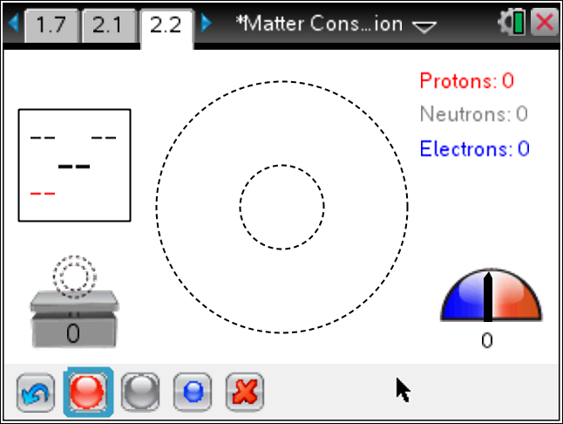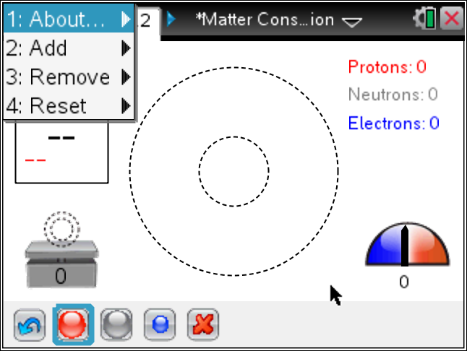

9. What can you conclude about the number of atomic particles before and after a reaction in a closed system?
10. If we combined Sodium and Chlorine to get Salt, state the number of each atomic particle before and after the reaction.
 | Item | Protons | Neutrons | Electrons
Before
After

11. If the real reaction between Sodium and Chlorine to make salt is 2Na + Cl₂ → 2NaCl, calculate the mass of the initial atomic particles and the mass of the final atomic particles. Research the needed masses or get them from your teacher. Is the mass conserved?

Tech Tip: To insert a calculator press /I and select Calculator.

