Science Objectives  - Students will simulate a reaction between Carbonic Acid and Water, as a catalyst, in a closed system so as to demonstrate the Law of Conservation of Matter.  - Students will determine the mass of the system before and after a reaction.  - Students will simulate the same reactions with an open system, seeing the gases escape and therefore the mass change.  - Students will develop an understanding of the relationship between the mass of a system and the number of molecules in the system.  - Students will build the atoms involved in the reaction.  - Students will examine each element in the molecules used in the simulation by exploring the periodic Table.  Vocabulary  - Conservation  - Matter  - Energy  - Atom  - Molecule  - System (Open and Closed)  About the Lesson  - A fundamental principle of classical physics is that matter cannot be created or destroyed in an isolated system. In this investigation, students will explore a reaction in an open and closed system, looking at the mass of the system before and after the reaction.  TI-Nspire™ Navigator™  - Send out the Matter Conservation.tns file.  - Monitor student progress using Class Capture.  - Use Student Live Presenter to spotlight student answers and presentation of solutions.  NGSS  MS-PS1 Matter and its Interactions  Students who demonstrate understanding can:  Develop and use a model to describe how the total number of atoms does not change in a chemical reaction and thus mass is conserved. [Clarification Statement: Emphasis is on law of conservation of matter and on physical models or drawings, including digital forms that represent atoms.] [Assessment Boundary: Assessment does not include the use of atomic masses, balancing symbolic equations, or intermolecular forces.]  Science and Engineering Practices  Developing and Using Models  Develop a model to predict and/or describe phenomena. (MS-PS1-1),(MS-PS1-4)  Develop a model to describe unobservable mechanisms. (MS-PS1-5)  Analyzing and Interpreting Data  Analyze and interpret data to determine similarities and differences in findings. (MS-PS1-2)  Constructing Explanations and Designing Solutions  Undertake a design project, engaging in the design cycle, to construct and/or implement a solution that meets specific design criteria and constraints. (MS-PS1-6)  Obtaining, Evaluating, and Communicating Information  Gather, read, and synthesize information from multiple appropriate sources and assess the credibility, accuracy, and possible bias of each publication and methods used, and describe how they are supported or now supported by evidence. (MS-PS1-3)  Connections to Nature of Science  Scientific Knowledge is Based on Empirical Evidence  Science knowledge is based upon logical and conceptual connections between evidence and explanations. (MS-PS1-2)  Science Models, Laws, Mechanisms, and Theories Explain Natural Phenomena  Laws are regularities or mathematical descriptions of natural phenomena. (MS-PS1-5)  Disciplinary Core Ideas  PS1.A: Structure and Properties of Matter  Substances are made from different types of atoms, which combine with one another in various ways. Atoms form molecules that range in size from two to thousands of atoms. (MS-PS1-1)  Each pure substance has characteristic physical and chemical properties (for any bulk quantity under given conditions) that can be used to identify it. (MS-PS1-2),(MS-PS1-3)  PS1.B: Chemical Reactions  Substances react chemically in characteristic ways. In a chemical process, the atoms that make up the original substances are regrouped into different molecules, and these new substances have different properties from those of the reactants. (MS-PS1-2),(MS-PS1-3),(MS-PS1-5)  Some chemical reactions release energy, others store energy. (MS-PS1-6)  ETS1.C: Optimizing the Design Solution  The iterative process of testing the most promising solutions and modifying what is proposed on the basis of the test results leads to greater refinement and ultimately to an optimal solution. (secondary to MS-PS1-6)  Crosscutting Concepts  Macroscopic patterns are related to the nature of microscopic and atomic-level structure. (MS-PS1-2)  Cause and Effect  Cause and effect relationships may be used to predict phenomena in natural or designed systems. (MS-PS1-4)  Energy and Matter  Matter is conserved because atoms are conserved in physical and chemical processes. (MS-PS1-5)  The transfer of energy can be tracked as energy flows through a designed or natural system. (MS-PS1-6)  Structure and Function  Structures can be designed to serve particular functions by taking into account properties of different materials, and how materials can be shaped and used. (MS-PS1-3)  Activity Materials  - Compatible TI Technologies: TI- Nspire™ CX Handhelds,  TI-Nspire™ Apps for iPad®,  TI-Nspire™ Software | 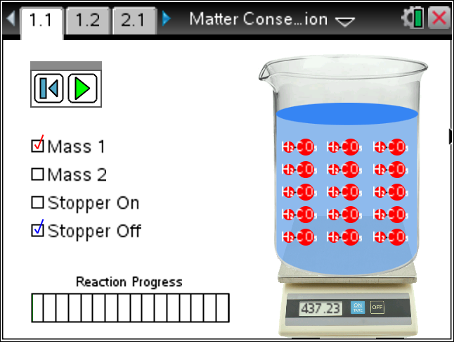  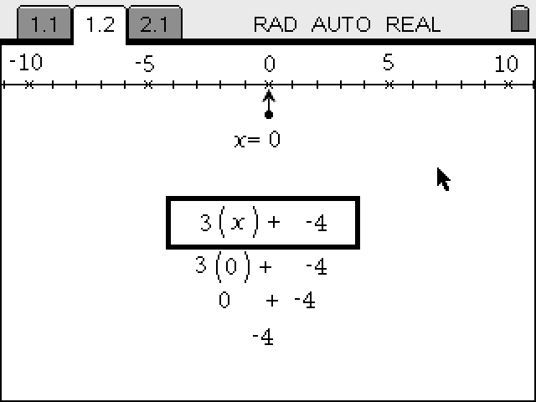  Tech Tips:  - This activity includes screen captures taken from the TI-Nspire CX handheld. It is also appropriate for use with the TI-Nspire family of products including TI-Nspire software and TI-Nspire App. Slight variations to these directions may be required if using other technologies besides the handheld.  - Watch for additional Tech Tips throughout the activity for the specific technology you are using.  - Access free tutorials at http://education.ti.com/calculators/pd/US/Online-Learning/Tutorials  Lesson Files:  - Matter_Conservation_Teacher.doc  - Matter_Conservation_Student.doc  TI-Nspire document  - Matter Conservation.tns
Materials
- TI-Nspire (handheld, APP, software)

Procedure
1. With your partner, explore the simulation. Read the Directions. If the Directions are missing, press Menu and select Directions.
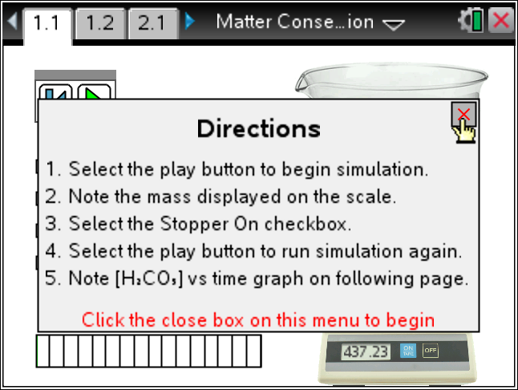
Tech Tip: To Play the simulation, Pause, or Reset click on the appropriate icon.  .
Change the initial settings by clicking on the radio boxes.
2. In this simulation you have the opportunity to start with two different amounts of Carbonic Acid (H₂CO₃) in water (H₂O). In addition, you can have the system open (Stopper Off) or closed (Stopper On). Explain what appears to happen with your assigned scenario.
Note: Assign students different situations and have them report their results. Use the Navigator Quick Poll and classify the answers, leading to the students connecting the conservation of mass when the system is closed.
3. Why does the initial mass change when the Stopper is changed?
Note: Adding or removing the mass of the stopper
4. How does the simulation deal with the mass of the extra water in the beaker?
Note: It is included in the total mass shown on the scale.

5. What do you normally do with a digital balance to account for the empty beaker and stopper?
Note: Tare the scale.
6. Run the simulation with the system closed and examine the plot shown on the following page. How does this plot reflect what you visualize during the simulation?
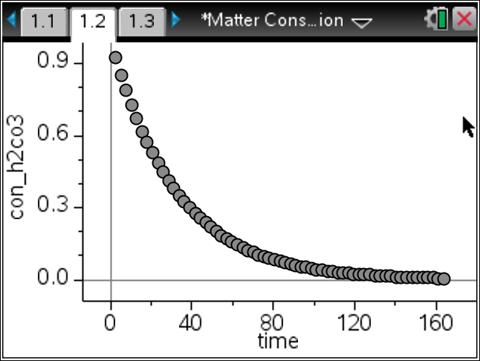
Note: The carbonic acid forms water and carbon dioxide rapidly initially and then slows.
Tech Tip: To move between several pages press /£ and move to select the desired pages using £¤¢ ¡ to get where you are going and then ·.
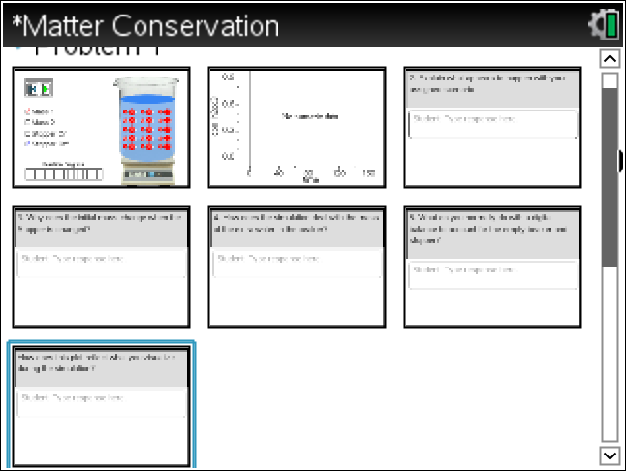

7. Look at the Periodic Table and find all of the elements involved in this reaction. Fill in the table below.
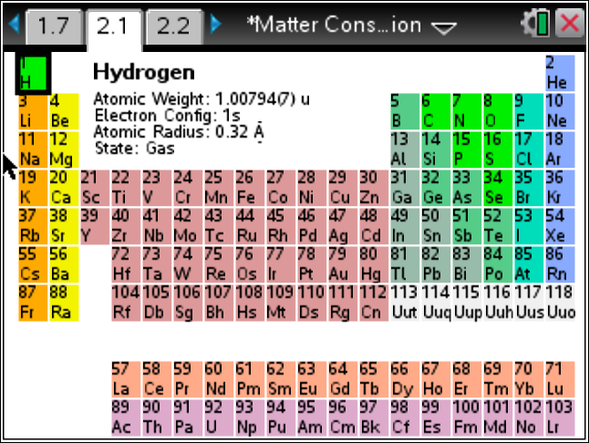 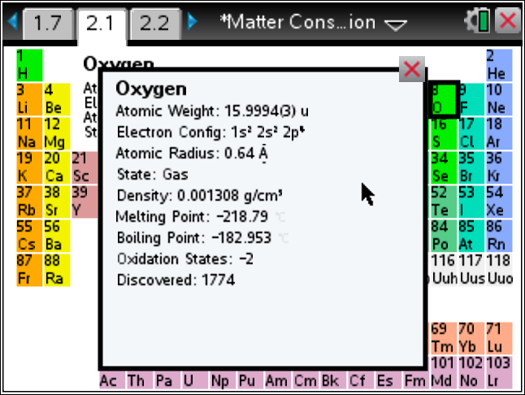
Element | Symbol | Atomic Number | Protons | Neutrons | Electrons
Answer:
Element | Symbol | Atomic Number | Protons | Neutrons | Electrons
Hydrogen | H | 1 | 1 | 1 | 1
Carbon | C | 6 | 6 | 6 | 6
Oxygen | O | 8 | 8 | 8 | 8

8. Build one of the elements involved in the reaction using the data from the table you just completed. Use the Menu to help. Ask your teacher which one of the atoms you are to build. Create a neutral atom.

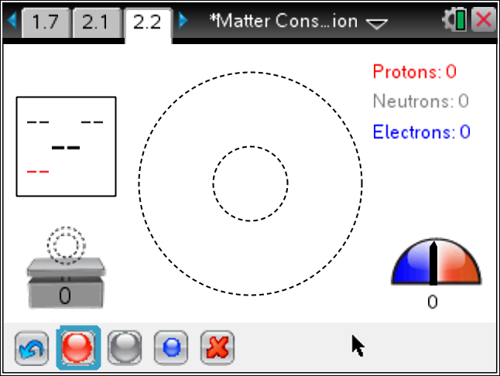 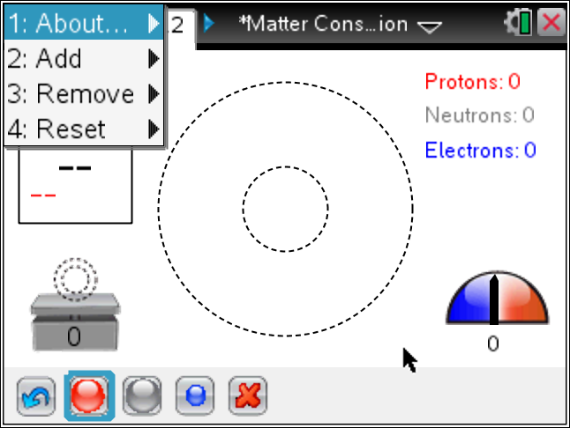
Note: Use the Navigator Screenshots to classify the atoms made.

9. What can you conclude about the number of atomic particles before and after a reaction in a closed system?
Note: The total number of each particle is the same.
10. If we combined Sodium and Chlorine to get Salt, state the number of each atomic particle before and after the reaction.
 | Item | Protons | Neutrons | Electrons
Before
After
Answer:
 | Item | Protons | Neutrons | Electrons
Before | Sodium | 11 | 11 | 11
 | Chlorine | 17 | 17 | 17
After | Salt | 28 | 28 | 28

11. If the real reaction between Sodium and Chlorine to make salt is 2Na + Cl₂ → 2NaCl, calculate the mass of the initial atomic particles and the mass of the final atomic particles. Research the needed masses or get them from your teacher. Is the mass conserved?

Tech Tip: To insert a calculator press /I and select Calculator.

Note:
Neutron = 1.6749286*10⁻²⁷ kg
Proton = 1.6726231*10⁻²⁷ kg
Electron = 9.1093897*10⁻³¹ kg

TI-Nspire Navigator Opportunities
Make a student a Live Presenter to demonstrate what they discover along the way.
Use Quick Poll as Formative Assessment.

Wrap Up
Students should compose a lab report, which includes their data, analysis, and a discussion of the results of their test. Students may choose to use the TI-Nspire™ Student Edition software to convert their .tns files to PublishView Documents.

Extensions
Students can create closed system reactions on a balance, with a small amount of Alka-Seltzer, and water; baking soda and vinegar; and even with a carbonated soda. Make sure the amounts are small as to avoid the stopper being blown off.

Assessment
- Use the questions in the Nspire document as Quick Polls during the lesson as needed.
- The questions in the Nspire document can be Self-Check, so students can check their answers.
- NES Pearson MG Science
http://www.nestest.com/Content/Docs/NES_Profile_204.pdf
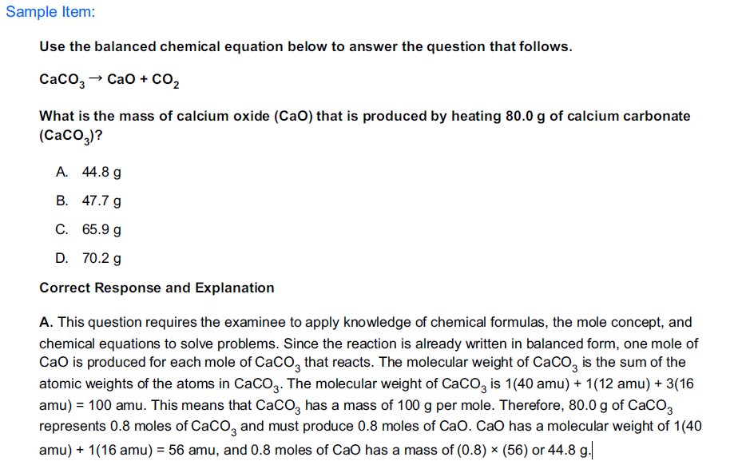
Reference Links:
CI_law_of_conservation_of_matter_4_3
http://employees.oneonta.edu/viningwj/modules/CI_law_of_conservation_of_matter_4_3.html

The Law of Conservation of Mass
http://chem.wisc.edu/deptfiles/genchem/sstutorial/Text1/Tx14/tx14.html

Conservation of mass
http://www.princeton.edu/~achaney/tmve/wiki100k/docs/Conservation_of_mass.html

NGSS – Next Generation Science Standards
http://www.nextgenscience.org/msps1-matter-interactions

What are the exact relative masses of protons, neutrons and electrons?
http://education.jlab.org/qa/particlemass_02.html

