Use the TI-Nspire document Chemical Reactions.tns file.  As you study the nature of the physical universe, you have encountered situations where the substances change. In this investigation you will look at the combination of various materials and explore the nature of the interactions between these substances.  Recall the differences between Physical and Chemical changes. In this simulation you will be able to combine several solid substances with various aqueous substances and then classify the various aspects of the reaction, if one occurs, based on the chemical nature of the reactants. | 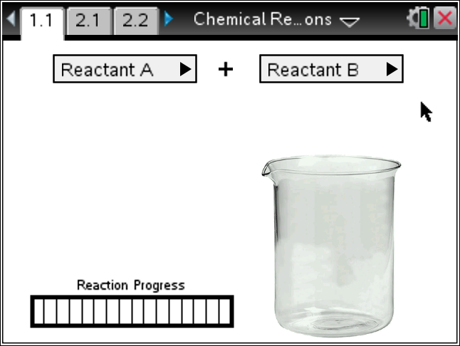

Materials
- TI-Nspire (handheld, APP, software)

Procedure
1. Discuss what you know about Physical and Chemical changes with your tablemate. Give an example of each. How can you tell which one it is? Be prepared to share with the class.
2. With your partner, explore the simulation. Read the Directions. If the Directions are missing, press Menu and select Directions.
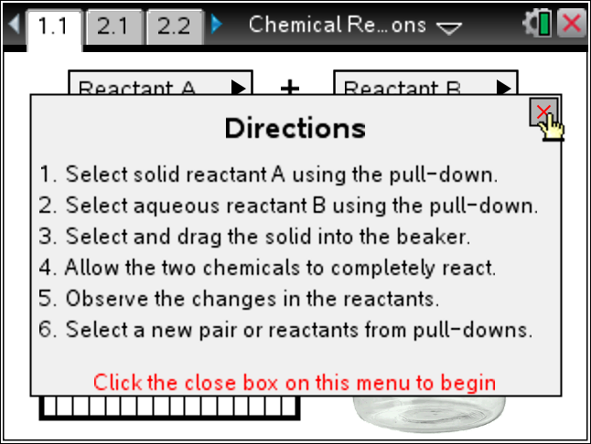
Tech Tip: To Pick up the solid, place your hand {over it and press click ( x ) to close the hand. Then move the solid into the beaker and press click ( x ) to release the reactant.
3. Select your assigned Reactants and see if a Chemical Reaction occurred. Describe it and share with the
class.
Solid: ________________ Liquid: _______________
Description of the reaction:
4. Now we want to explore the different reactants and the types of reactions we get. Confer with your teacher and partner and fill in the chart below as you decide.
Solid Reactant | Aqueous Reactant | Chemical Reaction? | Temp Change | Speed | Other

5. Explore one of the reactions that seem of greatest interest. Look at the elements that make up the reactants and where they fall on the Periodic Table. Look at the characteristics of each element and try to explain why you think the reaction occurred as it did.
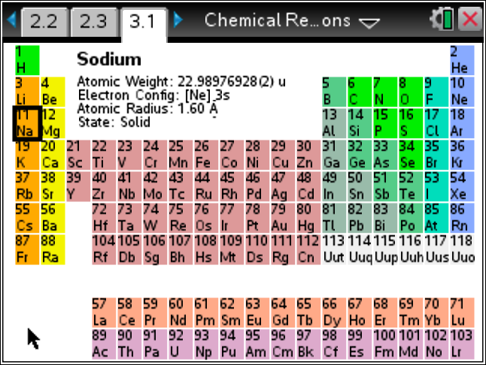 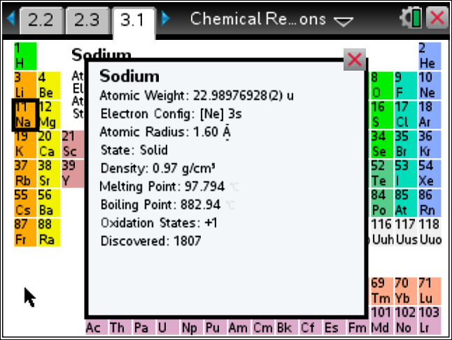
Tech Tip: To move between several pages press /£ and move to select the desired pages using £¤¢ ¡ to get where you are going and then ·.
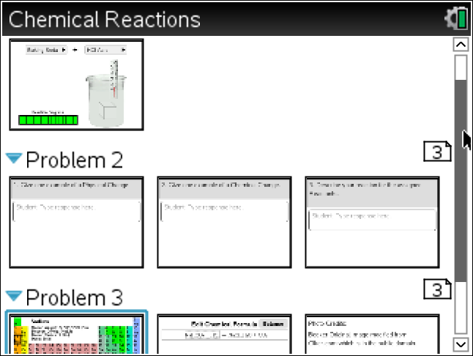

6. Research the chemical formula for the reactants and either guess the products or research this as well. Use the Chemical Equation Balancing page to set and then balance the reactions. Note what products may be gases, based on the temperature and the boiling points of the products.
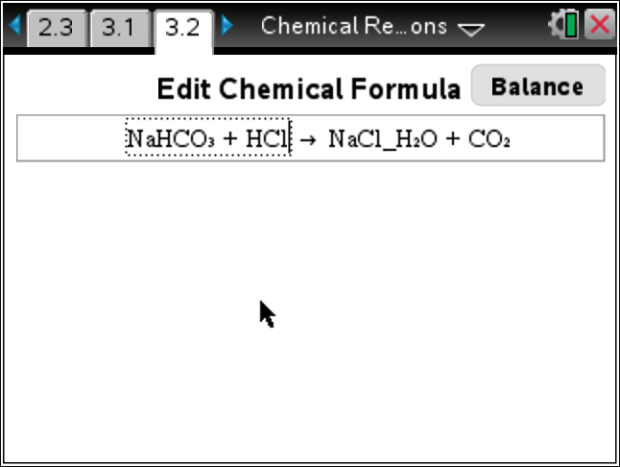 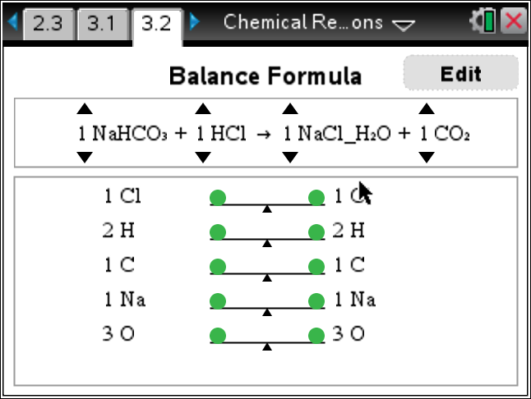
7. Check with other groups doing your same reactions and plan to share with the class your results and explanations.

