Science Objectives  - Students will explore various scenarios by using the simulation, looking for patterns and relationships based on the nature of the reactants.  - Students will classify each reaction, looking for common aspects of the various reactions.  - Students will explore the Periodic Table in an effort to relate the type of chemical reaction with the placement of the elements on the table.  - Students will develop an understanding of the types of chemical reactions that may occur.  - Students will analyze and interpret data on the properties of substances before and after the substances interact to determine if a chemical reaction has occurred.  - Students will balance the chemical reaction using the built-in Chemical Equation Balancing app. (Optional).  Vocabulary  - Physical Change  - Chemical Change  - Reactant  - Endothermic  - Exothermic  - Aqueous Solution  - Solid  About the Lesson  - Given a set of reactants to combine, students will create situations where a chemical reaction may or may not occur. They will examine the nature of the reactions and try to classify them. The students will also try to connect the reaction types with the nature of the reactants used.  Substances react chemically in characteristic ways. In a chemical process, the atoms that make up the original substances are regrouped into different molecules, and these new substances have different properties from those of the reactants.  TI-Nspire™ Navigator™  - Send out the Chemical Reactions.tns file.  - Monitor student progress using Class Capture.  - Use Student Live Presenter to spotlight student answers and presentation of solutions.  NGSS  MS-PS1 Matter and its Interactions  Students who demonstrate understanding can:  Analyze and interpret data on the properties of substances before and after the substances interact to determine if a chemical reaction has occurred. [Clarification Statement: Examples of reactions could include burning sugar or steel wool, fat reacting with sodium hydroxide, and mixing zinc with hydrogen chloride.] [Assessment boundary: Assessment is limited to analysis of the following properties: density, melting point, boiling point, solubility, flammability, and odor.]  Science and Engineering Practices  Developing and Using Models  Develop a model to predict and/or describe phenomena. (MS-PS1-1),(MS-PS1-4)  Develop a model to describe unobservable mechanisms. (MS-PS1-5)  Analyzing and Interpreting Data  Analyze and interpret data to determine similarities and differences in findings. (MS-PS1-2)  Constructing Explanations and Designing Solutions  Undertake a design project, engaging in the design cycle, to construct and/or implement a solution that meets specific design criteria and constraints. (MS-PS1-6)  Obtaining, Evaluating, and Communicating Information  Gather, read, and synthesize information from multiple appropriate sources and assess the credibility, accuracy, and possible bias of each publication and methods used, and describe how they are supported or now supported by evidence. (MS-PS1-3)  Connections to Nature of Science  Scientific Knowledge is Based on Empirical Evidence  Science knowledge is based upon logical and conceptual connections between evidence and explanations. (MS-PS1-2)  Science Models, Laws, Mechanisms, and Theories Explain Natural Phenomena  Laws are regularities or mathematical descriptions of natural phenomena. (MS-PS1-5)  Disciplinary Core Ideas  PS1.A: Structure and Properties of Matter  Substances are made from different types of atoms, which combine with one another in various ways. Atoms form molecules that range in size from two to thousands of atoms. (MS-PS1-1)  Each pure substance has characteristic physical and chemical properties (for any bulk quantity under given conditions) that can be used to identify it. (MS-PS1-2),(MS-PS1-3)  PS1.B: Chemical Reactions  Substances react chemically in characteristic ways. In a chemical process, the atoms that make up the original substances are regrouped into different molecules, and these new substances have different properties from those of the reactants. (MS-PS1-2),(MS-PS1-3),(MS-PS1-5)  Some chemical reactions release energy, others store energy. (MS-PS1-6)  ETS1.C: Optimizing the Design Solution  The iterative process of testing the most promising solutions and modifying what is proposed on the basis of the test results leads to greater refinement and ultimately to an optimal solution. (secondary to MS-PS1-6)  Crosscutting Concepts  Macroscopic patterns are related to the nature of microscopic and atomic-level structure. (MS-PS1-2)  Cause and Effect  Cause and effect relationships may be used to predict phenomena in natural or designed systems. (MS-PS1-4)  Energy and Matter  Matter is conserved because atoms are conserved in physical and chemical processes. (MS-PS1-5)  The transfer of energy can be tracked as energy flows through a designed or natural system. (MS-PS1-6)  Structure and Function  Structures can be designed to serve particular functions by taking into account properties of different materials, and how materials can be shaped and used. (MS-PS1-3)  Activity Materials  - Compatible TI Technologies: TI- Nspire™ CX Handhelds,  TI-Nspire™ Apps for iPad®,  TI-Nspire™ Software | 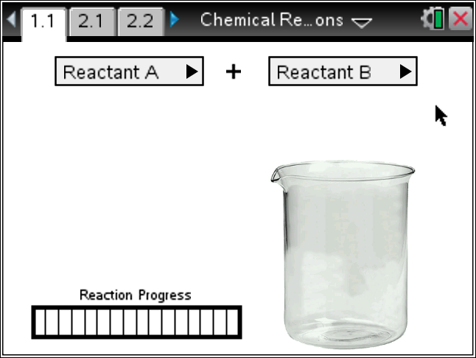  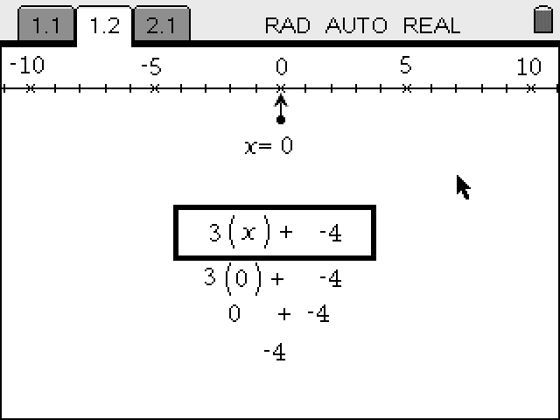  Tech Tips:  - This activity includes screen captures taken from the TI-Nspire CX handheld. It is also appropriate for use with the TI-Nspire family of products including TI-Nspire software and TI-Nspire App. Slight variations to these directions may be required if using other technologies besides the handheld.  - Watch for additional Tech Tips throughout the activity for the specific technology you are using.  - Access free tutorials at http://education.ti.com/calculators/pd/US/Online-Learning/Tutorials  Lesson Files:  - Chemical_Reactions_Teacher.doc  - Chemical_Reactions_Student.doc  TI-Nspire document  - Chemical Reactions.tns
Materials
- TI-Nspire (handheld, APP, software)

Procedure
1. Discuss what you know about Physical and Chemical changes with your tablemate. Give an example of each. How can you tell which one it is? Be prepared to share with the class.
Answer: Chemical Changes: Chemical changes take place on the molecular level. A chemical change produces a new substance. Examples of chemical changes include combustion, cooking, rusting, and mixing two chemicals to produce a new chemical or chemicals.
Physical Changes: Physical changes are concerned with energy and states of matter. A physical change does not produce a new substance. Changes in state or phase, crushing a can, and breaking a bottle.
How to Tell Chemical & Physical Changes Apart: A chemical change makes a new substance. There may be clues that a chemical reaction took place, such as light, heat, color change, gas production, odor, or sound. The starting and ending materials of a physical change are the same, even though things may look different.
2. With your partner, explore the simulation. Read the Directions. If the Directions are missing, press Menu and select Directions.
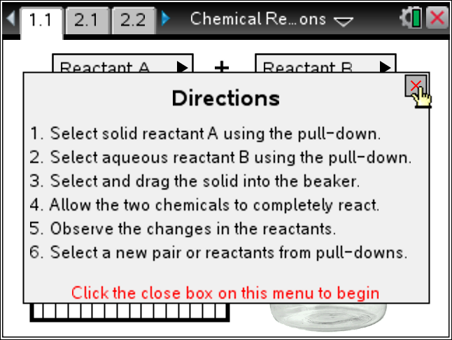
Note: Students select one solid reactant and one aqueous reactant and then drag the solid into the beaker and drop it. This will start the reaction, if there is one. Note the change in temperature, gases, and speed of the reaction.
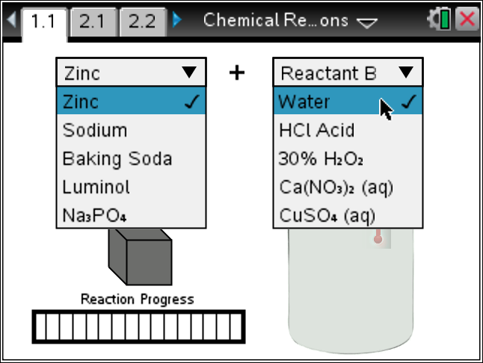
Tech Tip: To Pick up the solid, place your hand {over it and press click ( x ) to close the hand. Then move the solid into the beaker and press click ( x ) to release the reactant.
3. Select your assigned Reactants and see if a Chemical Reaction occurred. Describe it and share with the
class.
Solid: ________________ Liquid: _______________
Description of the reaction:
Note: Assign student teams one solid and then different liquids. Use the Navigator Quick Poll to collect their descriptions. Look for things like: violent/calm; fast/slow; heating/cooling, gases, etc. This will set the descriptors for the next steps.
4. Now we want to explore the different reactants and the types of reactions we get. Confer with your teacher and partner and fill in the chart below as you decide.
Solid Reactant | Aqueous Reactant | Chemical Reaction? | Temp Change | Speed | Other
Note: You can differentiate and have some groups do all of the combinations and others do just certain combinations. You may also want to use other descriptors for the reactions.
5. Explore one of the reactions that seem of greatest interest. Look at the elements that make up the reactants and where they fall on the Periodic Table. Look at the characteristics of each element and try to explain why you think the reaction occurred as it did.
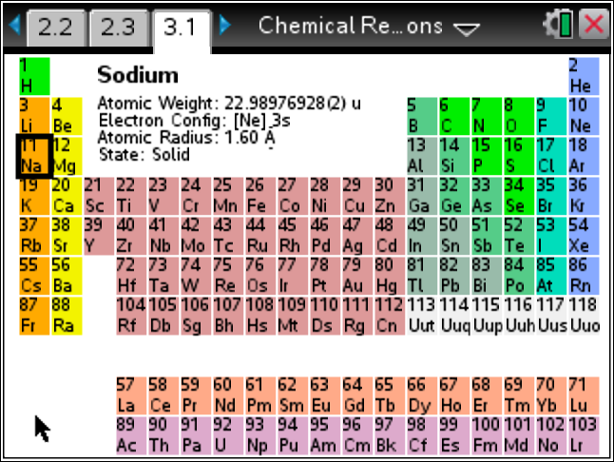 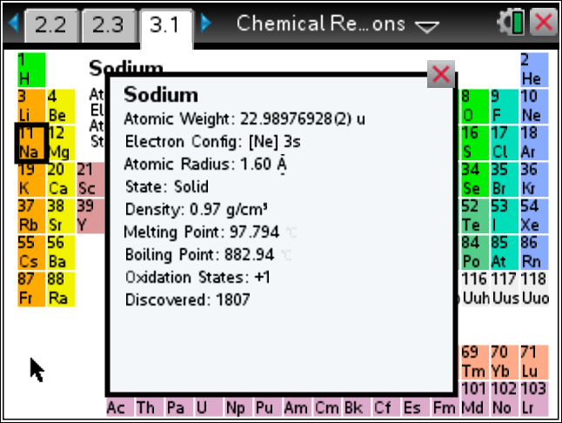
Note: You may assign some particular reactions to explore, or have the class come to some consensus. Look for placement in the Periodic Table Groups. This is another opportunity for differentiation.
Tech Tip: To move between several pages press /£ and move to select the desired pages using £¤¢ ¡ to get where you are going and then ·.
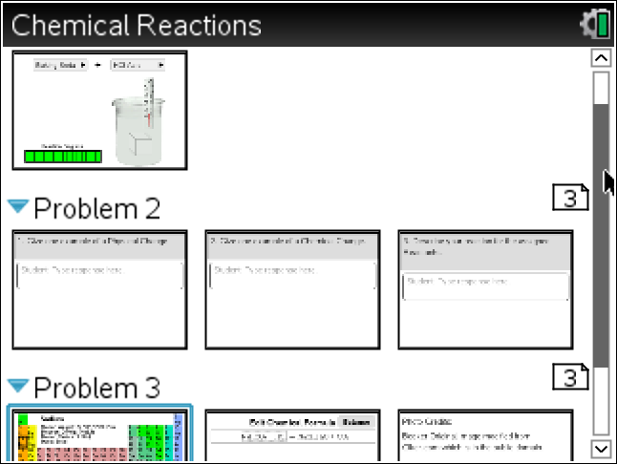

6. Research the chemical formula for the reactants and either guess the products or research this as well. Use the Chemical Equation Balancing page to set and then balance the reactions. Note what products may be gases, based on the temperature and the boiling points of the products.
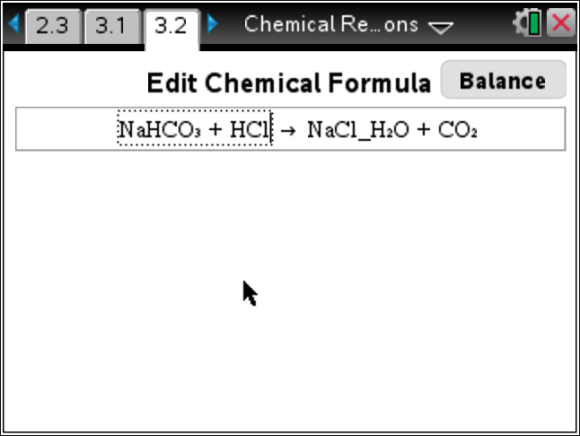 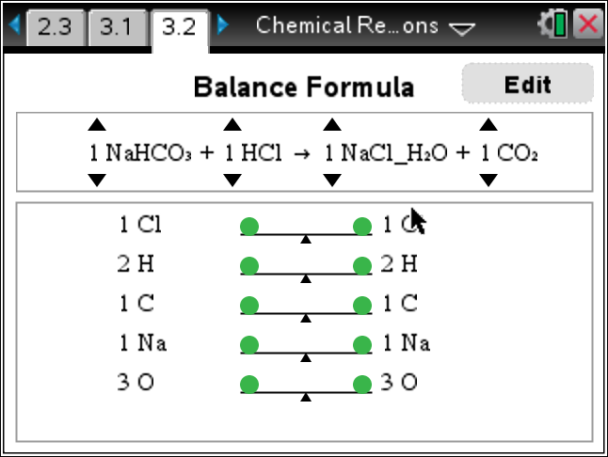
Note: This section can be optional based on your curriculum and the expertise of your students.

7. Check with other groups doing your same reactions and plan to share with the class your results and explanations

TI-Nspire Navigator Opportunities
Make a student a Live Presenter to demonstrate what they discover along the way.
Use Quick Poll as Formative Assessment.

Wrap Up
Students should compose a lab report, which includes their data, analysis, and a discussion of the results of their test. Students may choose to use the TI-Nspire™ Student Edition software to convert their .tns files to PublishView Documents.

Extensions
Students can create endothermic and exothermic reactions (see reference below) and use the EZ-Temp to collect the temperature change and rate.

Assessment
- Use the questions in the Nspire document as Quick Polls during the lesson as needed.
- The questions in the Nspire document are Self-Check, so students can check their answers.

Reference Links:
Chemical & Physical Changes: Understanding States of Matter
http://chemistry.about.com/od/lecturenotesl3/a/chemphyschanges.htm

The Six Types of Chemical Reaction
http://misterguch.brinkster.net/6typesofchemicalrxn.html

Top 10 Amazing Chemical Reactions
http://listverse.com/2008/03/04/top-10-amazing-chemical-reactions/
Types of Chemical Reactions: List of Common Reactions and Examples
http://chemistry.about.com/od/chemicalreactions/a/reactiontypes.htm

Chemical Reactions
http://www.nclark.net/ChemicalReactions
Endothermic & Exothermic Reaction Demos
http://chemistry.about.com/od/endothermicexothermic/
How To Create an Endothermic Chemical Reaction (Safe)
http://chemistry.about.com/cs/howtos/ht/endothermic.htm
How To Create an Exothermic Chemical Reaction
http://chemistry.about.com/cs/howtos/ht/exothermic.htm
Reactants, Products and Leftovers
http://phet.colorado.edu/en/simulation/reactants-products-and-leftovers

