Use the TI-Nspire document Wondering About Waves.tns file.  Today we want to explore the Nature and Needs of a Wave. You will use the simulated waves to come to “know” waves by adjusting different parameters for the waves and noting the ways we measure them as well as the way they behave under different conditions. | 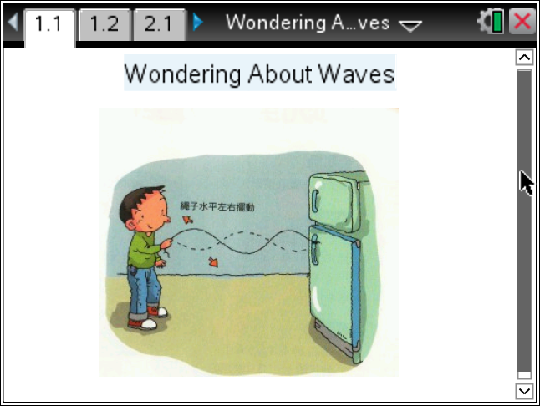

Materials
- TI-Nspire (handheld, APP, software)
- Ruler or some way to measure on the Nspire screen.

Procedure
1. First, let’s explore what you know about waves. Share with your partner what you know about waves and report at least two things you both know.
2. Open the Wondering About Waves.tns file. If prompted to save the current file on your handheld, use your discretion or ask your teacher what she would do.

3. With your partner, explore the simulation. Read the Directions. If the Directions are missing, press Menu and select Directions.
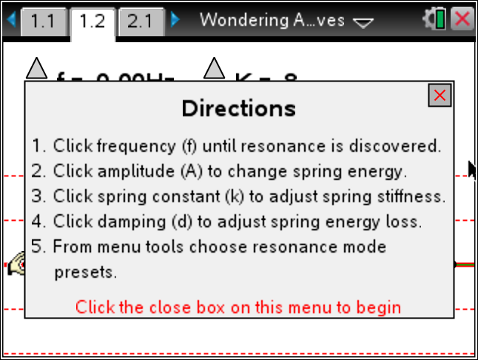
4. You will need to first select a resonance mode. Select from the list or do your assigned mode. Press menu>Waves Propagation>.
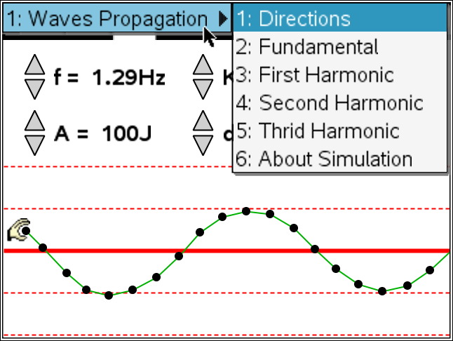
Tech Tip: To Play the simulation, Pause, or Reset click on the
appropriate icon. 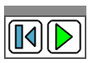 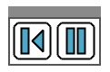.
the mass of a toy car click on the 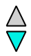 icon to increase or decrease.
5. Adjust all the parameters in the simulation, but be systematic so you can develop some understanding of how these change the wave.
Tech Tip: Click on the on the icon to increase or decrease the values of each
parameter.
6. Select the most stable wave to share with the class.
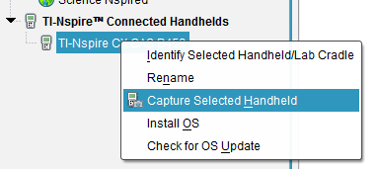
7. Now show off the coolest wave. Why is it so cool to you?
8. The f in the simulation is for the Frequency of the wave. The units are Hertz (Hz) and this means cycles per second. How long will it take a wave to repeat if the frequency is 1.81 Hz?
9. What if the frequency was 2.2 Hz? How many complete waves would you have after 10 seconds?

Tech Tip: To insert a calculator press /I and select Calculator.

10. Given a wave with a frequency of 10.0 Hz, how many seconds would it take to get one wave? This measure is called Period and is the number of seconds per wave cycle. It is the reciprocal of frequency.
11. The other parameters in the simulation are A, for amplitude, and it is related to the energy of the wave. The K is called the spring constant and is related to how hard the spring is to stretch, and the d is the damping which is to simulate the wave moving through different materials such as air (low d) and water (higher d).
12. Set up a wave that seems stable and report the parameters. Share this with the class.
Frequency | Amplitude | K | d | Resonance Mode
Tech Tip: To move between several pages press /£ and move to select the desired pages using £¤¢ ¡ to get where you are going and then ·.
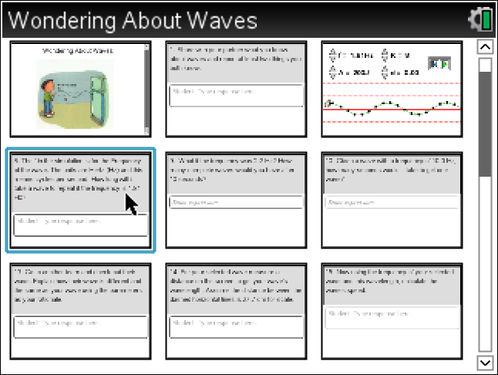
13. Go to another team and check out their wave. Explain how their wave is different and the same as your wave using the parameters as your rationale.

14. The wavelength (λ) of a wave is the distance between the repeating parts, This could be peak to peak, trough to trough, or any other reoccurring part of the wave.
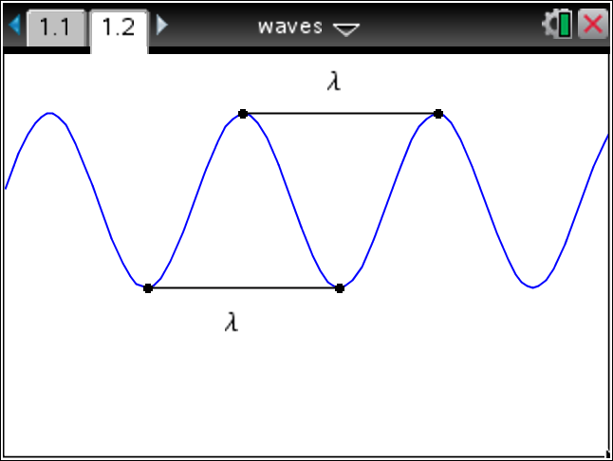
For your selected wave measure a distance on the screen to get your wave’s wavelength.
Assume the distance between the dashed horizontal lines is 27.7 cm for scale.
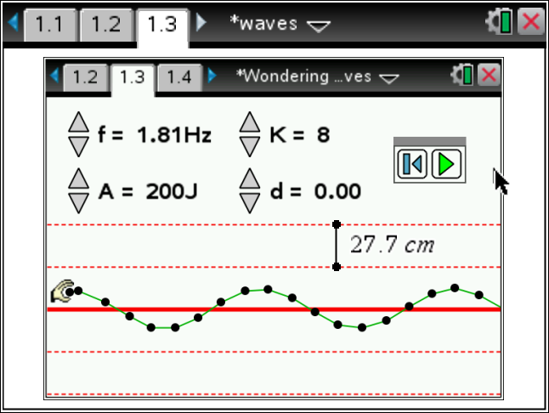
15. Now using the frequency of your selected wave and this wavelength, calculate the wave’s speed.
16. Set your animation for another wave that will have a greater speed. What do you need to change to make this happen?

17. What is the Wavelength and Frequency for this new wave?
18. What is the new wave’s speed?
19. Move to the page in your document with the animation of a light wave. Adjust the wavelength of the light. What happens when the wavelength gets larger?

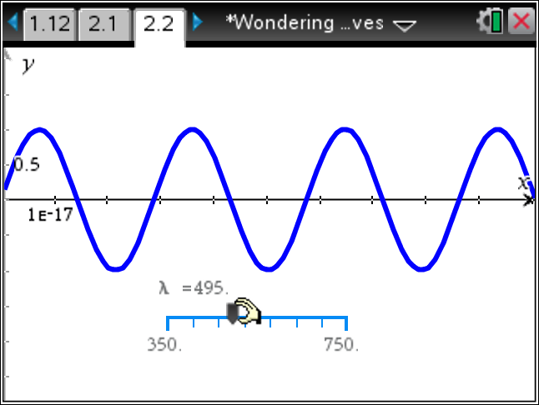

20. Since light is a form of Electromagnetic Radiation, it has a speed of c (about 300 000 km/s). So what can you say about the frequency of the light as you make the wavelength larger?

