Science Objectives  - Students will discuss what they know about waves, as prior knowledge.  - Students will explore different kinds of waves looking for patterns.  - Students will set a resonance mode preset and then vary the parameters of frequency, amplitude, k, and the damping, observing how the wave changes. This will simulate a wave moving through various materials.  - Students will produce a stable wave oscillation (a Standing Wave), they then measure a wavelength (using an arbitrary scale) and using the frequency, determine a wave speed.  - Students will relate frequency and period.  - Students will relate changes in the damping and the spring constant (k) to waves being transmitted through various materials.  Vocabulary  - Speed  - Amplitude  - Resonance  - Frequency  - Hertz  - Period  - Spring Constant  - Damping  - Oscillation  - Standing Wave  - Harmonics  - Node  - Anti-node  - Electromagnetic Radiation  About the Lesson  For a selected Harmonic, students will explore settings for Amplitude, Damping, Spring Constant and Frequency to create a Standing wave. As they do this they will discover the relationships between these parameters and the nature of the wave. In addition to this development of an understanding of a wave, students will mathematically relate the Period and Frequency, and calculate the speed of the wave using a measure off of the screen and the given Frequency. The simulation setting will produce different environments for which the wave propagates through.  TI-Nspire™ Navigator™  - Send out the Wondering About Waves.tns file.  - The questions are Self-Check which you might want to change to Exam.  - Monitor student progress using Class Capture.  - Use Student Live Presenter to spotlight student answers and presentation of solutions.  NGSS  MS-PS4 Waves and their Applications in Technologies for Information Transfer  Students who demonstrate understanding can:  MS-PS4-1.  Use mathematical representations to describe a simple model for waves that includes how the amplitude of a wave is related to the energy in a wave.  MS-PS4-2.  Develop and use a model to describe that waves are reflected, absorbed, or transmitted through various materials.  Science and Engineering Practices  Developing and Using Models  Develop and use a model to describe phenomena. (MS-PS4-2)  Using Mathematics and Computational Thinking  Use mathematical representations to describe and/or support scientific conclusions and design solutions. (MS-PS4-1)  Obtaining, Evaluating, and Communicating Information  Integrate qualitative scientific and technical information in written text with that contained in media and visual displays to clarify claims and findings. (MS-PS4-3)  Connections to Nature of Science  Scientific Knowledge is Based on Empirical Evidence  Science knowledge is based upon logical and conceptual connections between evidence and explanations. (MS-PS4-1)  Disciplinary Core Ideas  PS4.A: Wave Properties  A simple wave has a repeating pattern with a specific wavelength, frequency, and amplitude. (MS-PS4-1)  PS4.B: Electromagnetic Radiation  A wave model of light is useful for explaining brightness, color, and the frequency-dependent bending of light at a surface between media. (MS-PS4-2)  Crosscutting Concepts  Connections to Engineering, Technology, and Applications of Science  Influence of Science, Engineering, and Technology on Society and the Natural World  Technologies extend the measurement, exploration, modeling, and computational capacity of scientific investigations. (MS-PS4-3)  Activity Materials  - Compatible TI Technologies: TI- Nspire™ CX Handhelds,  TI-Nspire™ Apps for iPad®,  TI-Nspire™ Software |  | 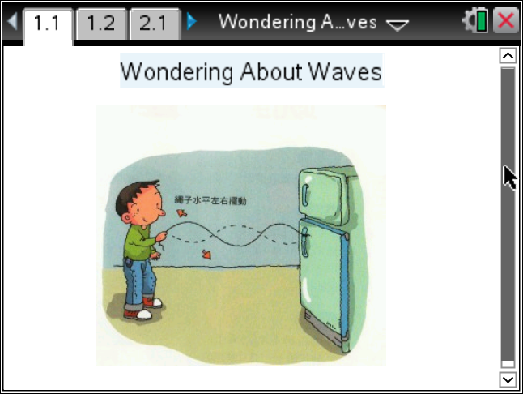  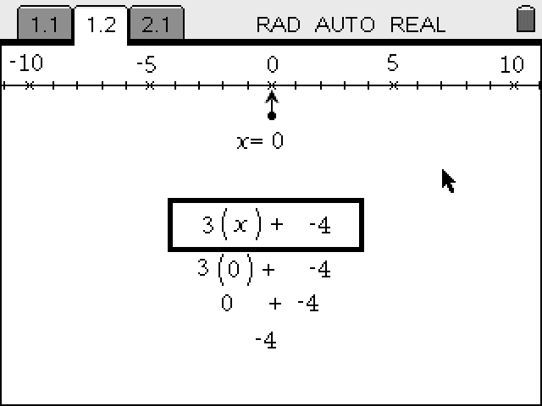  Tech Tips:  - This activity includes screen captures taken from the TI-Nspire CX handheld. It is also appropriate for use with the TI-Nspire family of products including TI-Nspire software and TI-Nspire App. Slight variations to these directions may be required if using other technologies besides the handheld.  - Watch for additional Tech Tips throughout the activity for the specific technology you are using.  - Access free tutorials at http://education.ti.com/calculators/pd/US/Online-Learning/Tutorials  Lesson Files:  - Wondering_About_Waves_Teacher.doc  - Wondering_About_Waves_Student.doc  TI-Nspire document  - Wondering About Waves.tns
Materials
- TI-Nspire (handheld, APP, software)
- Ruler or some way to measure on the Nspire screen.

Procedure
1. First, let’s explore what you know about waves. Share with your partner what you know about waves and report at least two things you both know.
Teacher Note: Look for key words, and well as the relationship to sound, explosions, light, ocean waves, tsunamis, earthquakes, and refraction and reflection.

2. Open the Wondering About Waves.tns file. If prompted to save the current file on your handheld, use your discretion or ask your teacher what she would do.

3. With your partner, explore the simulation. Read the Directions. If the Directions are missing, press Menu and select Directions.
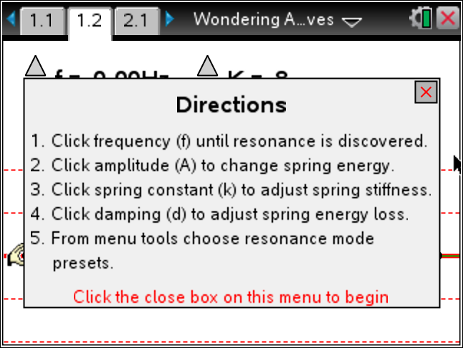
4. You will need to first select a resonance mode. Select from the list or do your assigned mode. Press menu>Waves Propagation>.
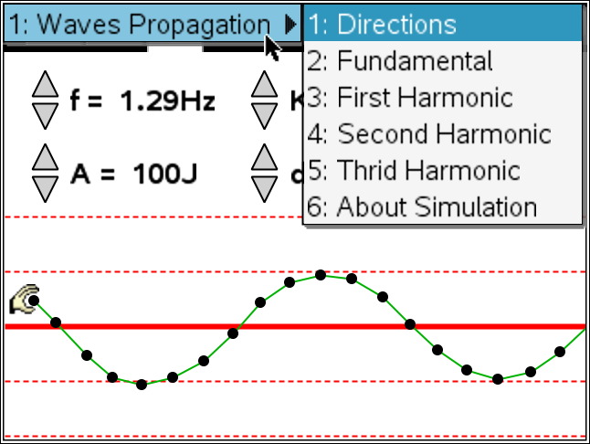
Teacher Note: Select the Third Harmonic to differentiate, with the First Hamonic being more difficult. You might want all groups to select the same harmonic.
Tech Tip: To Play the simulation, Pause, or Reset click on the
appropriate icon. 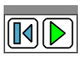 .
the mass of a toy car click on the  icon to increase or decrease.
5. Adjust all the parameters in the simulation, but be systematic so you can develop some understanding of how these change the wave.
Tech Tip: Click on the on the icon to increase or decrease the values of each
parameter.
6. Select the most stable wave to share with the class.
Teacher Note: Use the Navigator Screenshot or have the student plug into the teacher computer and get the image of their screen from the Content Tab in the Nspire software.
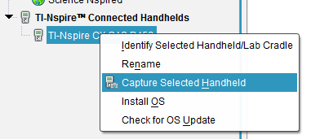
7. Now show off the coolest wave. Why is it so cool to you?
8. The f in the simulation is for the Frequency of the wave. The units are Hertz (Hz) and this means cycles per second. How long will it take a wave to repeat if the frequency is 1.81 Hz?
Teacher Note: 1.81 seconds

9. What if the frequency was 2.2 Hz? How many complete waves would you have after 10 seconds?
Tech Tip: To insert a calculator press /I and select Calculator.
Teacher Note: 4

10. Given a wave with a frequency of 10.0 Hz, how many seconds would it take to get one wave? This measure is called Period and is the number of seconds per wave cycle. It is the reciprocal of frequency.
Teacher Note: 1/10 or 0.1 seconds.

11. The other parameters in the simulation are A, for amplitude, and it is related to the energy of the wave. The K is called the spring constant and is related to how hard the spring is to stretch, and the d is the damping which is to simulate the wave moving through different materials such as air (low d) and water (higher d).
12. Set up a wave that seems stable and report the parameters. Share this with the class.
Frequency | Amplitude | K | d | Resonance Mode
Teacher Note: You may want to have some control of the variables, locking in one or more paremeter for the class.
Tech Tip: To move between several pages press /£ and move to select the desired pages using £¤¢ ¡ to get where you are going and then ·.
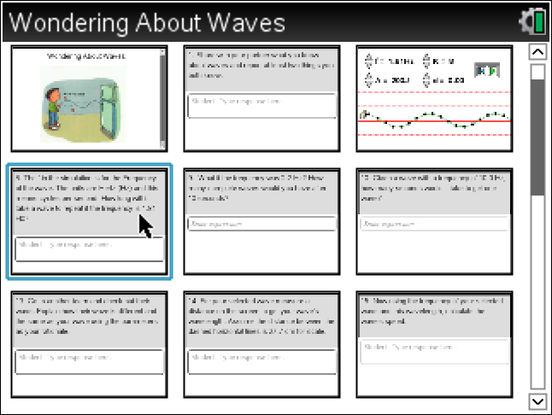
13. Go to another team and check out their wave. Explain how their wave is different and the same as your wave using the parameters as your rationale.
Teacher Note: Look for the use of the parameters reported to compare and contrast the waves. To differentiate, you could have the kids just adjust one parameter at a time, and repeat.

14. The wavelength (λ) of a wave is the distance between the repeating parts, This could be peak to peak, trough to trough, or any other reoccurring part of the wave.
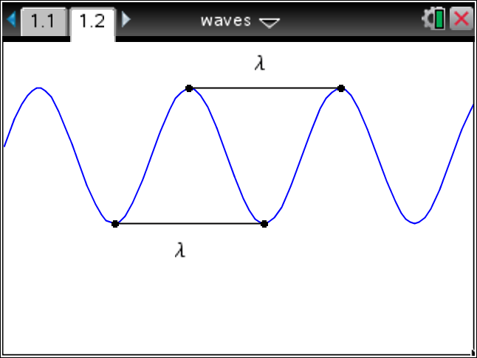
For your selected wave measure a distance on the screen to get your wave’s wavelength.
Assume the distance between the dashed horizontal lines is 27.7 cm for scale.
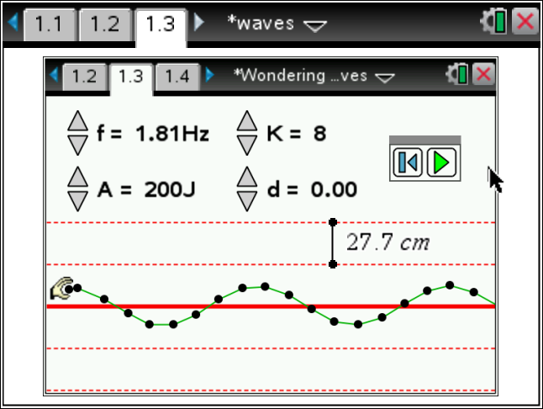
Teacher Note: If more than one group has the same wave, they may get different wavelengths, which would be a good opportunity to discuss significant figures. It might be useful to determine the setting for the class on the first measure of wvelenght, so all or many have the same wave to look at.
15. Now using the frequency of your selected wave and this wavelength, calculate the wave’s speed.
Teacher Note: Use
16. Set your animation for another wave that will have a greater speed. What do you need to change to make this happen?
Teacher Note: Answers will vary, but in general the wavelength and frequency product must become larger.
17. What is the Wavelength and Frequency for this new wave?
18. What is the new wave’s speed?
Teacher Note: The product of wavelength (measured) and the frequency.
19. Move to the page in your document with the animation of a light wave. Adjust the wavelength of the light. What happens when the wavelength gets larger?

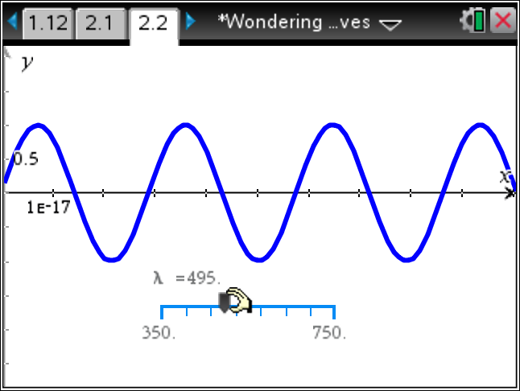
Teacher Note: The color moves from Violet, Blue, Green, Yellow, Red.

20. Since light is a form of Electromagnetic Radiation, it has a speed of c (about 300 000 km/s). So what can you say about the frequency of the light as you make the wavelength larger?
Teacher Note: The frequency must get smaller since the speed is the product of the wavelength and
frequency.

TI-Nspire Navigator Opportunities
Make a student a Live Presenter to demonstrate what they discover along the way.
Use Quick Poll as Formative Assessment.

Wrap Up
Students should compose a lab report, which includes their data, analysis, and a discussion of the results of their test. Students may choose to use the TI-Nspire™ Student Edition software to convert their .tns files to PublishView Documents.

Assessment
- Use the questions in the Nspire document as Quick Polls during the lesson as needed.
- The questions in the Nspire document are Self-Check, so students can check their answers.
- Use Ranking Task as shown below.
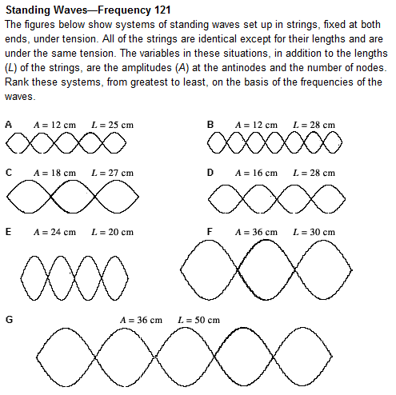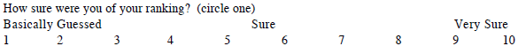

Reference Links:
The Physics Classroom:
http://www.physicsclassroom.com/class/waves/u10l4d.cfm
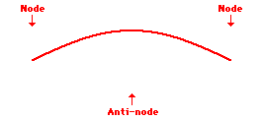
First Harmonic Standing Wave Pattern

- PhET – Wave on a String:
http://phet.colorado.edu/en/simulation/wave-on-a-string
- Wilson Physics Ranking Task:
http://wps.aw.com/aw_wilson_physics_7/109/28123/7199679.cw/-/7199721/index.html

