Use the TI-Nspire document Exploring Energy Transfer.tns file.  In this exploration you will examine the consequences of placing a warm block a metal in a beaker of room temperature water. Since temperature is a measure of the average kinetic energy of the particles in a substance, we will use this measure to quantify the exchange of energy between the players. If an object gets warmer, it should be gaining energy, and conversely, if an object gets cooler, it should be losing energy. | 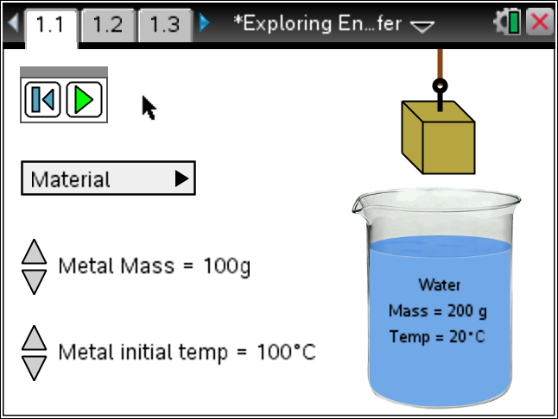

Materials
- TI-Nspire (handheld, APP, software)

Procedure
1. Discuss temperature with your tablemate. What do you know of it? How do you measure it? What does it mean? Why do we use it? What is it now? How do you know? How does it change?
2. Identify three facts about temperature to share with the class.
3. With your partner, explore the simulation. Read the Directions. If the Directions are missing, press Menu and select Directions.
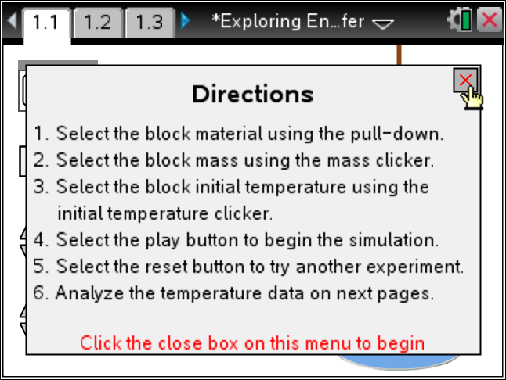
4. Play the simulation and explain what happens. Look at the pages following after you run the simulation.
Tech Tip: To Play the simulation, Pause, or Reset click on the
appropriate icon.  .
Change the initial mass and temperature of the metal by clicking on the  icon to increase or decrease.
5. What parameters can you change in the simulation? To what degree?
6. What is the ambient condition of the water?
7. Using your assigned metal run the simulation with your assigned initial temperature and mass. Fill in the chart below by using data from others in the class. Use the information at 25 seconds. You may need to run the simulation several times to get the data at 25 seconds, or estimate from the spreadsheet. Note your temperature change will be negative if your temperature drops.
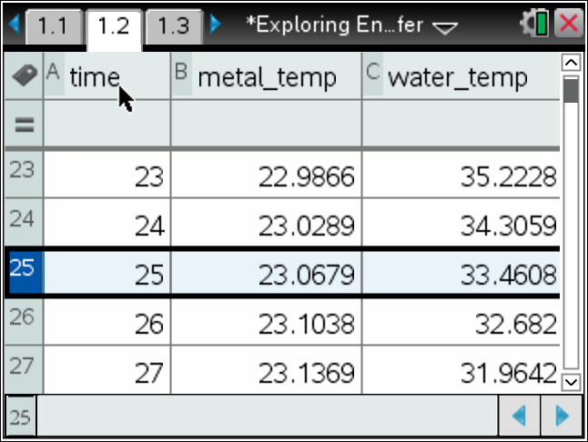
Your Metal: ________________
Initial Mass  (gram) | Metal Temp  (°C) | Water Temp  (°C) | Metal  Change in Temp | Water  Change in Temp
10
20
30
40
50
60
70
80
90
100
Look at the Scatter plot and/or set up a plot on the Data & Stat page.
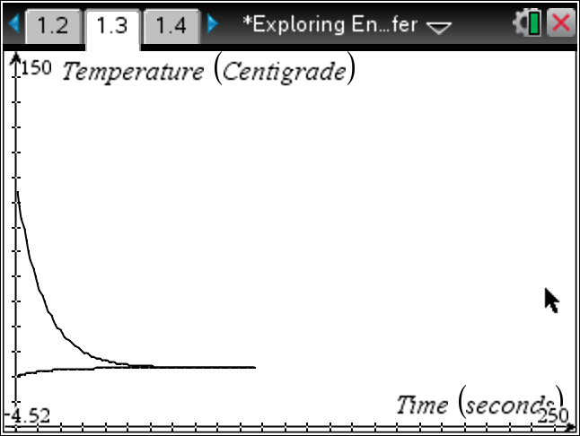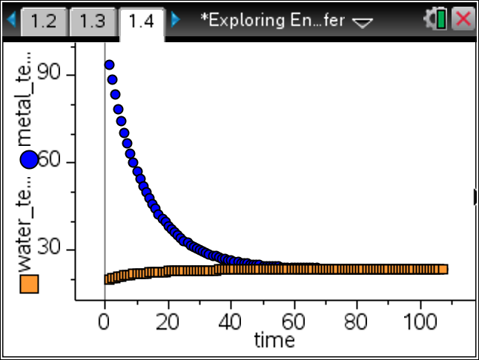
8. For a given metal what seems to determine rate of temperature change as it is placed in cooler water?
Tech Tip: To insert a calculator press /I and select Calculator.

9. Now let’s explore different metals with the same initial settings. Which metals seem to have a greater rate of temperature change? Share your finding with other groups and the class.
10. With the exception of Brass, these metals are all elements. Look at the Periodic Table and see if you can connect any of the parameters given with your rankings. Do some research on what metals make up Brass. Share your thoughts with the class.
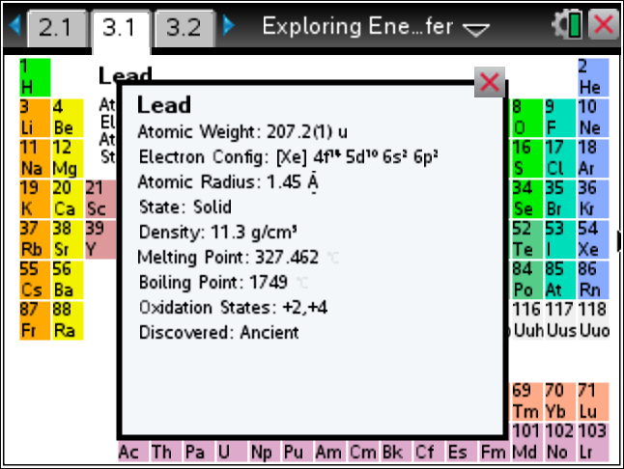
11. Determine the ratio of the [mass * change in temperature for the water] to the [mass * change in temperature for a selected metal]. Calculate this for several scenarios for the given or assigned metal.
Metal mass | Change in Metal Temp | Water mass | Change in Water Temp | (Mass_H2O* Temp_Chg)  --------------------------------- (Mass_Metal*Temp_Chg)
Tech Tip: To move between several pages press /£ and move to select the desired pages using £¤¢ ¡ to get where you are going and then ·.
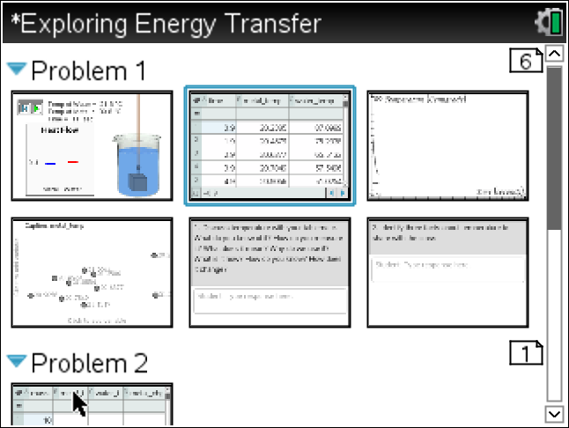
12. Check with other groups doing your same metal and with groups doing another metal. What can you conclude?
13. Move to the page showing the Specific Heat Capacity for the metals and water. This is a measure of how materials give up heat. Water has a high value and will lose, or gain heat energy at a rapid rate, while the metals have a low rate of heat energy transfer and therefore retain their heat.
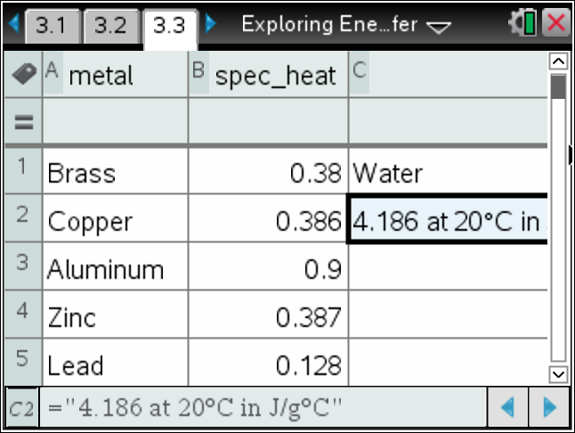
For your selected metal, calculate the product of the mass * spec_heat * Temp_Chg at some time during the event. For that same time, calculate these values for water [mass*spec_heat*Temp_Chg]. Repeat for different times.
What happens if you add these values?
14. Check this relationship for the other metals. Does it hold?

15. The Energy gained or lost should be the same in a closed system at any point in the experiment. We often use this relationship after the two materials reach the same temperature to determine unknown measures of one of the materials, or even to determine the name of one of the materials.
Given that the heat energy gained or lost is:
Create an experiment to determine one of the unknown values (mass, specific heat, initial Temperature, or Final Temperature) for one of the two materials is a system similar to the simulation.

