Science Objectives  - Students will plan an investigation to determine the relationships among the energy transferred, the type of matter, the mass, and the change in the average kinetic energy of the particles as measured by the temperature of the sample.  - Students will explore various scenarios by using the simulation, looking for patterns and relationships based on the nature of the materials used with the water.  - Students will develop an understanding of the inverse relationship between a materials density and its specific heat.  - Students will use the formula to connect the energy transfer with the change in temperature for each material (water and metal).  - Students will examine the properties of the metals in an effort to determine a relationship between these properties and heat-loss when interacting with room temperature water.  - The student will come to know that complex interactions occur between matter and energy and illustrate interactions between matter and energy including specific heat.  Vocabulary  - Joules  - Temperature  - Kinetic Energy  - Specific Heat  - Inverse  - Density  - Heat  About the Lesson  Given a set about of water at room temperature, students will explore the rate and magnitude of heat gain and loss of the water and a selected metal. Students will explore initial settings for the temperature and mass of a selected metal and then start the simulation examining the heat gain and loss and the rate at which these occur. Given the characteristics of each metal, students will look for relationships between the rate and magnitude of heat loss to water for the different metals.  TI-Nspire™ Navigator™  - Send out the Exploring Energy Transfer.tns file.  - The questions are Self-Check which you might want to change to Exam.  - Monitor student progress using Class Capture.  - Use Student Live Presenter to spotlight student answers and presentation of solutions.  NGSS  MS-PS3 Energy  Students who demonstrate understanding can:  MS-PS3-3. Apply scientific principles to design, construct, and test a device that either minimizes or maximizes thermal energy transfer.* [Clarification Statement: Examples of devices could include an insulated box, a solar cooker, and a Styrofoam cup.] [Assessment Boundary: Assessment does not include calculating the total amount of thermal energy transferred.]  Science and Engineering Practices  Science and Engineering Practices  Developing and Using Models  Develop a model to describe unobservable mechanisms. (MS-PS3-2)  Planning and Carrying Out Investigations  Plan an investigation individually and collaboratively, and in the design: identify independent and dependent variables and controls, what tools are needed to do the gathering, how measurements will be recorded, and how many data are needed to support a claim. (MS-PS3-4)  Analyzing and Interpreting Data  Construct and interpret graphical displays of data to identify linear and nonlinear relationships. (MS-PS3-1)  Constructing Explanations and Designing Solutions  Apply scientific ideas or principles to design, construct, and test a design of an object, tool, process or system. (MS-PS3-3)  Engaging in Argument from Evidence  Construct, use, and present oral and written arguments supported by empirical evidence and scientific reasoning to support or refute an explanation or a model for a phenomenon. (MS-PS3-5)  Connections to Nature of Science  Scientific Knowledge is Based on Empirical Evidence  Science knowledge is based upon logical and conceptual connections between evidence and explanations (MS-PS3-4),(MS-PS3-5)  Disciplinary Core Ideas  PS3.A: Definitions of Energy  Temperature is a measure of the average kinetic energy of particles of matter. The relationship between the temperature and the total energy of a system depends on the types, states, and amounts of matter present. (MS-PS3-3),(MS-PS3-4)  PS3.B: Conservation of Energy and Energy Transfer  The amount of energy transfer needed to change the temperature of a matter sample by a given amount depends on the nature of the matter, the size of the sample, and the environment. (MS-PS3-4)  Energy is spontaneously transferred out of hotter regions or objects and into colder ones. (MS-PS3-3)  ETS1.A: Defining and Delimiting an Engineering Problem  The more precisely a design task’s criteria and constraints can be defined, the more likely it is that the designed solution will be successful. Specification of constraints includes consideration of scientific principles and other relevant knowledge that is likely to limit possible solutions. (secondary to MS-PS3-3)  ETS1.B: Developing Possible Solutions  A solution needs to be tested, and then modified on the basis of the test results in order to improve it. There are systematic processes for evaluating solutions with respect to how well they meet criteria and constraints of a problem. (secondary to MS-PS3-3)  Crosscutting Concepts  Scale, Proportion, and Quantity  Proportional relationships (e.g. speed as the ratio of distance traveled to time taken) among different types of quantities provide information about the magnitude of properties and processes. (MS-PS3-1),(MS-PS3-4)  Systems and System Models  Models can be used to represent systems and their interactions – such as inputs, processes, and outputs – and energy and matter flows within systems. (MS-PS3-2)  Energy and Matter  Energy may take different forms (e.g. energy in fields, thermal energy, energy of motion). (MS-PS3-5)  The transfer of energy can be tracked as energy flows through a designed or natural system. (MS-PS3-3)  Activity Materials  - Compatible TI Technologies: TI- Nspire™ CX Handhelds,  TI-Nspire™ Apps for iPad®,  TI-Nspire™ Software | 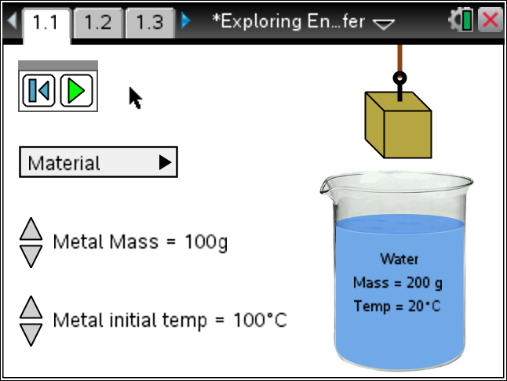  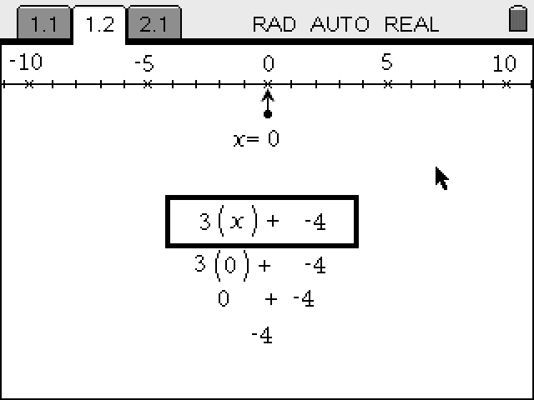  Tech Tips:  - This activity includes screen captures taken from the TI-Nspire CX handheld. It is also appropriate for use with the TI-Nspire family of products including TI-Nspire software and TI-Nspire App. Slight variations to these directions may be required if using other technologies besides the handheld.  - Watch for additional Tech Tips throughout the activity for the specific technology you are using.  - Access free tutorials at http://education.ti.com/calculators/pd/US/Online-Learning/Tutorials  Lesson Files:  - Exploring_Energy_Transfer_Teacher.doc  - Exploring_Energy_Transfer_Student.doc  TI-Nspire document  - Exploring Energy Transfer.tns
Materials
- TI-Nspire (handheld, APP, software)

Procedure
1. Discuss temperature with your tablemate. What do you know of it? How do you measure it? What does it mean? Why do we use it? What is it now? How do you know? How does it change?
Answer: Answers will vary. Look for these points.
They may know that temperature is the measure of the average kinetic energy of the molecules.
It is measured in Celsius, Kelvin and sometimes in Fahrenheit.
We use it to be aware of how it changes during an experiment or over a period of time.
See the thermometer on your classroom wall. If one is missing kids will guess, based on their intuition.
Change comes from the addition of energy, or extraction of same.
2. Identify three facts about temperature to share with the class.
Answer: Will vary. Units, it varies, wind chill, heat index, warm and cold fronts, stratification, varies with altitude, the material determines the speed at which the temperature will change.
3. With your partner, explore the simulation. Read the Directions. If the Directions are missing, press Menu and select Directions.
Note: The simulation allows you to select a metal, at a particular mass and initial temperature and then drop it into a set amount of water at a set temperature. Data is collected on the temperature of each material over a set amount of time.
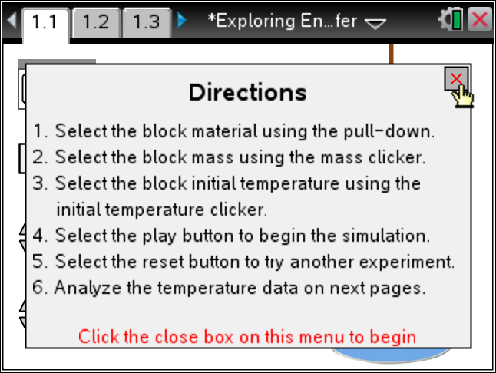
4. Play the simulation and explain what happens. Look at the pages following after you run the simulation.
Answer: The material drops into the water and the temperatures change, the metal drops and the water increases. You can see the heat flow, energy out of the metal, and into the water. A graph and table are shown on the next pages.
Tech Tip: To Play the simulation, Pause, or Reset click on the
appropriate icon.  .
Change the initial mass and temperature of the metal by clicking on the  icon to increase or decrease.
5. What parameters can you change in the simulation? To what degree?
Answer: The type of metal, the mass of the material (10 grams to 200 grams by 10 gram steps) and the initial temperature of the metal (50 to 150 degress Celcius, by syeps of 10 degrees).
Adjust all the parameters in the simulation, but be systematic so you can develop some understanding of how these change the wave.
6. What is the ambient condition of the water?
Answer: 200 grams at 20 degrees Celsius.
7. Using your assigned metal run the simulation with your assigned initial temperature and mass. Fill in the chart below by using data from others in the class. Use the information at 25 seconds. You may need to run the simulation several times to get the data at 25 seconds, or estimate from the spreadsheet. Note your temperature change will be negative if your temperature drops.
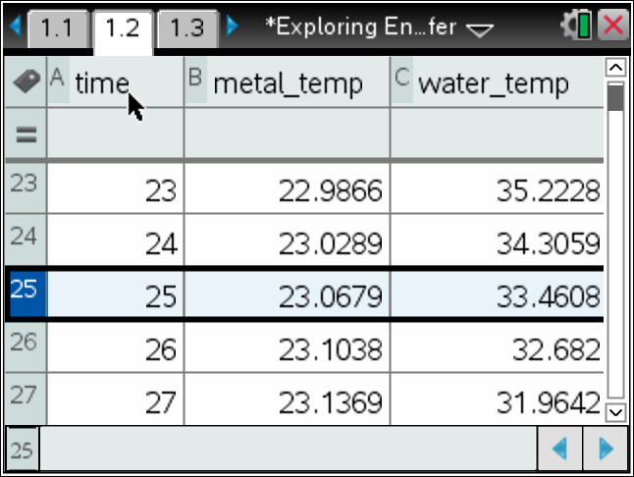
Your Metal: ________________
Initial Mass  (gram) | Metal Temp  (°C) | Water Temp  (°C) | Metal  Change in Temp | Water  Change in Temp
10
20
30
40
50
60
70
80
90
100
Note: Assign a metal and initial temperature for everyone in the group, and then vary the mass by team. Depending on your selection, the temperature changes will be completed at the time selected. To repeat this, change the metal and initial temperature, or use this for the other groups.
Look at the Scatter plot and/or set up a plot on the Data & Stat page.
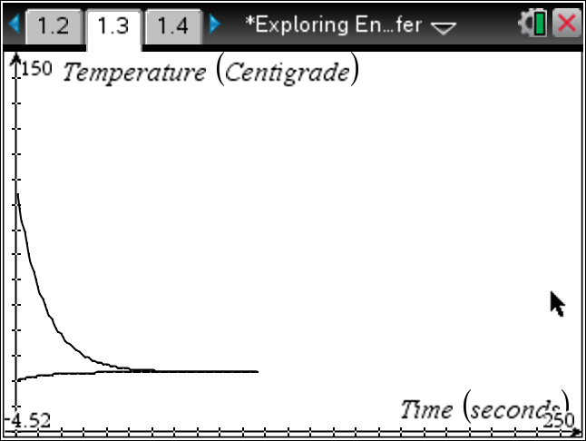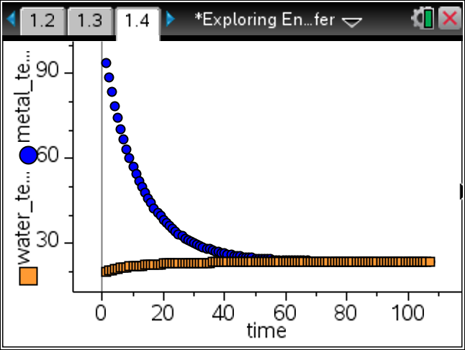
8. For a given metal what seems to determine rate of temperature change as it is placed in cooler water?
Answer: As the mass increases, the rate increases.
Tech Tip: To insert a calculator press /I and select Calculator.

9. Now let’s explore different metals with the same initial settings. Which metals seem to have a greater rate of temperature change? Share your finding with other groups and the class.
Answer: From least to most – Lead, Brass, Copper, Zinc, Aluminum.
10. With the exception of Brass, these metals are all elements. Look at the Periodic Table and see if you can connect any of the parameters given with your rankings. Do some research on what metals make up Brass. Share your thoughts with the class.
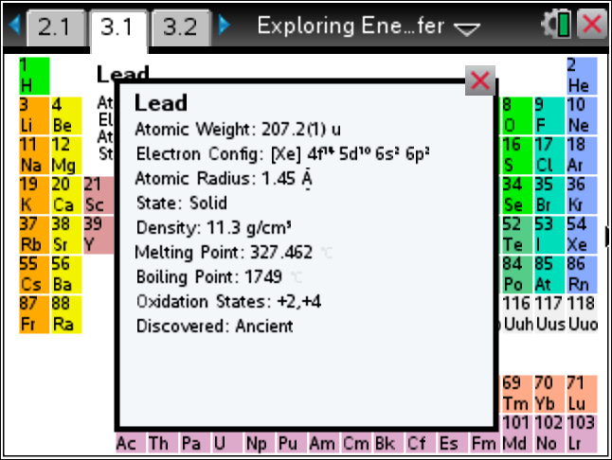
Answer: Answers will vary. Our goal is to help the students connect the properties of these metals with the specific heat capacity, so mass is the measured parameter. Brass is an alloy made of copper and zinc.
11. Determine the ratio of the [mass * change in temperature for the water] to the [mass * change in temperature for a selected metal]. Calculate this for several scenarios for the given or assigned metal.
Metal mass | Change in Metal Temp | Water mass | Change in Water Temp | (Mass_H2O* Temp_Chg)  --------------------------------- (Mass_Metal*Temp_Chg)
Note: This ratio should be the same reflecting the ratios of the specific heat of the metal to the specific heat of water.
Tech Tip: To move between several pages press /£ and move to select the desired pages using £¤¢ ¡ to get where you are going and then ·.
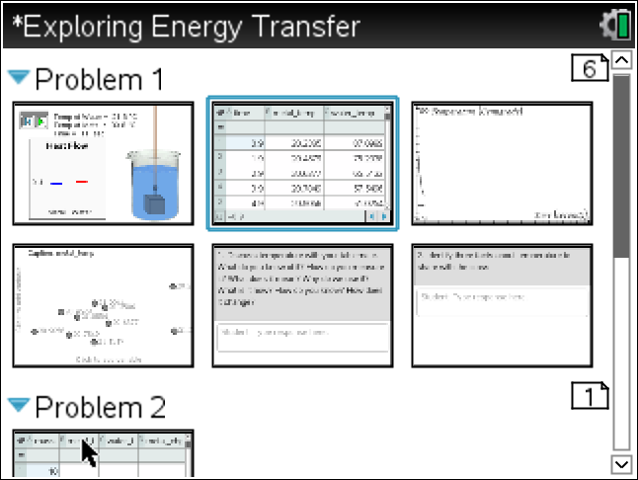
12. Check with other groups doing your same metal and with groups doing another metal. What can you conclude?
Note: Trying to lead the kids to the formula:
You may want to stop here, or continue to the development of this relationship.
13. Move to the page showing the Specific Heat Capacity for the metals and water. This is a measure of how materials give up heat. Water has a high value and will lose, or gain heat energy at a rapid rate, while the metals have a low rate of heat energy transfer and therefore retain their heat.
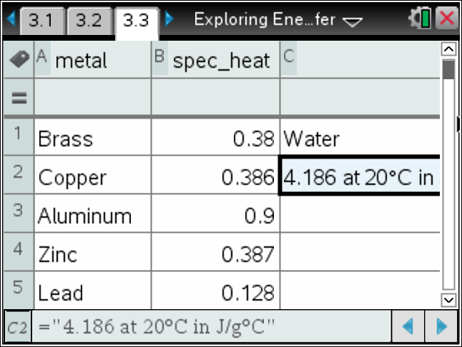
For your selected metal, calculate the product of the mass * spec_heat * Temp_Chg at some time during the event. For that same time, calculate these values for water [mass*spec_heat*Temp_Chg]. Repeat for different times.
What happens if you add these values?
Answer: The sum of the two values should be zero.
14. Check this relationship for the other metals. Does it hold?
Answer: Yes

15. The Energy gained or lost should be the same in a closed system at any point in the experiment. We often use this relationship after the two materials reach the same temperature to determine unknown measures of one of the materials, or even to determine the name of one of the materials.
Given that the heat energy gained or lost is:
Create an experiment to determine one of the unknown values (mass, specific heat, initial Temperature, or Final Temperature) for one of the two materials is a system similar to the simulation.
Note: Answers will vary. You might use some solutions for an assessment or differentiate by assigning some groups simpler unknowns like mass, and some more complicated unknowns.

TI-Nspire Navigator Opportunities
Make a student a Live Presenter to demonstrate what they discover along the way.
Use Quick Poll as Formative Assessment.

Wrap Up
Students should compose a lab report, which includes their data, analysis, and a discussion of the results of their test. Students may choose to use the TI-Nspire™ Student Edition software to convert their .tns files to PublishView Documents.

Extensions
Students can measure heat gain or loss in a Calorimeter, using a EZ-Temp and known metals.

Assessment
- Use the questions in the Nspire document as Quick Polls during the lesson as needed.
- The questions in the Nspire document are Self-Check, so students can check their answers.
- Use Ranking Task (see link below).

Reference Links:
Science in Action
Hands-On and Interactive Computer Tasks From the 2009 Science Assessment
National Assessment of Educational Progress at Grades 4, 8, and 12

GRADE 12
25% of students designed and conducted an investigation using a simulated calorimeter, and related patterns in temperature changes in two different metals to decide which metal has the higher specific heat capacity. Students had to interpret this complex set of data and relate it to their knowledge that the metal with the higher specific heat capacity caused the temperature of the water to change more than the metal with the lower specific heat capacity

Energy Transfer
In this 20-minute task, students investigate which metal would be better for making the bottom of a cooking pan. While designing and conducting their investigations, students use a simulated calorimeter to test the specific heat capacities of two metals that could be used for the bottom of the pan.

http://nces.ed.gov/nationsreportcard/pdf/main2009/2012468.pdf

- Specific Heat Capacity Table:
http://hyperphysics.phy-astr.gsu.edu/hbase/tables/sphtt.html
- Grade 8 Science TEKS:
http://misdscience.wikispaces.com/file/view/TAKS+Info+Book+Grade+8.pdf
- Physlet Physics: Christian and Belloni:
Chapter 19: Heat and Temperature
http://www.uvm.edu/~mfuris/INTRO_PHYSLETS/contents/thermo/heat/default.html
- The Physics Classroom:
Thermal Physics - Lesson 2 Calorimetry:
http://www.physicsclassroom.com/class/thermalP/u18l2b.cfm

- Ranking Task 1: Heat and Temperature I:
http://faculty.sdmiramar.edu/gbochicchio/heatrev.doc

