In this celebration of π-DAY you will explore the nature of the number π.

- In GSP construct a large, medium, and small circle.
- Measure each circle.
- Determine the Diameter of each circle.
- Now construct a small circle. Measure it and determine its diameter.
- Copy this circle 37 times.
- Now we wish to Circle the Circles. To do this, grab one of the 37 baby circles, and move it so that its center is on the edge of the circle of choice.
- Continue the process until you have completed circling the circle.
- Count the number of circles needed to circle the chosen circle.
- Repeat the process until all three circles are circled. Make more babies as needed.
- Report the number of circles needed to circle each circle with the diameter of each circle. Place this data in your calculator.
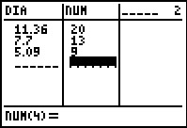
- Plot the data Number of Baby Circles vs. Diameter of the Circle Circled. Report the plot and window.
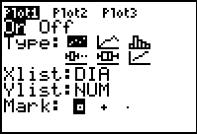
- Get the mathematical model for the plot. Use Guess and Test, or Regression as needed. Produce an image of the plot and the function on the same graph.
- Relate the slope in your model to the data and images in GSP.
- For each circle calculate the ratio below:
- What do you think this value should be? Do you see a pattern?
- This value should be π. Determine how far you are off by calculating the Percent Error. Do it for all three circles.
- report and document and print or email to DAY [dyoung@fayar.net]

