Now that you have the four lists from Part I of the Trip to Tulsa simulation, we would like to identify the point of intersection of these two trips. This point could represent the “time” and place along the trip that the paths meet.

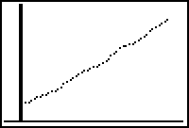
- Set up the Scatter Plot of the Time TO Tulsa, and the Distance TO Tulsa.
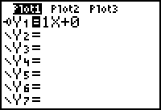
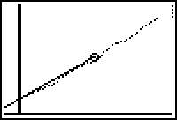
- Put the “general” linear equation in the □ Editor using “Bubble baby”. Starting with 1 as the Slope, and 0 as the Y-Intercept.
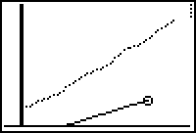
- Now look at the graph, and adjust the Slope and then the Y-Intercept of the model, until you get the best fit.
- Report this equation. Give the Slope and the Y-Intercept, using units of measure.
- Repeat the process for the trip back FROM Tulsa. Report this equation and give the Slope and Y-Intercept, using units of measure.
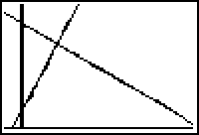
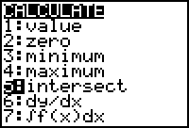
- Now we wish to use the Intercept option on the calculator to identify the time and distance at which the paths cross.
- Report the Time and Distance of this intersection using units of measure.
- Verify this location/solution using TII, or by hand.
- Now we need to find this point on the actual trip to Tulsa. To do this we must scale the times and distances up to the real measures. We said the simulated distance to Tulsa should be 300 centimeters (from home at 100 centimeters to Tulsa at 400 centimeters). If it was really 200 miles to Tulsa, we would have a conversion rate of 300 centimeters to 200 miles, or 1 centimeter = 200  300 miles = 2/3 miles. This means that if I had a distance of 50 centimeters in my model, that would be 50 centimeters * 2/3 miles per centimeter = 33.33 miles. Identify the real scale value for your Trip from Fayetteville to Tulsa and calculate your conversion rate. Report the True Distance to Tulsa (see Mapping on the Algebra II web page or a map) along with the conversion rate and the source of the True distance.
- Now we will us use this conversion rate to see if we can find where the intersection occurred. If I found that the intersection of my simulation occurred at Y=255 centimeters, this would mean that the intersection occurred 155 centimeters from home (recall that we started at Home at the 100 centimeter mark). Using the conversion rate from question #9 (in my case 1 centimeter = 2/3 miles) get the distance from Fayetteville that the intersection occurred from question #7 (155 * 2/3 = 103.33 miles from Fayetteville). Report this distance, using a complete sentence (using nouns and verbs and ly-words).
- Use a Mapping Page of your choice (see #9) and find the place on the map at that distance from Fayetteville, on the path to Tulsa. Identify this place by map, and or name.
- Now let us use the suggested driving time from Fayetteville to Tulsa, to scale the time from centiseconds to minutes, and then give the time, after starting the trip, that the intersection will occur. Use 4 seconds as the normal driving time, for our simulation. Locate a suggested driving time, and report it, giving the source of this information, and then use it to scale the time. For example, if Yahoo says that you should take 5 hours and 30 minutes to get to Tulsa from Fayetteville, the scale will be between 4 seconds and 5.5 hours. Report, in a complete sentence (using nouns and verbs and ly-words), when this intersection would occur, in the Real deal.
- Submit the answers to all the questions listed above, the graph of the two Scatter Plots, with the corresponding “Bubble Baby” linear equations including the WINDOW, and the names of your team members to me to complete Part II.

