PARAFUN

In this investigation, an individual lab, you will explore the variables needed to construct regular polygons on the TI-83/82.

- Load the PARAFUN program in your TI-83/82, and run the program.
- Explore the values for Tstep so that you can obtain the basic polygons (three sides, four sides, five sides, etc. ).
- Report the values in Lists on your Calculators as shown below.
Collect information for as many-sided figure as possible.
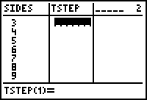

- Capture each graph with the graph link, and paste it in your write-up, in Word.
- Make a Scatter Plot of the data, and do a Bubble Baby or Regression to fit the pattern. Report the equation, and type of Model, as well as the graph.
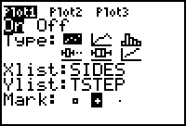

- Compare this equation to the following relationship for angles and sides in a regular polygon. Angle = (sides - 2) * 180/ sides
- Explore the variations of the graph when you change your MODE to Dot rather than Connected, and Radians rather than Degrees, or any variations of these. Share one graph that you feel is unique; give the Tstep, and other settings with the image.

