Making Cents of Math:
Linear Relationship between Weight and Quantity
The slope of a line describes its steepness. The numerical value of the slope can represent a number of other important mathematical concepts. Given any two points on a line, (x1, y1) and (x2, y2), the slope of that line can be computed using the formula:
$m=\frac{y_{2}−y_{1}}{x_{2}−x_{1}}$
where m represents the slope of the line, x1 and x2 represent the independent variable coordinates, and y1 and y2 represent the dependent variable coordinates.
In this activity you will use a Force Sensor to collect a linear set of data points. Specifically, you will measure the weight of 8, 16, 24… pennies. You will then analyze this data and interpret the meaning of the slope as it relates to the independent and dependent variables. A model will help you predict future measurements and interpret past results.

objectives
Collect weight versus number data for a collection of identical pennies.
Model the weight versus number data using a linear equation.
Interpret the slope and intercept values from the linear model.

MATERIALS
TI-83 Plus or TI-84 Plus graphing calculator  EasyData application  data-collection interface  Vernier Force Sensor | Styrofoam coffee cup  string  32 post-1982 pennies

PROCEDURE
During this activity the Force Sensor will be used to determine the weight of the pennies placed in the cup. The sensor must be positioned as shown in the setup diagram and should remain level at all times.
1. Use a pencil to poke small holes on opposite sides of the coffee cup near the top rim. Thread a piece of string through the holes, and then tie the ends of the string together to hang the cup.
2. Suspend the cup from the hook on the end of the Force Sensor.
3. Separate your pennies into four stacks of eight pennies each. As you do this, confirm that all pennies are dated after 1982.
4. Prepare the Force Sensor and the cup for data collection.
- Turn on the calculator.
- Set the Force Sensor range switch to 10 N.
- Connect the Force Sensor, data-collection interface, and calculator.

5. Set up EasyData for data collection.
- Start the EasyData application, if it is not already running.
- Select  from the Main screen, and then select New to reset the application.
- Select  from the Main screen, and then select Events with Entry.

6. In this experiment you only want to measure the weight of the pennies, and not of the cup and string. To account for the weight of the cup and string, you need to zero the Force Sensor.
- Hang the empty cup from the Force Sensor using the string.
- Select from the Main screen, and then select Zero…
- Wait until the cup stops swinging so that the reading is stable. Select  to zero the Force Sensor. This will set the current weight reading to zero, and so ignore the weight of the cup.

7. You are now ready to collect weight versus number of penny data.
- Select  to begin data collection.
- Select  to record the weight of zero pennies.
- Enter 0, for the number of pennies now in the cup. Select  to store this weight-number data pair.
- Place eight pennies in the cup, and allow the cup to stop swinging.
- Select to record the weight of eight pennies.
- Enter 8, which is the number of pennies in the cup. Select to store this weight-number data pair.
- Continue with this procedure using 16, 24 and 32 pennies. In each step, enter the total number of pennies in the cup.
- Select  when you have finished collecting data.

8. The calculator screen shows a graph of weight versus number of pennies. The graph should appear linear. If you want to repeat data collection, select  and repeat Step 7.
9. Once you are satisfied with the graph, select to return to the Main screen. Exit EasyData by selecting  from the Main screen and then selecting .

analysis
1. Before you can work with the data on the calculator, you need to redisplay the graph outside of EasyData.
- Press 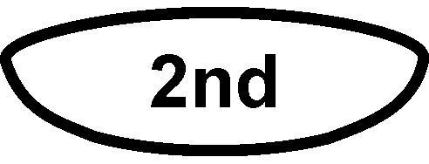 [STAT PLOT].
- Press  to select Plot1 and then press again to select On.
- Press .
- Press  until ZoomStat is highlighted; press to display a graph with the x and y ranges set to fill the screen with data.
- Press  to determine the coordinates of a point on the graph using the cursor keys.

2. Round the values of your points to the nearest 0.01 Newton and record them in the Data Table on the Data Collection and Analysis sheet.
3. The slope of a line can be determined from two points on the line. Using the two points, the slope is defined as the ratio of the change in a pair of y-values to the change in their corresponding x-values.
⇒ Answer Questions 1–6 on the Data Collection and Analysis sheet.
4. Next plot the line whose equation you just determined. You can plot the line on the same graph as the data.
- Press 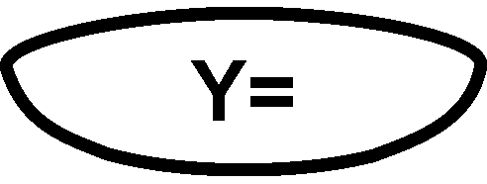.
- Press  to remove any existing equation.
- Enter the equation for the line you determined into the Y1 field. For example, if your line is y = 4x + 3, enter 4*x+3.
- Press  until the icon to the left of Y1 is blinking. Press until a bold diagonal line is shown which will display your model with a thick line.
- Press  to see the data with the model equation superimposed

⇒ Answer Question 7 on the Data Collection and Analysis sheet.
5. Instead of using a model from only two points, you can use the calculator to do a linear regression, a type of least-squares regression, on all the data points.
- Press  and use the cursor keys to highlight CALC.
- Press the number adjacent to LinReg(ax+b) to copy the command to the home screen.
- Press [L1] 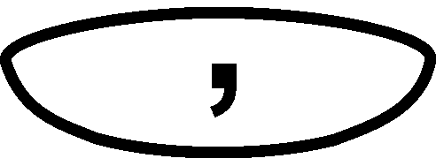 [L2] to enter the lists containing the data.
- Press  and use the cursor keys to highlight Y-VARS.
- Select Function by pressing .
- Press to copy Y1 to the expression.
On the home screen, you will now see the entry LinReg(ax+b) L1, L2, Y1. This command will perform a linear regression using the x-values in L1 and the y-values in L2. The resulting regression line will be stored in equation variable Y1.
- Press to perform the linear regression. Use the parameters a and b to write down the regression equation in your Data Table. Use the parameters a and b to write the equation of the calculator’s best-fit line, and record it as the regression equation in the Data Table on the Data Collection and Analysis sheet.
- Press to see the graph.

⇒ Answer Questions 8–10 on the Data Collection and Analysis sheet.

EXTENSION
The data you collected in this activity depends on the fact that your pennies were all dated after 1982. Repeat this activity with a group of pennies dated before 1982. Use the modeling procedure described in this activity to find the average weight of a pre-1982 penny. Look in a coin book and determine why the model for pre-1982 pennies differs from the model for post 1982 pennies. How do your values for the weights of pre-1982 and post-1982 pennies compare with their official weights?

Data Collection and Analysis | Name  Date
DATA TABLE

Number of pennies | Weight in Newtons
0
8
16
24
32
Model equation
Regression equation

questions
1. Find the slope of the line passing through any two points in your table and record it below:
m = ______________

2. What do the x-values in this problem represent?

3. What do the y-values represent?

4. If slope can be described as change in y over change in x, then from Questions 2 and 3 above, slope represents the change in the_________________ divided by the change in the ___________________.

5. Simplifying the answer to the previous question, the value for slope in this data set represents the ______________________ per ______________________.

6. The slope-intercept form of a line is y = mx + b, where m represents the slope and b is the y-intercept. The y-intercept is the y value when x = 0. Determine this value from the table and record it below:
y-intercept: b = ________________

Use the values for m and b found above to write the equation of the line through your data. Record the equation in your Data Table above as the model equation.

7. Is your line a good fit for the data?

8. Are the values of a and b in the linear regression equation consistent with your results from Step 4?

9. How would using quarters instead of pennies affect the slope of the graph?

10. What would the slope of a graph made with quarters represent?

APPLICATIONS
Use your regression equation from the activity to answer the following questions.
1. Courtney has been saving her pennies for a rainy day. She has lived in the desert all of her life. By the time the rainy day arrives, she has saved $4,763.89! What is the total weight of her pennies?
_______________ Newtons

2. While cleaning out the attic Kelly finds an antique milk can that contains a large number of pennies. He weighs the can of pennies and finds that it weighs 450 Newtons. He then empties the can and weighs it. He finds that the can weighs 100 N without the pennies. Use your model to find how much money Kelly has found.
$____________________

