Air Resistance
Concepts  - Relationship between mass and air resistance  - Mathematical models of physical phenomena  Materials  - TI-Nspire™ Math and Science Learning Technology  - Five basket-style coffee filters  - Pen or pencil  - Vernier® CBR 2™ (Calculator-Based Ranger™ 2) or Go! ™Motion motion sensor  - Blank sheet of paper  - AirResistance.tns file | Overview  In this activity, students will collect data on the rate at which coffee filters fall. They will attempt to determine the terminal velocity for different numbers of falling filters. They will then explore the relationship between mass and terminal velocity.

Teacher Preparation
Students will probably be familiar with the idea that objects fall at different rates in air. Before beginning this activity, make sure students understand that these differences in falling rate are entirely due to the presence of air—some students may have the misconception that heavier objects fall more quickly than lighter objects.
- The screenshots on the following pages demonstrate expected student results.
- Refer to the screenshots for a preview of the student TI-Nspire™ document (.tns file.)
Classroom Management
- This activity is designed to be student-centered, with the teacher acting as a facilitator while students work cooperatively.

- Students should record their answers to the questions on a separate sheet of paper.
- The ideas contained in the following pages are intended to provide a framework as to how the activity will progress.
- Suggestions are also provided to help ensure that the objectives for this activity are met.
- In some cases, these instructions are specific to those students using TI-Nspire™ math and science learning handheld devices, but the activity can easily be done using
TI-Nspire™ computer software.

The following questions will guide student exploration during this activity:
- How does the mass of an object affect its terminal velocity?
- What is the best mathematical model for the drag force?

Part 1: Collecting Terminal Velocity Data
- First, students will use a Vernier® CBR 2™ or Go!™Motion motion sensor to collect data on the velocity of a falling coffee filter.
- Students should clamp or hold their motion sensors as high above the ground as possible; a distance of at least 2 m is ideal.
- When students reach first Data & Statistics page, they should connect the motion sensor to their handhelds.
- Select the Data & Statistics application.
- This should activate the motion sensor, and a distance display should appear in the data collection box (Figure 1).
- Select Menu 1: Experiment, 3: Set Up Collection, 1: Time Graph to specify the time between samples of 0.05 s and the experiment length of 3 s (Figure 2).
- Click OK.

- One student from each group should now hold a single coffee filter below the wire mesh of the motion sensor, as shown in Figure 3.
- The coffee filter should be no less than 0.2 m from the motion sensor.
- Students can use the distance display on the handheld to determine the distance from the sensor to the filter.
- Next, students will begin data collection (press ►); and release the filters.
- If time allows, have students practice releasing the filters several times.
- They should be able to release the filters so that they fall straight down with little sideways motion.
- Ideally, the students' motion graphs should resemble the one shown in Figure 4.
Q1. Describe the characteristics of the graph.
Answer: The graph should have a short region of curvature, followed by a long linear region.
- The linear region represents the time during which the filter was falling at constant velocity.
- Next, students repeat the experiment using two coffee filters.
- Move to the next page which is labeled 2 Filters.
- Press ►, and click the Store option
(Figure 5).
- Click OK to save the first data set dc01.
- The data for two coffee filters will be found in dc02.
- Have the students set the axis labels to dc02.time and dc02.dist1 so they will see the data being collected.
- Repeat this process for three, four, and five filters.
- If time is short, you may have each group carry out the experiment with a different number of coffee filters, and then pool the data using TI-Nspire™ Computer Link software.

- To graph each data set, students will plot dc01.dist1 vs. dc01.time, dc02.dist1 vs. dc02.time, etc. on subsequent
Data & Statistics application pages 1.3 to 1.7.
- On each of the graphs students should fit a straight line to the linear portions of their graphs.
- They will use the Movable Line tool in the Data & Statistics application page to produce the line that best fits their data (Figure 6).
- They should record the terminal velocity of the filter (the slope of the best-fit line) in Lists & Spreadsheet application page 1.8.
Q2. Why is using this movable line tool preferable to performing a linear regression in this case?
Answer: The data set contains regions at the beginning and the end that are nonlinear.
- A linear regression would attempt to fit a line to the entire data set, not just the linear portion.
- As an extension activity, you could have students “trim” the nonlinear data from their data sets; and then carry out a linear regression on the data.
- They can then compare the terminal velocities they determined using both methods, and discuss any differences.
- Students should store their best-fit terminal velocities in Lists & Spreadsheet application page 1.8 (Figure 7).

Part 2: Exploring the Relationships between Mass, Drag Force, and Terminal Velocity
- First, students calculate the square of the terminal velocity for each of their trials in Lists & Spreadsheet application page 1.8 (Figure 8).
- Next, students move to pages 1.9 and 1.10, which contains empty Data & Statistics application pages.
- They plot vterm vs. mass and vtermsq vs. mass, and use the Movable Line tool to determine which plot produces the best fit to the data (Figures 9 and 10).
Q3. From your graphs, which proportionality is consistent with your data; that is, which graph is closer to a straight line that goes through the origin?
- Why should the line go through the origin?
Answer: The graph of v_{T}² vs. mass is closer to a direct relationship than is the graph of v_{T} vs. mass.
- In particular, the v_{T}² vs. mass graph passes close to the origin, while the v_{T} vs. mass graph does not.
- The data therefore suggest that, for these coffee filters, mass is proportional to v_{T}².
- Note that both data sets are very close to linear.
- Students may have difficulty determining which data set gives the best fit to the linear relationship.
- Remind them that, for this relationship, it is important that the best-fit line pass through the origin; this will help them differentiate between the two lines.
Q4. From the choice of proportionalities in the previous step, which of the drag force relationships (–bv or –cv²) appears to model the real data better?
Answer: Since the v_{T}² vs. mass graph is close to a proportionality, it appears that the drag force is proportional to the square of the velocity, or
F_{drag} = –cv².
Q5. If one filter falls in time t, how long would it take four filters to fall, assuming the filters are always moving at terminal velocity?
Answer: Since the graphs show that terminal velocity squared is directly proportional to mass, the terminal velocity of four filters is about twice as large as the terminal velocity of one filter.
- Therefore, if one filter falls in time t, four filters would fall in time 0.5t.
Q6. Make a sketch of velocity vs. time for a falling coffee filter. On the graph, label the following:
- region(s) in which the filter is accelerating (if any)
- region(s) in which the filter is falling at constant velocity
- the terminal velocity of the filter

Answer:

Q7. Describe the forces acting on the filter in each region.
- Explain how these forces produce the motion you have drawn.
Answer: At all times during the filter's fall, gravity is pulling it down, and air resistance (drag) is resisting its fall.
- During the time when the filter is accelerating, gravitational force is greater than drag force; so the net force on the filter is downward, and the filter accelerates.
- During the time when the filter is falling at constant velocity, gravitational force is equal to drag force.
- The net force on the filter is therefore zero, and the filter does not accelerate.
Q8. Why does a coffee filter reach terminal velocity after falling less than 1 m, but a basketball or other heavier object must fall farther before reaching terminal velocity?
Answer: Drag force is proportional to velocity (or velocity squared), so it increases as long as the falling object is accelerating.
- The object stops accelerating when the drag force equals the weight of the object.
- Therefore, heavier objects must fall a greater distance (a longer time) to reach a high enough velocity for the drag force to balance their weight.

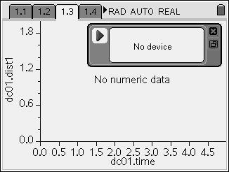
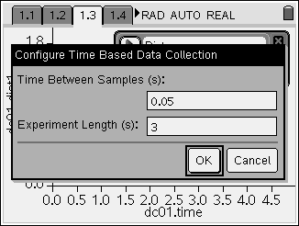
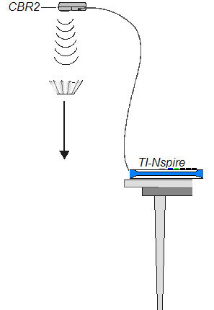
Figure 1
Figure 2
Figure 3

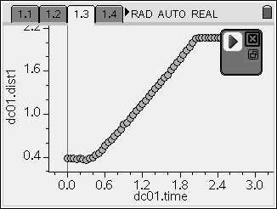
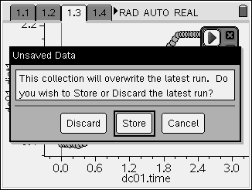
Figure 4
Figure 5

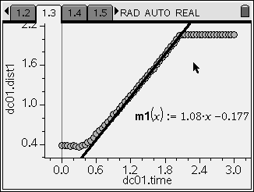
Figure 6
Figure 7

Figure 8
Figure 9
Figure 10

Time (s)
Velocity (m/s)
Filter accelerating
Filter falling at constant velocity
Terminal velocity

Student TI-Nspire™ File: AirResistance.tns
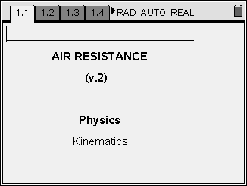

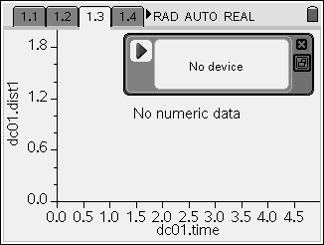
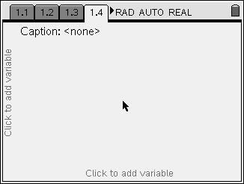
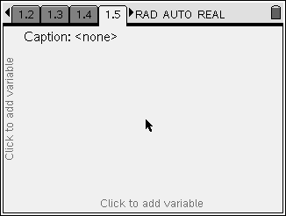
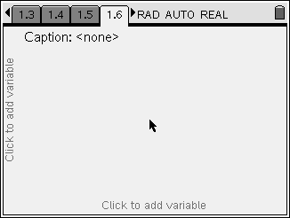
Figure 11
Figure 12
Figure 13
Figure 14
Figure 15
Figure 16

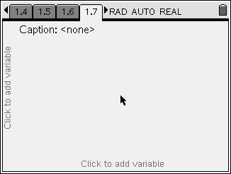
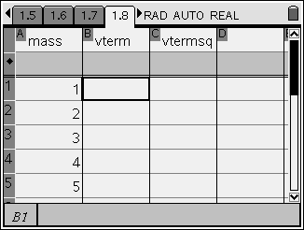
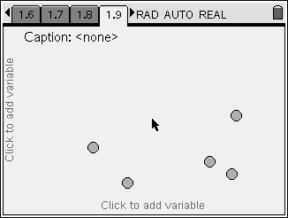
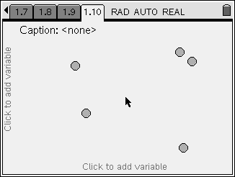
Figure 17
Figure 18
Figure 19
Figure 20

This page intentionally left blank.

