Charging Up, Charging Down: Exponential Models
A capacitor is an electronic component used to store electrical energy. Many of the devices you use on a daily basis, such as your calculator, rely on capacitors as part of their electronic circuitry. Cameras use capacitors, too. Before using an electronic flash, energy is transferred from the camera battery to a capacitor. That energy quickly dissipates in the flash unit when you press the shutter release. The result is a bright flash!
When a capacitor discharges through a resistor, the voltage (or potential) across the capacitor drops off rapidly at first, and then decreases more slowly as the energy dissipates. The action of a discharging capacitor is described by the exponential model
$$y={\text{Ve}}^{−\text{Kx}}$$
where y represents the voltage across the capacitor at any time x; V is the capacitor’s initial voltage; K is a positive parameter that depends on the physical characteristics of the capacitor and resistor; and e is a special number called the base of the natural logarithm. The number e, about 2.718, is similar to π in that it never repeats and never terminates. It is a common base used in exponential expressions.
In this activity, you will collect voltage data from a discharging capacitor using a Voltage Probe. The capacitor will be connected to another circuit element called a resistor, which controls the rate at which the capacitor discharges. You will then compare the exponential model to the data you collect.
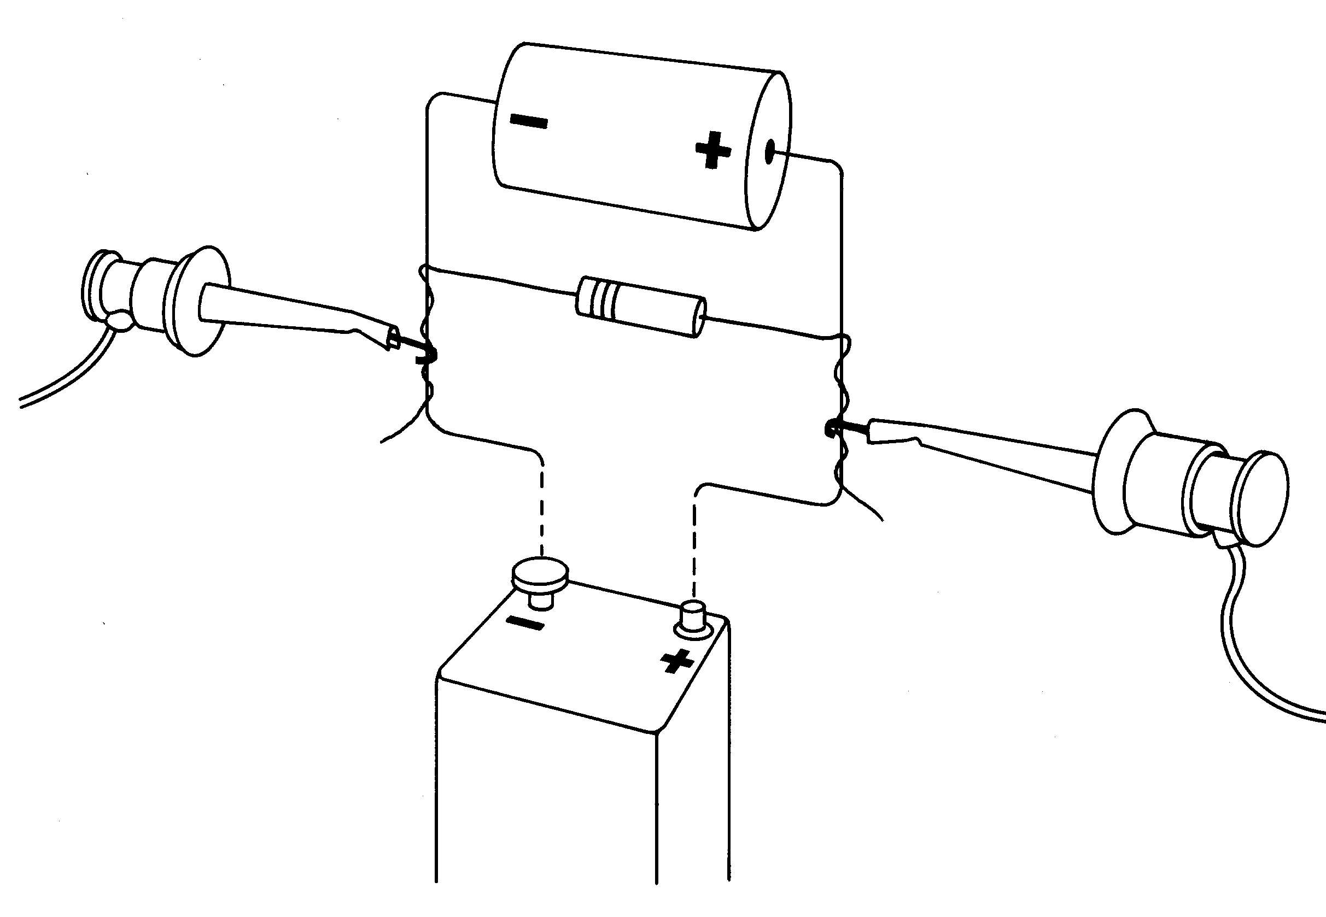
objectives
- Record potential versus time data for a discharging capacitor.
- Model potential data using an exponential function.
MATERIALS
TI-83 Plus or TI-84 Plus graphing calculator  EasyData application  data-collection interface  Voltage Probe | 100-kΩ resistor  220-µF capacitor  9-volt battery
PROCEDURE
1. Connect the circuit as shown with the 220-μF capacitor and the 100-kΩ resistor. Record the values of the resistor (R) and capacitor (C), as well as any tolerance values marked on them, in the Data Table on the Data Collection and Analysis sheet.
2. Prepare the Voltage Probe for data collection.
- Turn on your calculator.
- Connect the Voltage Probe, data-collection interface, and calculator.
- Connect the clip leads on the Voltage Probe across the capacitor, with the red (positive lead) to the positive side of the capacitor. Connect the black lead to the other side of the capacitor. Connect the resistor across the capacitor as shown.

3. Set up EasyData for data collection.
- Start the EasyData application, if it is not already running.
- Select  from the Main screen, and then select New to reset the application.
- Select  from the Main screen, then select Time Graph…
- Select  on the Time Graph Settings screen.
- Enter 0.5 as the time between samples in seconds.
- Select .
- Enter 100 as the number of samples and select .
- Select  to return to the Main screen.

4. Verify that the wires are in the position illustrated, which will confirm that the capacitor is charged.
5. Remove the battery from the circuit, and quickly select  to begin data collection. After data collection is complete, a graph of potential versus time will be displayed.
6. Select  to return to the Main screen.
7. Exit EasyData by selecting , and then selecting .
8. Print or sketch the graph of potential versus time. To return to a graph of the data outside of EasyData,
- Press  [STAT PLOT].
- Press  to select Plot1 and press again to select On.
- Press .
- Press  until ZoomStat is highlighted; press to display a graph with x and y ranges set to fill the screen with data.
- Press  to determine the coordinates of a point on the graph using the cursor keys.
Analysis
1. The standard model for the capacitor discharge curve is an exponential. You can now fit a curve of the form y = Ve–Kx to your data, where x is time and y is the capacitor voltage.
Using the graph now on the calculator screen, find the y-intercept and move the flashing cursor to it to read the value. Round the value to the nearest hundredth, and record this voltage V in the Data Table on the Data Collection and Analysis sheet for use in the next step.
2. In order to graph the model with the data, you must enter the model equation and initial values for V and K. As a first guess, use K = 1. In a moment you will adjust K to improve the fit of the model to the data.
- Press [quit] to return to the home screen.
- Enter your value for V. Press  V to store the value in the variable V.
- Enter 1, your first guess for K. Press K to store the value in the variable K.
- Press 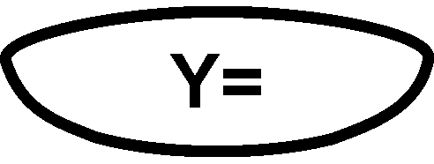.
- Press  to remove any existing equation.
- Enter V*e^(–K*X) in the Y1 field. Access e^ using [e^{x}].
- Press  until the icon to the left of Y1 is blinking. Press until a bold diagonal line is shown to display your model with a thick line.
- Press  to see the data with the model graph superimposed.
- Press [quit] to return to the home screen.

3. To obtain a good fit, you will need to adjust the value of K. Enter a new value for K, and display the graph again. Repeat until the model (drawn with a thick line) fits the data well. Record the K value that works best in the Data Table.
- Enter a value for the parameter K. Press K to store the value in the variable K.
- Press to see the data with the model graph superimposed.
- Press [quit] to return to the home screen.

4. Redisplay the graph and use the calculator’s trace function to move the cursor along the data plot. Determine the approximate time at which the capacitor voltage reached half its initial value. This value is sometimes called the half-life value, denoted t1/2.
Record the value in the Data Table. It represents the time required for a quantity that is decaying exponentially to reach half its starting value.
You can compare the value of t1/2 to the K parameter you determined in the model, using this formula for determining half-life
$$t_{1/2}=\frac{\text{ln}2}{K}$$
Use the formula and the K value determined in Step 3 to compute a value of t1/2, and record it in the Data Table.
⇒ Answer Questions 1–4 on the Data Collection and Analysis sheet.
EXTENSIONS
1. Another possible model is a fourth-degree polynomial equation. Perform a quartic (fourth power) regression on the data you have collected, and see if the model is a good one.
- Press  and use the cursor keys to highlight CALC.
- Press the number adjacent to QuartReg to copy the command to the home screen.
- Press [L1] 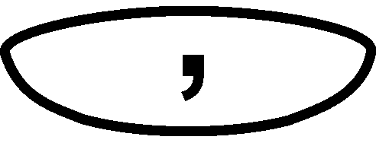 [L2] to enter the lists containing the data.
- Press  and use the cursor keys to highlight Y-VARS.
- Select Function by pressing .
- Press to copy Y1 to the expression.
- On the home screen, you will now see the entry QuartReg L1, L2, Y1. This command will perform a quartic regression with L1 as the x and L2 as the y values. The resulting regression curve will be stored in equation variable Y1. Press to perform the regression.
- Press to see your graph.

⇒ Answer Extension Question 1 on the Data Collection and Analysis sheet.
To see just how the model fits the data when a wider range is graphed, change the scale of the graph. This is a more severe test of the model than just graphing the model over the same range as the data.
- Press .
- Press the number next to Zoom Out.
- Press to zoom out.

⇒ Answer Extension Question 2 on the Data Collection and Analysis sheet.
A more appropriate regression model for the data is an exponential. To perform an exponential regression on the data you collected, use the same method you used above for the quartic regression, but choose ExpReg as the regression choice. Obtain a display of the data and the exponential regression curve on the same screen.
⇒ Answer Extension Question 3 on the Data Collection and Analysis sheet.
Notice that the exponential regression equation used by the calculator is of the form y = abx while the modeling equation used in this activity was y =Ve–Kx.
⇒ Answer Extension Question 4 on the Data Collection and Analysis sheet.
2. Use the expression
$$y={\text{Ve}}^{−\text{Kx}}$$
to derive the expression
$t_{1/2}=\frac{\text{ln}2}{K}$.
Note: When the voltage across the capacitor has dropped to ½V, the time is called t_{1/2}.

Data Collection and Analysis | Name  Date
DATA TABLE

R (Ω)
C (F)
V
K
t1/2 (from graph)
t1/2 (from K)
QUESTIONS
1. How does this half-life compare to the one you extracted from the graph?

2. In your own words, describe how the values of V and K affect the shape of the voltage versus time graph, y = Ve–Kx.

3. According to the model, when does the capacitor voltage reach exactly zero?

4. Compare the value of K to the value of 1/RC. Calculate 1/RC from the values of R and C in the Data Table. What could you do to the circuit to make the capacitor take longer to discharge?

Extension Questions
1. How well does the quartic curve fit the data, given the way the graph is now plotted?

2. Now that you have a wider view of the data and the fit, is the quartic equation still a good model for the data?

3. Does this model provide a good fit?

4. How are the values of a and V related? How are the values of b and K related?

