Activity Overview: Homeless Shelters

In the city you live in, there is a public housing issue. All the public shelters are at capacity. You and your team members are a public works team that has received a grant for creating the greatest number of shelter units possible with the funds. Due to the transient nature of many homeless people and lack of public zoning for a permanent encampment, the designed units must be portable. The grant specifies that the shelters must be long lasting, lightweight, and easily assembled.

Teacher Preparation and Notes
- In this activity, you can either leave the materials open ended, or you can collect some materials and tell them the shelters can only be made out of the materials that are found.
  - Possible materials
    - Blanket, different types of cups, different types of materials
  - Possible probes
    - Surface Temperature Sensor
    - Drop counter
    - Calorimeter

- You will need to get all the materials that you are going to use from the above list. You will also want to examine the videos and websites listed in the lesson plan. If they are blocked, contact your server administrator
- Prerequisite knowledge,
  - Homeless information
    - http://www.teachertube.com/view_video.php?viewkey=598b850bc8bf9837c279
    - http://www.hud.gov/homeless/index.cfm

  - Shelter information
    - http://www.spaceref.com/news/viewpr.html?pid=18099
    - http://pbskids.org/designsquad/profiles/connie_yang.html

- Classroom set up/instructional approach as appropriate
  - Allow for individual brainstorming, before group work.
  - This activity is inquiry-based, so your students may develop different strategies for addressing the problem. .
- Helpful hints, as needed (Is there supposed to be something here?
- Download support documents from education.ti.com/exchange. Search for the appropriate topic and look for State Standard alignments.

Materials
- TI-Nspire™ handheld technology, or TI-Nspire™ CAS handheld technology
- TI-Nspire™ computer software for demonstration and presentations
- EasyTemp and other sensor as needed
- Homeless_STEM_Student_2.1.doc
- HomelessShelter.tns
- Nspire Link with Direct Connect cable to insert data into the design proposal
- Any safety equipment including safety glasses

Engineering Design Process

Brainstorming – Provide students the activity scenario and ask them to brainstorm their ideas. They can use http://www.gliffy.com/ or the attached graphic organizer. Have groups present their ideas by placing their ideas on the graphic organizer.

Research and generate ideas – Search the internet for information on homeless shelter design and materials, then add information to the group’s graphic organizer. Each student should search for ideas from different elements of the graphic organizer.

Identify Criteria and Constraints - Revisit the original grant scenario and ask the students for missing criteria that have not been considered. This may have some groups brainstorming and doing more research to cover all the criteria and constraints in the grant.

Explore Possibilities - Collect Data - Select type of probes and materials that can be used. You might want to start with different types of cups, so that students understand about different types of cups and how the inter temperature can be impacted due to the material.

Model/prototype/simulation - collect data components - Develop a method for data collection, identify variables (independent/dependent/control),

Test and Evaluate – Make sure that the model does what is required and expected. Collect data that verifies compliance.

Select an approach – The students will use their tns file that has all the data used in the simulation process. Their approach must be back by mathematical simulations.

Develop a design proposal, Communicate Results – Students will produce a report communicating their findings. Members of the class will serve as a review board that will fund grants to the best and most cost effective designs.
Here is just one idea that students may try to determine what materials to use.
Start with the temperature sensor and connect it to your calculator.
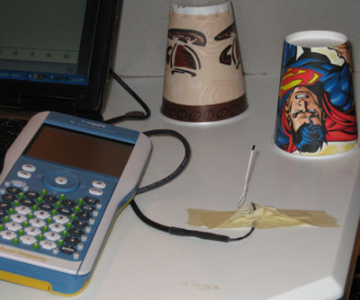

Wait for the probe to reach room temperature and then cover it with one of the cups,
start the calculator to collect data, then turn on a hair dryer to see how the temperature is impacted in 60 seconds.
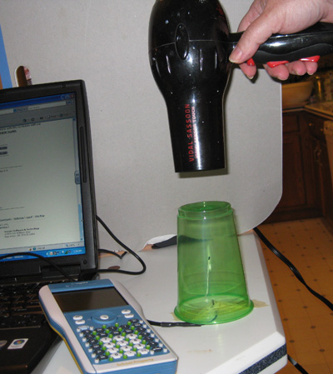

.

When the probe returns back to room temperature, then continue the data collection with different cups.
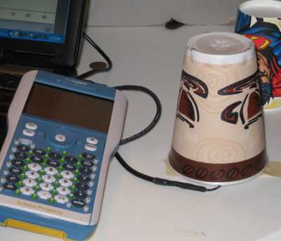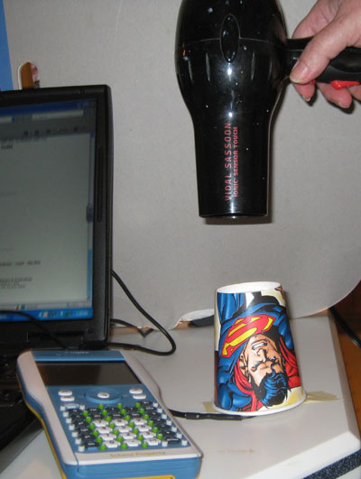

You can have the students compare the data sets.
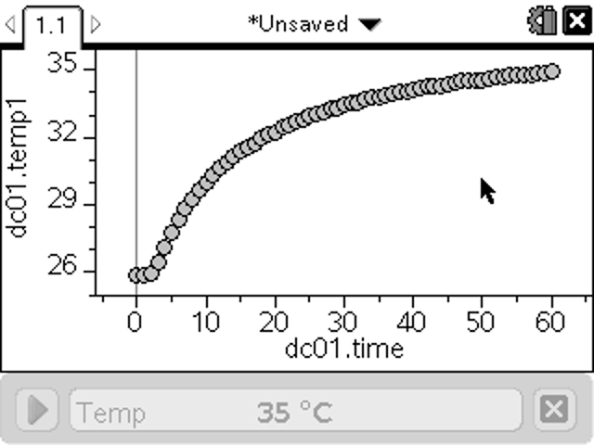 Green see through cup

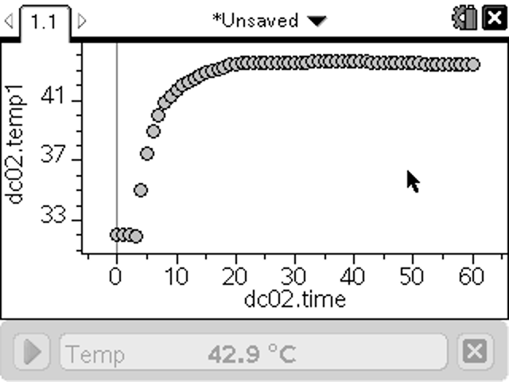 Kids superman cup

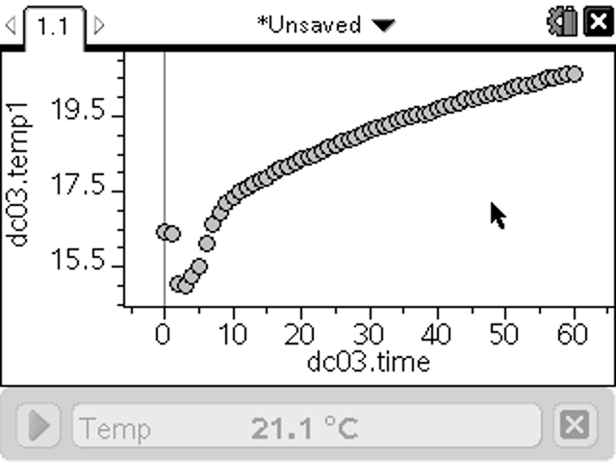 Coffee styrophone cup

Pictures of other possibilities are shown below:
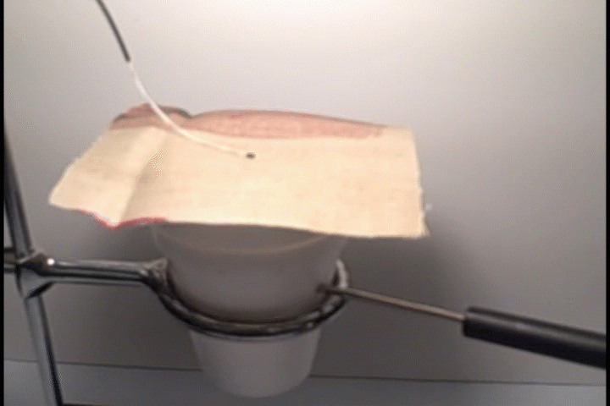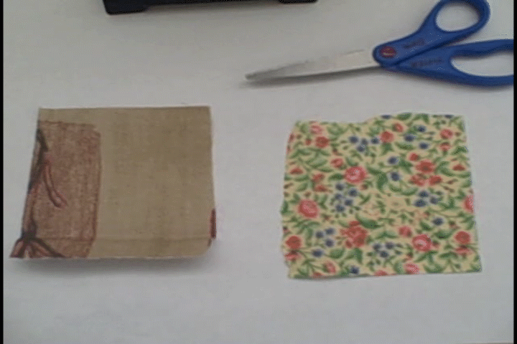
Calorimeter materials
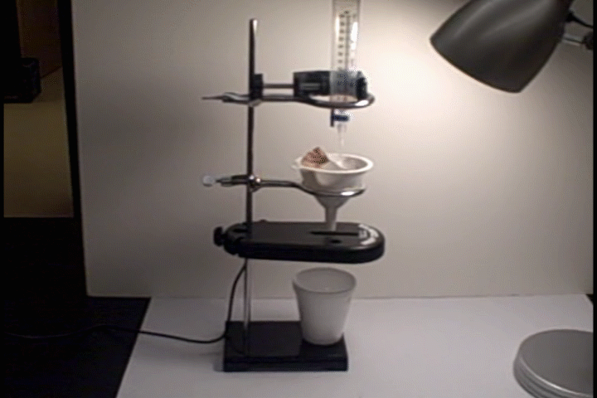
Dropcounter
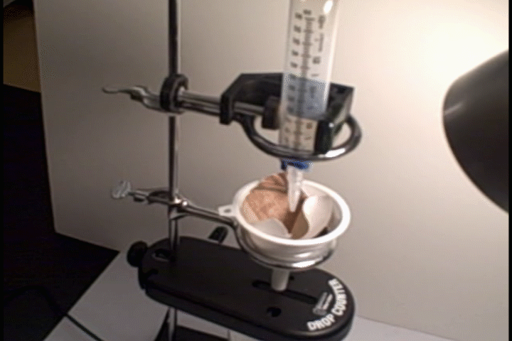

Part 1 – The Problem
In the city you live in, there is a public housing issue. All the public shelters are at capacity. You are a public works team that has received a grant for creating the most amounts of housing units. Do to the transient nature of these people and lack of public zoning for permanent encampment, the units must be portable. The grant specifies that the shelters must be long lasting, lightweight, and easily assembled.

Part 2 - The Engineering Design Process (EDP)

Have the student proceed through the design process to create the best homeless shelter that would fit a climate of your choosing.

Part 3 - Scoring Rubric

Explain and discuss the Rubric with the class. Make sure the teams understand that they should check it as they work on their design, implement it, test it, and present the results.

The Homeless Shelter Rubric | 4  Expert | 3  Competent | 2  Beginner | 1  Novice
Evidence of research | Evidence of appropriate design of and materials for shelter, all references are credible | Some evidence of appropriate design of and materials for shelter, most references are credible | Little evidence of appropriate design of and materials for shelter, has at least one credible reference | Shows no evidence of research
Evidence of following the engineering design process (EDP) | Documents all steps of the EDP, including evidence of multiple design considerations | Documents most steps of the EDP, including evidence of more than one design consideration | Documents some steps of the EDP | Shows no evidence of following the EDP
Data collection with probeware | Uses multiple probes, has evidence of data, relevant data collection | Uses multiple probes, relevant data collection | Uses at least one probe | Shows no evidence of data collection

Effective use of the Nspire as a research notebook | Uses multiple Apps throughout the Document, labels all figures, uses appropriate units on all measures | Uses multiple Apps throughout the Document, labels most figures, uses appropriate units on most measures | Uses more than one App throughout the Document, use some labels and /or some appropriate units on measures | Shows no evidence of use of the Nspire
The Shelter | The shelter allows access for accurate measurements, the shelter allows adequate room for one person, the shelter is portable, materials for the shelter were a factor in the final design. | The shelter allows access for accurate measurements, the shelter allows adequate room for one person, the shelter is portable, materials cost for the shelter were not considered. | The shelter allows access for accurate measurements, the shelter does not allow adequate room for one person, the shelter is portable, materials cost for the shelter were not considered. | The shelter does not allows access for accurate measurements, the shelter does not allow adequate room for one person, the shelter is portable, materials cost for the shelter were not considered.
Effective presentation of the solution to your house through the use of the Nspire and design proposal | Presents solution that outlines use of the EDP, answers relevant questions in an expert manner | Presents solution that outlines use of the EDP, answers relevant questions in an acceptable manner | Presents solution, answers most relevant questions acceptably | Presents solution, answers relevant questions unsatisfactorily

Evidence of team work with individual responsibility | Evidence that the design was chosen as a team through thoughtful deliberation, all team members are able to explain to the class what they did in the activity | Evidence that the design was chosen as a team after some deliberation, most team members are able to explain to the class what they did in the activity | Evidence that the design was chosen as a team after a little discussion, some team members are able to explain to the class what they did in the activity | Evidence that the design was chosen as a team hastily with out much discussion, only one team member is able to explain to the class what he did in the activity

Name __________________________________________ Date _______________________________

Concept Map

