Purpose: Investigate the effect of mass on the length of three different springs.
Equipment: A single spring, rigid support, and mass holder with a wide range of masses, meter stick and masking tape.

Setup Procedure: Divide into groups of three. One of the team members should login and get the Nspire document.
Data Collection Procedure/Analysis

Activity: Explore the relationship between the amount of mass and how far it stretches. What do you think will be the relationship between these two variables? Within the group make a sketch of the functional relationship between these two variables.
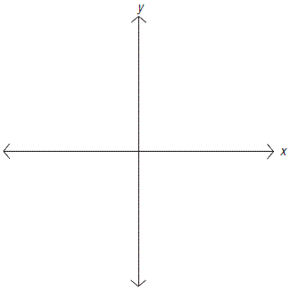

  - Attach one spring to stand placing enough mass on the holder to establish a small amount of extension (this is your initial value or equilibrium)
  - Record in the table below and on the spreadsheet in your Nspire the amount of mass hanging from the spring and the length of the spring for the initial values.
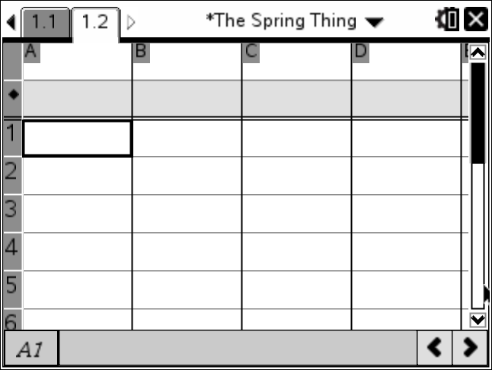
  - Add enough mass to slightly increase the amount of extension but not enough to come any where close to over stretching the spring.
  - Record the amount of mass and the length of the spring for an additional point in the table below.
  - Repeat the previous two steps to have a total of 7 ordered pairs.
Independent Variable  Quantity:__________________ Units:___________________ | Dependent Variable  Quantity:________________  Units:_________________

Procedure:
- Plot the 7 ordered pairs (Do not forget the requirements for an appropriate graph)
- Based on the data that you collected and the plot of this data, produce a sentence that describes how the spring behaves. Write this in a Notes page in the Nspire.
- Create a mathematical function that best models the pattern of the data and described in your sentence.
- Examine the plot of this data with the graph of the function. ie compare with others that have the same spring, what are the units? Predict if the function is realistic if you increase your independent or dependent variable by a factor of 10? Doubled?
- Given this experimental setup, what would be the limits on the domain and range? What is the domain and range of the function?
- What would this function predict in the other three quadrants? Is this realistic?
- What are the magnitudes and the units for the slope, y-intercept, x-intercept and area under the curve?
- Compare your results with the other groups.
- Rewrite your function as an inverse and see if it matches any better with the class.
Math/Physics Language Sheet
Math  Domain/Range  Area  Slope  Y-Intercept/Initial Condition  X-Intercept/Roots/Zeros  Inverse  Rounding | Physics  Contextual Restraints  Work  Spring Constant  Ambient Condition of the system  What happens when the dependent variable is zero  Switch the experiment so that the independent variable is now the dependent variable  Significant Figures
Differences  Units  Inverses  Domain | Similarities  Collect ordered pairs  Plot ordered pairs  Determine Functions  Parse the Functions

