Purpose: Investigate the effect of mass on the length of three different springs.
Equipment: A single spring, rigid support, and mass holder with a wide range of masses, meter stick and masking tape.

Setup Procedure: Divide into groups of three.
Data Collection Procedure/Analysis

Activity: Explore the relationship between the amount of mass and how far it stretches. What do you think will be the relationship between these two variables? Within the group make a sketch of the functional relationship between these two variables.
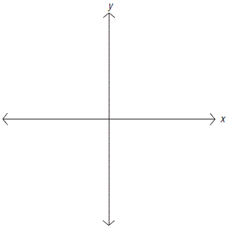

  - Attach one spring to stand placing enough mass on the holder to establish a small amount of extension (this is your initial value or equilibrium)
  - Record in the table below the amount of mass hanging from the spring and the length of the spring for the initial values.
  - Add enough mass to slightly increase the amount of extension but not enough to come any where close to over stretching the spring.
  - Record the amount of mass and the length of the spring for an additional point in the table below.
  - Repeat the previous two steps to have a total of 7 ordered pairs.
Independent Variable  Quantity:__________________ Units:___________________ | Dependent Variable  Quantity:________________  Units:_________________

Procedure:
- Plot the 7 ordered pairs (Do not forget the requirements for an appropriate graph)
- Based on the data that you collected and the plot of this data, produce a sentence that describes how the spring behaves.

- Create a mathematical function that best models the pattern of the data and described in your sentence.
- Rewrite your function as an inverse and see if it matches any better with the class.
- Examine the plot of this data with the graph of the function. ie compare with others that have the same spring.
- Predict if the function is realistic when you increase your independent variable by 10 times your max? How about by double your max?
- Given this experimental setup and your functional model, what are the limits on the domain? the range?
- What is the domain of your function?
- What is the range of your function?
- What would your function predict if it existed in Quadrants II, III, and IV? Is this realistic?
- What is the magnitude and units of the slope?
- What is the magnitude and units for the y-intercept?
- What is the magnitude and units for the x-intercept?
- What is the magnitude and units for the area under the curve?
- Compare your results with the other groups.
Math/Physics Language Sheet
Math  Domain/Range  Area  Slope  Y-Intercept/Initial Condition  X-Intercept/Roots/Zeros  Inverse  Rounding | Physics  Contextual Restraints  Work  Spring Constant  Ambient Condition of the system  What happens when the dependent variable is zero  Switch the experiment so that the independent variable is now the dependent variable  Significant Figures
Differences  Units  Inverses  Domain | Similarities  Collect ordered pairs  Plot ordered pairs  Determine Functions  Parse the Functions

