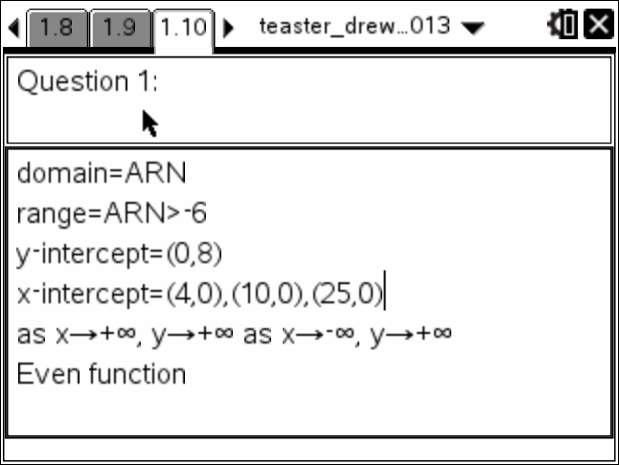

Lost points for using > rather than >=. I had several that lost out on the use of Interval Notation. Using (-6,8) for the Range.

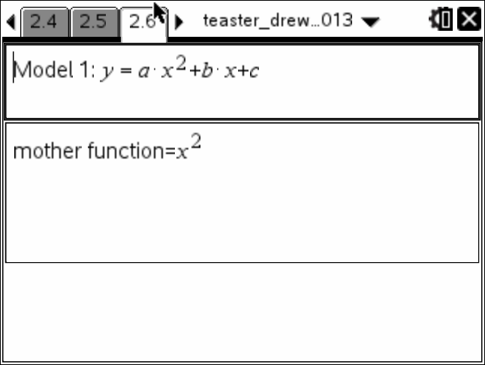

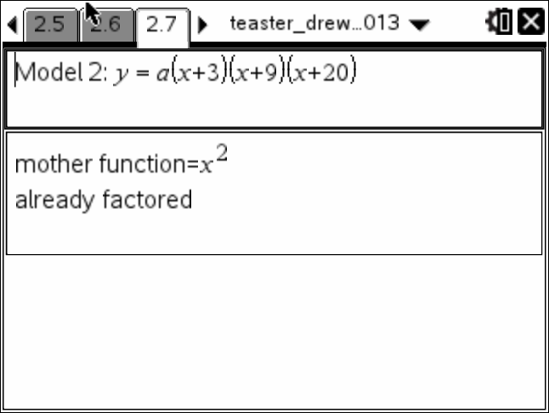

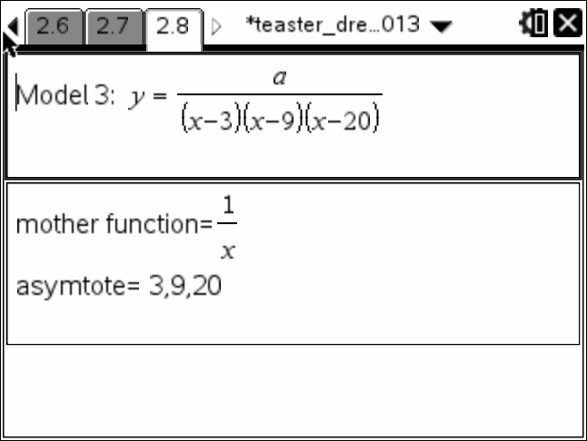

I think we need to spend more time in a group deciding on what assessment to use and clarifying the Rubric. Also we need to avoid having a teacher hover over another teacher as they grade that teacher’s student work. In most experiences I have had, we check a teacher’s scoring on random papers.

In this prompt, it was bad from the start. Not well constructed (good idea though) and the initial rubric had no attention to context. You should come to the College Ready Topical for Math and Physics the first week in June.

Samples for Question One:

Walker y-int=(0,8)

x-int=(4,0),(10,0),(25,0)

domain and range-all real numbers

max=(0,8)

min=(21,−6)

the key characteristics are as the days go on it gets colder. but towards the end of the month the temp. starts to fluctuate.

Bryceson y = (0,8)

x = (4,0), (10,0), (25,0)

relative min= −6

relative max= 8

sarah x-intercept:4,10,25

y-intercept:8

domain:≤8

range:−6≥

max:0,8

min:21,−6

Clayton x intercept,25,10,4

y intercept,8

minimum,21p,−6

maximum,0,8

as the day goes on it begins to fluxuate

troy the weather is decreasing at first then, it increased a lot. the zeros are day 4 and 10

stephanie the temperature on the month of january the domain expresse month and range is the temperature and y-intercept is the range and domain is the x-intercept and minium is(20,−6)

maximum is(0,8)

elizabeh the other two chararistics would be rain or shine

nick the graph varies a lot,containing an out-lier of 8. the domain is x<0 The range = 2, X-intercept =0, Y-intercept = 8

Mode = 0, Temp median = 0

chris the graph has an x intercept at 4 points and the min is 21,−6 the max is 0,8. the range and domain are all real numbers

julia domain−all numbers

range−−y<0

x−intercepts-(4,0) (10,0) (25,0)

y−intercepts-(0,8)

relative max-(0,8)

relative min-(21,−6)

even odd functions-even function

The key Chara. are as date goes on thetemp fluctuates

Rhoda domain=all reals

range=10

x-intercept=0

y-intercept=8

the graph has a vertex

and goes up and down

realitive max=(25,0)

realitive min=(0,8)

in the future the temp is likely to drop

drew Tea domain=ARN

range=ARN>−6

y−intercept=(0,8)

x−intercept=(4,0),(10,0),(25,0)

as x→+∞, y→+∞ as x→−∞, y→+∞

Even function

robby domain= (4,0) range= (0,8) y-intercept= 8 x-intercept= 4 min= −6 max= 8

kimbely domain 10

range 25

x intercept cant see graph

y intercept

median temp 0

median day 8

kendall The graph is showing you the pattern that thhe data makes. The values on the graph are the domain, range, x−intercept, and y−intercepts. It also determines the maximum and minimum values, and you can use it to predict future data.

chrystal The graph dips down into the − axis then curves backzup and touches the x-axises 0 only to do a u turn and go right back to the negative but this time going much more −. Now that it has reached its lowest point it curves right back up and breakes into the + direction.

Audrey The domain is 0, 4, 6, 10, 21, and 25. The range is −6, −2, 0, and 8. The y-intercept is 8 and the x-intercept is 4, 10, and 25. The graph is a function because it passes the vertical line test. The graph measures the temperature at °C for certain dates. The maximum is 8°C and the minimum is −6°C. The temperature was warmer than 8°C in the past. The temperature will increase in the future.

maddie In Frostburg the weather changed the range is (8,0,−2,0,−6,0) the domain is (0,4,6,10,21,25)

The max is 8

The min is −6

I predict in the past it was warmer because in day 0 it was 8°

I in the future i predict it will get colder bc in graph as the days go on it get to 0,−2,0,−6,and 0 again so it makes since to predict it will get colder

paxton A few key characteristics of the gragh are that it's difficult to understand, with a domain of

drew Tea mother function=((1)/(x))

asymtote=3,9,20