In this investigation we will refresh our memory of some algebraic concepts by manually calculating a Median-Median best-fit line for a set of collected linear data.

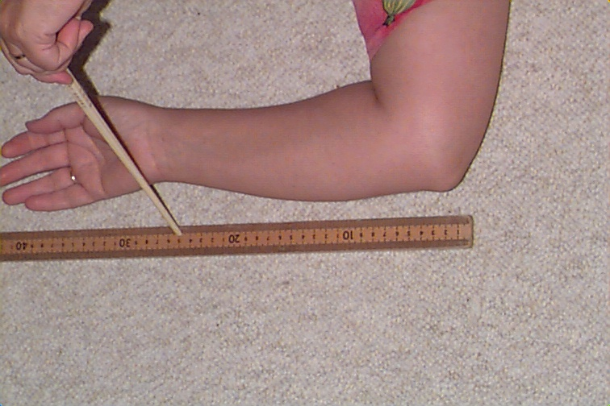
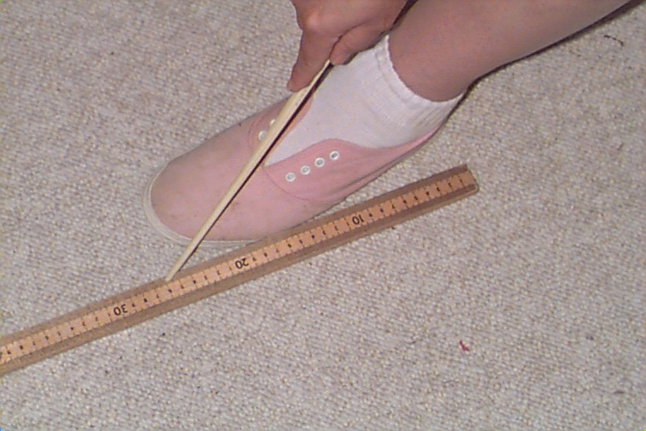
- Measure in centimeters, to the nearest millimeter, the length of your left arm and foot, and then the right arm and foot as shown below.
From elbow to wrist From heel to toe
- Send the data to the class through the Navigator’s Activity center. Once we have the complete set of measures of the length of the forearm and clothed foot of all of the class, I will send it back to your calculator.
- Plot the data. Let the length of the arm be the independent variable and the leg be the dependent. Partition the data into three groups, the 1st, 2nd and 3rd thirds.
- Identify the Median X (Arm) and the Median Y (Leg) for each third, and plot these three points on the graph above. Make sure to identify these points on the graph. Draw vertical lines on the graph to show the Thirds.
Third | Median X | Median Y
1st
2nd
3rd

- Find the equation of the line passing through the points for the Median in the 1st and 3rd Thirds. Graph this line on the plot above and identify.
Y₁₃ = ______________________________
- Find the equation of the line that passes through the Median point for the 2nd Third with the same slope as the equation from question 5. Graph this line on the plot above and identify it.
Y₂ = ______________________________
- Find the weighted average of the y-intercepts to use with the common slope above to get the Median-Median line of fit.
y-intercept of Y₁₃+ y-intercept of Y₂+ y-intercept of Y₁₃
3
Graph this line on the plot above and identify it.
Y₁₂₃ = ______________________________
- Compare this equation with the one generated by your calculator when you do the Med-Med regression.
- Submit all graph and data lists.

