CBL/CBR Data Collection

In this investigation, your team will design an experiment to determine the value of a measurement that select. The item to be measure will be selected by your team, but must be either a distance or length measured in feet or meters; or a temperature measured in Celsius or Fahrenheit. The measurement should be representative of the item measured – the height of a door, the temperature of the hall, the width of a parking space. That is, we will be determining the real value of the measurement of an average.

Equipment: TI calculator; Link cable; CBL or CBL2 with temperature probe; or CBR alone, or with the CBL or CBL2 using the CBR to CBL link cable.

Set Up:
- You may use the CBL in Multimeter Mode with either the Temperature probe or the CBR with the CBR to CBL cable. To do this, you will need to key the data into your calculator as well as listing it on the table below. Plug the probe in the CBL and then press M and then O as needed to display the require value (temperature or distance, and units – feet or meters). The CBL will continue to collect data until you are finished. Hold the probe in the correct position until the reading stabilizes and then record it on the table below. When finished, press M again to take the CBL out of Multimeter mode.
- You may use the GAUGE with the CBL, CBL2, or CBR. In this case you will use the APP on the TI-83 Plus as shown below. Connecting the appropriate probe as the directions explain. This mode will automatically record your data in a list, but you should write it down as you get the values as a back up. Press  and a Reference number for each measure until you have the 21 data points. Then press  and  [QUIT] and then  to leave the GAUGE mode. The data will be located in the lists DREF and DIST or TREF and TEMP.
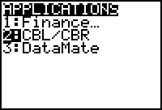 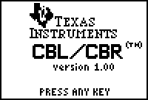
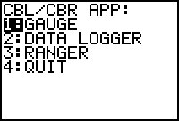 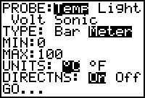
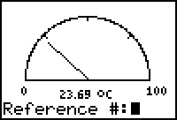 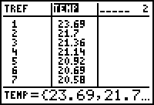
- The third method uses the LogData function of DATAMATE. To get this program or APP in your calculator. Connect to the CBL2, press  [LINK]  on your calculator to set it to Receive and then press TRANSFER button on the CBL2. Run the program with the probe attached to the CBL2 and record the data in the table below.
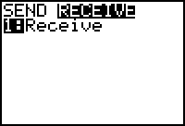 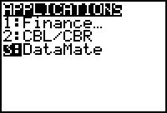
Data Collection and Analysis:
  - What Set Up Method are you using? _____________________
  - What Item are you measuring? __________________________
  - What units of measure are you using? __________________
  - The 21 values:

Measured Values | Measured Values | Measured Values

  - Identify the following values for your data set:
Mean
Median
Mode
Maximum
Minimum
Standard Deviation
Average

  - Produce a Histogram of your data, including a Window.
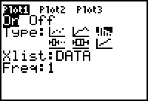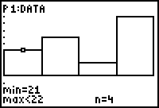

  - Produce a Box and Whiskers of your data, including a Window.
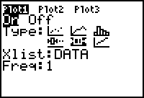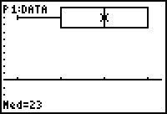
  - Produce a Z-Distribution of your data, including a Window.
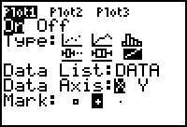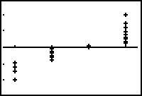
  - Produce a Scatter Plot of your data, including a Window. Hint: make a list (NO) to number your measurements.
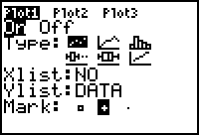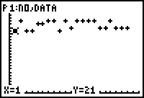
  - Do a T-Test to evaluate your data at the p = 0.1 level (10%). Use a value for u₀ - the True value - that you determine, and explain why you picked that value. Do both Calculate and Draw. Determine if your data survives the test at the 10% level. (In the example the level is 1.1% since p =0.0118, lower/better than the p = 0.1 level.)
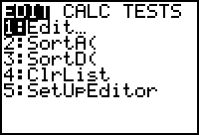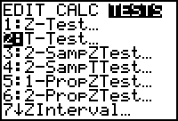

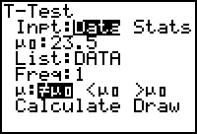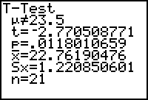
  - Which of the above analysis methods best demonstrates the data that you collected and why?

