NSES Content Standards:
• Unifying concepts and processes in science.
• Science as inquiry.
• Physical science.
• Life science.
• Earth and space science.
• Science and technology.
• Science in personal and social perspectives.
• History and nature of science.

Activity 2: Shedding Light on the Weather with Relative Humility
In this activity we will:  - Collect the data for temperature and relative humidity for every hour over a DAY from the newspaper or the local airport.  - Place the data in your handheld.  - Examine the data for patterns.  - Plot the data for  Temperature vs. Time,  Relative Humidity vs. Time, and  Relative Humidity vs. Temperature.  - Look for the patterns displayed by the three plots and relate them to your experiences.  - Place the Sunrise and Sunset times on your plot.  - Determine the mean, median, mode, and range of the temperatures.  - Determine how they report the daily temperature for a city.  - Make conjectures about the patterns you discover as the seasons change or for different locations in the U.S.A. or World. | 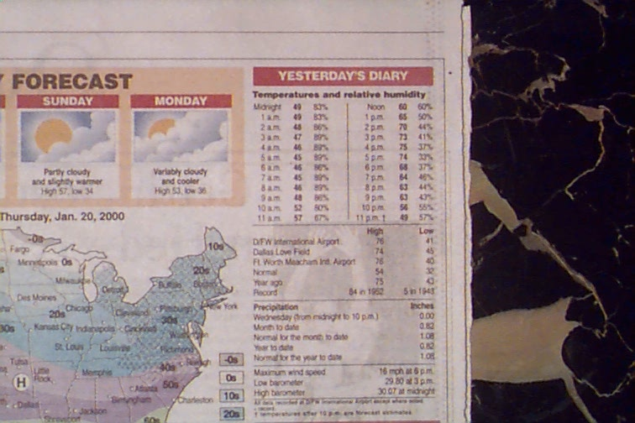
Get the data from your teacher. This data is collected every hour by weather stations at airports. It is often reported in the local newspaper. You may also get the data for Dallas, Texas from the link below for any given DAY.
http://weather.dallasnews.com/history/airport/DFW/2006/12/24/DailyHistory.html?req_city=NA&req_state=NA&req_statename=NA

Note: If your paper does not report the data your class might email them and ask that they do so as a public service.
As a warm up, discuss what time of day you think it gets the hottest? When do you think it gets the coldest? Key it in your home screen and share with your partners/teacher/class. To do this press o and then clear off the home screen with a C. Remember to just space over (either aÆ or the __ from the  screen on the 73 recalling that you press e on Done when you are full or finished.) Don’t press e since the computer will what to evaluate what you said and your are not ready for that! | 
Now let’s run the Science Tools APP. To do this press Aa and the letter S. You might need to move down to highlight SciTools as the choice.  Note: If you TI-73 just jump down to the instructions for deleting the old lists and naming the new ones below. | 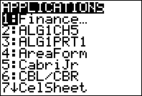  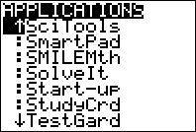
Then press e to run the APP and see the splash screen and then e again to dismiss it. | 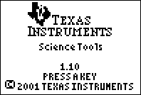
Select the option for the graph lizard by highlighting it and pressing e or by pressing 3 . | 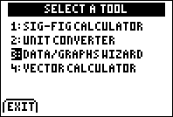
This screen gives us three options. We want to deal with the data initially, so we choose the softkey for DATA which is !. | 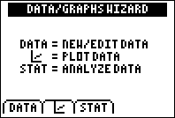
Now we are in the List Editor. This is where we will name the lists and enter the data. Depending on what was last done on your handheld you will see different lists here. That’s OK since you just what to delete them.  Note: 73 people will start here. | 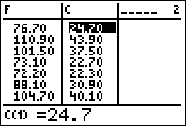
Move your cursor above the line to the List Header and then, if necessary, move to the left or right to get into the first column. See the 1 in the upper right-hand corner. | 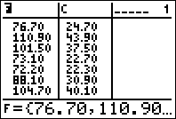
Now press d until you get tired. This will leave you with a blank setup – ready to get your list names. | 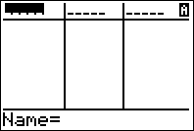
Now we need to decide what names to use for the lists that contain the hour that the data was collected, the temperature that was read at that hour and the relative humidity. We suggest HOUR, TEMP, and RH. You may use any names that you feel appropriate, but you are limited to 5 characters and you must start with a letter. It is best if the whole class comes to consensus on the names. Find the alphabet and key in the names. Move over to the next list and repeat until you have all three as shown. The alphabet mode is already on in the 84 (see the A in the upper right) and on the 73 you get the alphabet from  pressing e on Done when you are. | 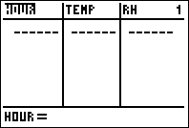  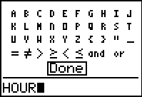
Now we enter the data. Make sure you keep the three numbers together. We call them an ordered triple.  We will need to use Zulu Time so the computer will understand. That means that Midnight (12 AM) is 0 hour, and 1 PM is 13 hours (12+1). If your teacher wants to have several DAYS, the next DAY will start at hour 24 and then go 25, 26, and 27 were 27 is 3 am the next DAY.  The relative humidity is in percent. Do you know what it implies if the relative humidity is 100%? | 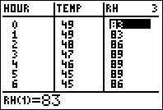
Exam the list for mistakes. Do you see any patterns? What happens when the sun sets? When it comes up? Were you correct on your estimation of the hottest hour? Coolest? What relationship do you see between the temperature and the relative humidity? Do you know what units the temperatures are in? How do you know?
Now we will plot the data. If you are in the SciTools APP just press  to get to the screen of choices. If you are 73 you will need to set the plot up by pressing  and then telling what you want. Select the PLOT DATA option softkey in the SciTools APP by pressing . | 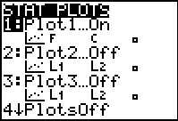
Now we need to tell the computer what type of plot you want. If we are looking at the hour and the temperature we probably should not connect it, but you might want to. The unconnected version is the Scatter Plot. Select that with the softkey for SCATTERPLOT which is  | 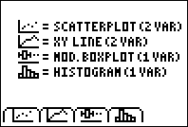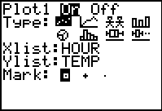
Now you are asked to select the list that contains the Independent variable. Since the people read the weather station data every hour the HOUR is the independent variable, x. Move to the list for HOUR and select it by pressing e. You could also pick the number or letter in front of it. On the 73 the list are accessed by pressing . Don’t forget to set the Window with a ZoomStat. Press ☺.  How would you design the experiment so that TEMP was the independent variable?  Note: If you have many named lists, you might not be able to see your named list. If you don’t see it, leave the APP using  until you pick the EXIT option softkey . Then delete the excess lists and return to the SciTools APP. | 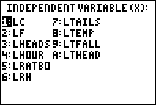  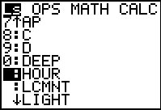
You will now see a request to select the Dependent variable, y. Notice that only lists that are compatible are shown. Select TEMP as you did before with HOUR. Notice the L in front of the list names. This is how the computer knows it is a list. | 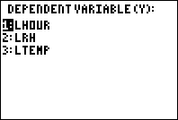
Examine the graph. Trace along it. Do you see the sunset? The sunrise? When was it the maximum temperature? The minimum? | 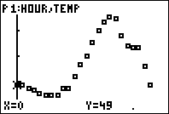
Press  to set up the plot of RH vs. HOUR. Repeat the process above. On the 73, you can just set up the second plot for this. Don’t forget to adjust the Window and turn off Plot 1 to see the pattern. | 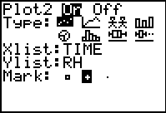
Examine this plot. Do you see the sunset? Sunrise? When did it get the hottest? The coolest? Do you see the hours? Trace along the HOUR, back and forth. | 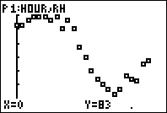
Before you leave the SciTools APP set up the first plot again. Press  to select PLOTDATA. You should leave the APP with the TEMP vs. HOUR plot up.
Leave the APP by pressing  repeatedly until you reach the screen and then use the softkey for EXIT, .
The person who wrote the SciTools APP decided to turn off your plot when you left the APP. Go to  and we can quickly turn it back on. The 73 people will need to go to  as well and switch back to the first plot, resetting the Window with ZoomStat as before.
To turn the Plots on and off from the Y= editor, just move your cursor to the top and press e to turn on or off. Dark is on, as you can see to the right which has Plot1 on.
Press  to check to see if your plot of TEMP vs. HOUR is still active. If you have trouble, check with another student in your group and see how she did it. | 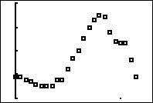
Let’s put in the sunrise and sunset times. Should we draw a Horizontal or Vertical line to do this?
Return to the Home Screen and clean yourself up by pressing .
Now chose the DRAW tool for the line you need. Make sure you do this from the HomeScreen so we can put in the exact time for the sunrise and sunset. Get these values from your teacher. Press õ and then select the tool (either highlight it and e or press the number in front of it). On the 73 you have your very on key for the drawing tools. Press  to access it.
Now you are on the Home Screen and the computer is waiting for you to key in the time for the sunrise or sunset. Since the sunrise came first key in the time your teacher gave you. Notice in the sample the sun rose at 7:05 am. Press e to actually draw it. This should send you back to the plot screen. Where you correct? Did you hit “see” the sunrise in the data? | 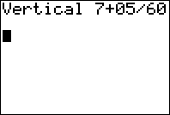
Do   to return to the Home Screen to enter in the time that the sunset occurred. Call back the last line by pressing  to edit it. On the 73, just move up  the memory stack and highlight the command and press e to retrieve it for editing. Notice in the example shown, the sunset at 6:25 pm. Don’t forget to press e to see the sunset. | 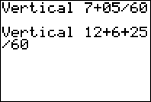
Discuss what you think happens to the temperature as the sun comes up or sets. Explain how the plot shows this. If other teams have done different days, is the pattern the same. What other factors could be involved. What city did the data come from? Would it be different on the ocean or a lake, or in the mountains, on a prairie, or in the desert? What about rain, fronts coming into the area, cloud cover? | 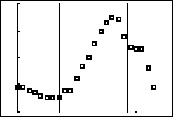
What about relative humidity? Set up the plot for RH vs. HOUR. If you are 73, you are set to turn on Plot2. Otherwise, press å and setup Plot2 as shown.
Don’t forget to go to ! to turn off Plot1.
Reset the Window for the data using ZoomStat. Press #9, or on the TI-73 press #7.
Place the sunrise and sunset times back on the graph. Just return to the Home Screen [] and use the methods mentioned above to retrieve previous commands. This time you don’t need to edit, but you will need to do it twice, once for the set and once for the rise.

Do you see the relative humidity react to the changes? Do you think it is the sunset or the cooling that causes the change? What about when it heats up after sunrise? What happens to the relative humidity? What is relative humidity? What was the dew point for that day? What does that have to do with it?
Look both plots now. Turn Polt1 back on from the ! area.
We will need to reset the Window, but let’s do it manually this time. Press @ and adjust the values. In this case x is the hour but y will be either the temperature or the relative humidity. You will see this type of graph on may high stakes assessments so this will be good practice. We did help ourselves by using boxes for the temperature and + for the relative humidity. Note that the relative humidity can range from 0 to 100 while the temperature range will vary depending on the season. In January we could go from 10 to 60 but in August we could be 70 to 110 depending on the area you get the data from and the units used for the temperature. See the sample Window to the right. Set yours as you think best. Don’t worry since you can edit it if you are unhappy with the results.
Press % to get a look. Adjust the Window if you like.
What do you see going on? Discuss what happens as you go through the 24 hours. Place the sunrise and sunset back on the screen if you don’t “see” them. Notice on the Plot shown we have a temperature of 57 degrees Fahrenheit at 11 am.
Now set up Plot3 as shown to see the relationship between the relative humidity and temperature. Don’t forget to go to the Y= Editor to turn off the other two Plots and reset the Window either manually or with the ZoomStat.
Press å3 to start.
Do you see a pattern when you look at the Plot by pressing $? Move over the data with ><. Discuss.
When you hear reports about the temperature in Chicago what temperature are they using? Is it the maximum, minimum, mean, mode, median? Identify these values for your temperatures. Press S1 or  to see the data.
Max =
Min =
Mean =
Mode =
Median =
The computer will give you most of these values using 1-Var Stats. To get this, return to the Home Screen and clean up []. Then press S> 1 to select 1:1-Var Stats from the CALC Menu. On the 73 you will press . | 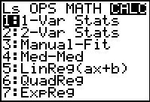
Now you need to tell the computer which list you want to analyze. Do this by accessing the list of list by pressing ò on the 73 press  and selecting the list for TEMP. Press  to pick the list and  to make it go. On the 73 if you press  you get a list that is easier to scroll up and down.\

Look at the results. How did you do? How would these values change with location or season? Which would you use to report the temperature of the day for your city? | 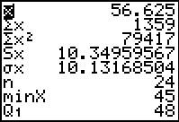
Repeat this investigation later in the year. Do things change? Relationships?

