NSES Content Standards:
• Unifying concepts and processes in science.
• Science as inquiry.
• Physical science.
• Science and technology.
• Science in personal and social perspectives.
• History and nature of science.

Activity 3: The 1 Cent Event
In this activity we will:  - Collect data on a 1 cent coin as it falls under its own volition after being placed on its edge 25 times.  - Report your data to the class and collect their data.  - Enter the data into your handheld.  - Examine the data from the collective and discuss patterns revealed in the data.  - Set up a Scatter Plot of the data.  - Identify the mathematical relationship in the plot.  - Explore what we have discovered in relation to the y=x function.  - Determine the experimental probability of a result from a fall. What are the chances we get a head, a tail.  - Conjecture on the nature of the meaning of our results.  - Examine the coins with a magnifying glass and discuss center of mass. | 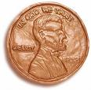
Collect the following equipment:
- Your TI-84 Plus
- A new penny coin
- Paper and Pencil to record your results.
Find a level table top with a “sweet spot” where you can easily place your coin on edge. Place the coin on its edge and wait until it falls. Don’t hit the table or blow on it. Just wait until it falls. Record the result, Heads or Tails, and repeat the event for a total of 25 times. Mark your results and shown.
  HEADS | TAILS
  ||| | ||||
Send your results to your teacher in the form of a total. Like 10 Heads and 15 Tails. Check your math.
Note: This may be collected with the TI-Navigator in the Activity Center with a Form or with a Screen Capture if you type the data on the screen.
Now we want all the data from the class. Get this from your teacher and enter it into your handheld. From the Home Screen, press C. and then press S1 to get to the List Editor.
We need to trash the lists that are in our space so just move your cursor to the top of the list, above the line in the header of the lists. Move over so you have a 1 in the upper right and then press d until you get tired.
Now the computer wants the names of the lists. Let’s call them HEADS and TAILS. You are in the alphabet mode already (see the A in the upper right). Press e when you are finished to accept it.
Repeat this for the other list but remember to move over to the second column before you key in the name. | 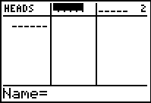  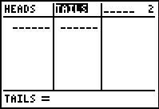
Now key in the data. Double check your entries with the Truth.
What is the maximum number of heads? How about the minimum number of tails? Do you see any pattern? What could you do if one student reported the number of heads but left the room before they told the number of tails?
If we plot the data with HEADS as the x-values and TAILS as the y-values, what do you think the graph will look like? Sketch it in the space to the left.
Now we will set up the plot. Press `å1 to set up Plot1. Get the list names from `ò or just key in the name.
Before we plot we need to look at the Y= Editor. Press  and either turn off or delete any functions you have and check to see you only have Plot1 on.
Setup the graph paper by pressing  and adjusting the values. Recall that HEADS was the x-value and TAILS the y-value. Do you know what you get when you have 5 pennies?
When you are ready press  to access the plot. How well did you guess? What pattern do you see? What does it mean? | 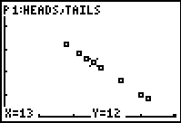
Return to the Y= Editor and enter in the equation that models the pattern. If you need to you could do a regression. Look at the plot with the equation. Did you get it? Do you get it? | 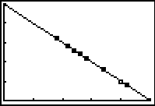
Let’s compare this with the y=x equation. That is the number of TAILS = the number of HEADS. Press  and go to Y₂ and enter X.
Return to the graph (press ) and explain what it means to be in the areas I, II, III, and IV. What does it mean to be on the lines? You can just move around on the screen with your arrows  or press  to follow on the lines. Press  to switch what you trace on. | 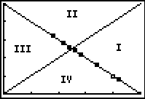
Now we want to look at the probability that the coin will fall showing heads. Return to the List Editor by pressing S1. Move over to the third column and using the technique you used before name a list for the total number of heads – THEAD. | 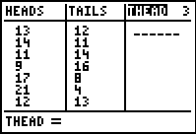
While still in the header of the list get the cumulative sum operation. Press `ò>6.
Now tell the computer which list you want to sum. Press `ò and find the HEADS list.
Press e to finish and sum.
Now we need the total numbers of falls. Make a fourth list named TFALL. | 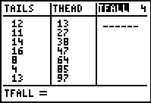
Another way we can fill a list is with the sequence operation. This will work because we know the falls were 25, 50, 75, … since everyone did this 25 times. To get the values, while you are still in the header of the TFALL list as shown above, press `ò>6.
The syntax for sequence is seq(variable, rule, start, end, step). So your need to know how many total falls you had. In the sample shown you have 400.
seq(F,F,25,400,25)
To get the probability we need to divide the total heads by the total falls. In the sample we have 13/25 = 0.52 or 52%. We will make a PROB list to hold these values. | 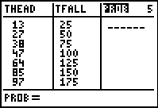
While still in the header tell the computer to do this calculation; _{L}THEAD/_{L}TFALL. Press `ò to get the names of the lists. | 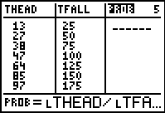
Notice the numbers are all between 0 and 1. When you flip a coin you expect 50% of the time you will get heads. How many of your data points are more than 50%? What does that mean? | 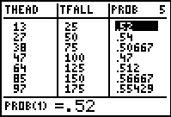
Set up a plot of PROB vs. TFALL and see how the probability is revealing itself with repeated trials. Don’t for get to turn off your Y= equations and to reset the window. Press å to set up Plot1 as shown.
Press ! and check your equations and for other plots turned on.
We will set up the window manually. Press @ and enter the data as shown, with the exception of Xmax. This number will be determined by the total number of falls that your class had.
Now look at the plot by pressing $. What do you think the probability is tending toward? | 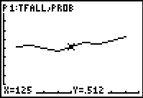
Look at the average of the probabilities to help. Press ! and move to a free line. Key in the key word for average by pressing `ò<3.
Now tell which list you want the mean of by pressing `ò and finding the PROB list.
Go to  and see the Truth. | 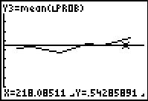
Now examine your coin with a magnifying device. Do you notice anything that might cause your coin to fall over one way more often than the other? As your teacher to explain to you the concept of center of mass.

