Introduction

In this investigation we will examine the measurement of liquid volume in various consumer products. Besides developing a relationship between the two selected units of measure (milliliters and fluid ounces) we will explore the precision and accuracy of these measurements and slope. In addition we will investigate the sources of theses measures (how did they actually determine the values for each unit) and the ability to estimate (Small, Medium, and Large).

Data Collection

Each person will get measures of volume in milliliters (ml) and ounces (oz) from seven products in their home. These should be from a Small, Medium, and Large container, and from different products. Look at the labels from containers of liquids to get this information. Watch out for mass measures (grams and ounces). Place the data collected in the Data Reporting Form (DRF).

Analysis

- Make a list for the Ounces, and the Milliliters.
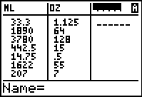
- Look at the pattern in the values in the ounce list, when compared to the milliliter list. Do any numbers seem out of line?
- To help in the examination of this data, we would benefit by sorting the data. Go to the Home Screen (Press    ) and then get the Sort Command. Press    and select either the SortA( or SortD( command. One will sort from smallest to largest, and one sorts the other way. Back at the Home Screen, tell the calculator which list to sort on, and which lists to keep paired (associated) with this list. Press   and pick the list for milliliters, then repeat for the ounces list BEFORE YOU PRESS . When you are finished, your lists will be sorted, by the size of the milliliter values. Press  to see the lists.
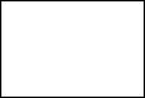 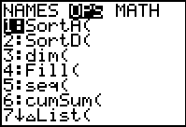
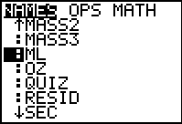 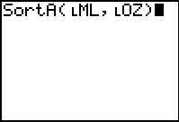
- Now it should be easier to see any erroneous data. In addition you should be able to see if the distribution of the values, between Small, Medium, and Large was as expected. Answer questions 1-7 on the DRF.
- Now we would like to determine what conversion factor is used to change Ounces to Milliliters. As we look at the list OZ, what could be done to these values to make them into the values in the ML list? Try out your factor on several data pairs, in the Small, Medium, and Large ranges. Answer question 8 on the DRF.
- To see the data more graphically, we can set up a Scatter Plot. After setting upm the Plot as shown, set the graph screen by pressing  and use the smallest value for the Ounce data to set Xmin, the largest in Xmax, and then the smallest Milliliter value in Ymin, and the largest in Ymax. Set the scale for OZ (Xscl) and ML (Yscl) as you see fit. Press  to see he results and then modify the window as you like. Answer question 9 on the DRF.
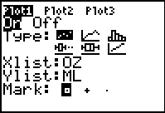 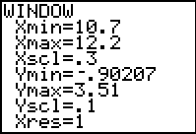
- Create the function that best models the pattern in the data. Use Guess and Test, Calculations, Science Tools, or the Regression. Report the equation and the graph with the data in the DRF, question 10.
- To see the conversion factor in another way, Make a list to hold the Ratios of
ML OZ since that will be Y divided by X.
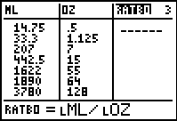
- Average this value and use it in the Equation Editor to see how closely it fits the data. To get the Mean, use the CATALOG and select the list ◻RATBO. Answer question 11 on the DRF.
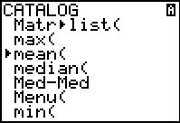 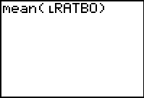
- The True conversion from Ounces to Milliliters can be discovered using the Science Tools. Report this on the DRF, question 12.
- Can you repeat the process to convert from milliliters to ounces?

Data Reporting Form

- Give the Ranges that you feel determine the classifications of volumes:
Small: ______________ Medium: ______________ Large: _______________
- Place the information you collected in the table below.
Size  S.M.L | ml | OZ

- What was the largest and smallest value you collected?
 | ml | OZ
Largest
Smallest

- How many items were Small: ____; Medium: ____; and Large: ____.
- Are there any numbers that seem not to fit as you look at the pairs of numbers in the OZ and ML lists? Explain the problem, and state what you think is going on.
________________________________________________________________
________________________________________________________________
________________________________________________________________
- Do all the measures show the same number of:
Significant digits? _______ Place value? _______
Do any of the values seen estimated? _______ Calculated? _______
Explain: _________________________________________________________
- Do you now see any inconsistency in the reported values that you had not already identified? ________________________________________________________
Do the values seem well distributed over the selected range of sizes? __________
Explain: __________________________________________________________
- How would you change values for ounces into milliliters?
ADD SUBTRACT MULTIPLY DIVIDE OTHER
What factor (number) would you use? __________
Give one calculation showing the result, and compare it to the reported milliliters value. ___________________________________________________________
- Give the Window settings and the graph for your Plot. Print or sketch below.

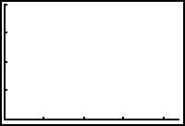
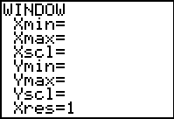

- What equation did you use? __________________
How well did it fit the data? _________________________________________
Sketch the graph or print it out.
- What was the Mean of your RATBO list? ___________
- What is the correct conversion between ounces and milliliters?

