NSES Content Standards:
• Unifying concepts and processes in science.
• Science as inquiry.
• Physical science.
• Science and technology.
• Science in personal and social perspectives.
• History and nature of science.

Activity 1: Coming to Know F and C or 350 Million People Can’t Be Wrong | 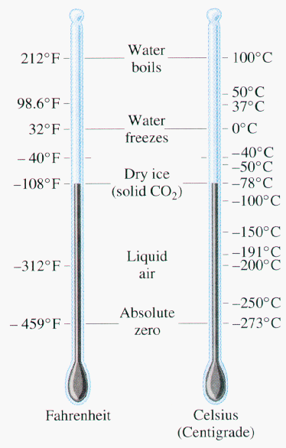
In this activity we will:
- Collect 14 temperatures from two temperature probes (one reading Fahrenheit and one reading Celsius) covering the range of temperatures from 0 to 100 degrees Celsius as best we can.
- Examine the Plot of the data and determine the Rule that relates Fahrenheit and Celsius units.
- Check our answers with Truth.
- Explore the pattern between the units to help come to know the two measures.
Measurement is in the eye of the beholder. We can understand measures better if we have some jump points.
For example:
- A nickel has a mass of 5 grams.
- A yard stick is just short of a meter
- A glob of spit is about a milliliter (unless you get excited).
Get the following materials from your teacher:
- Two Graphing Calculators
- Two Temperature probes (EasyTemps or CBL2s with temperature probes)
- Some tape to secure the heads of the probes so that they are measuring the same location.
- Some hot water in an insulated cup and some ice water, insulated as well.
Note: Hot water may burn you!
We will record on paper 14 temperature pairs trying to cover temperatures at about 0, 10, 20, 30… degrees Celsius. You don’t have to have exactly these values, but at some temperature say GO and have the recorder write the two temperatures at that instance. Get the temperatures to change by moving them from the hot to cold cups.
  Fahrenheit | Celsius
  … | …
To get the probes to tell your calculator the temperatures you can run EasyDATA. Plug the EasyTemp probe or the CBL2 with the Temperature Probe into your calculator. If EasyTemp does not launch automatically press A to get the list of Applications on your handheld.
Move down to EasyDATA by pressing as to get E and then  to launch and get this splash screen. [Note: TI-73 users may use the CBL2 with the CBL/CBR App in the GAUGE Mode.] |   Or….
The application will recognize your temperature probe on each handheld and place it in the default mode.
On one of the calculators change the units to Fahrenheit. To do this in EasyData: press the softkey (the one on the calculator right below the screen tab) for Setup. In this case you press @. If you are using the CBL/CBR App just move your cursor down to highlight the ßF and press  to make it dark/selected. | 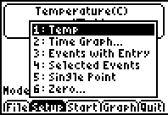
In EasyData to finish the setup, press  to select 1:Temp and then to select Units press @. Change to 2:(F) by highlighting the choice and pressing  or just pressing 2 . Then select OK by pressing %. Remember to do this on only one of the two calculators. Leave the other to record in degrees Celsius. | 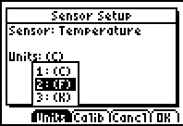
Now you are ready to collect the data. Just read the display and report the two temperature measures at the same instant. Try to cover the range of values from 0 to 100 degrees Celsius.
[Note: In the CBL/CBR APP, Turn the Instructions OFF and the highlight GO and press . Then just read the values from the screen.]
Now that we have the data recorded on our paper we want to enter it in our calculators. To exit the APP select by pressing % to get the Quit option and then % again for OK.
[Note: To leave the CBL/CBR APP press C to get back to the setup screen and then `î to get to the main screen where you select 4:Quit to exit.
To enter the data we need to go to the List Editor. To do this press S1 to select 1:Edit. [Note: on the TI-73 just press .] | 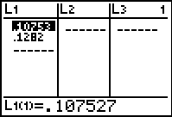
We need to remove the list that the last user of the handled left us so we can enter our data. To do this move your cursor up to the Header of the list and make sure you are in the first column (the number in the upper right is a 1).
Now [Trust me here], press delete until all of the list left for use are out of our face. To do this just press ddddddd until you get tired. If you don’t get the screen to the right it is probably because you did not have your cursor in the header, above the line in the Lists Editor or you just got tired too soon. Check with another student who had success and ask her how she did it.
Now we need to name these lists. Since we use the symbol F for Fahrenheit and C for Celsius… The calculator is ready for you to Name them, so find your alphabet and key in F and then . Then move to the second column, next door [>] and select C and . Since you are in the Alpha Mode, see the A in the upper right corner you just need to press c for F and p for C. Don’t forget to move over to the second column before you name the Celsius list.  [Note: On the TI-73 we press  to get to the alphabet and after we select the letter(s) we highlight Done and press  to finish. | 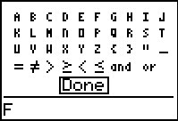
Move down into the lists and enter the 14 data pairs. Double check your numbers to make sure you have the correct data. You can link and send the data to your partners or split up the work and send the list either from unit to unit or to the teacher through the TI-Navigator and then have the teacher send the list to your team members. In the sample to the right see that this team got 20s, 30s and 40s only. Maybe they did better on the second set of seven.
Looking at the data you might see the relationships. For example If I was anywhere else in the World and they said the temperature was 25 degrees I could see that this was about 77 degrees in my house, so I would know if I needed socks on or just have my naked feet in my sandals. This is of course not exact, but maybe close enough so I can avoid any errors in translation from their language to mine. Can you find a hotter jumping over point? A colder one?
Another way to examine the data is to see a plot. Let’s set up a plot of the data looking at C vs. F. Press å or  on the TI-73 to get the STAT PLOTS Menu. Notice if you have any lists turned On. If so, make sure you turn them off (see 4:PlotsOff) before you try the plot you are about to set up and turn on. | 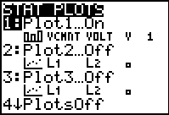
Press  to set up the first plot option. Set it up as shown. You can name the list needed by just using the alphabet or you can find all of the lists names on your calculator by pressing ò or on the TI-73 . Make sure you are on the Xlist or Ylist lines when you do this. | 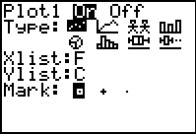  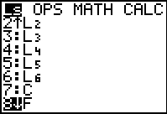
Two things to do before we plot this data. Let’s look at the ! screen to see if we have any lines set up to graph and double check to make sure just our Plot1 is turned on. Place your cursor on stuff you want to trun off/on and press  or if you want to remove a function you can get on that line you can just choose C. | 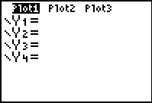
Second we need to set up the graph paper to make sure we can see the data. Press @ and let’s edit the choices. Since the X values were Fahrenheit and the Y values were Celsius we know we wanted values from 32 to 212 degrees F and 0 to 100 degrees C. A Scale of 10 for Celsius would be good and maybe 20 for Fahrenheit might work. You could also go to 0 degrees for the X values (Fahrenheit) if you like.  [Note: You could also just select ZoomStat to let the computer set up your graph paper. Press #9 or ☺ on the TI-73.] | 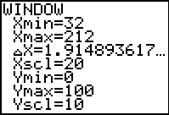
Now look at the plot by pressing  and moving along your data with  and then back with . You can see that this team did not cover the range from 0 to 100 degrees Celcius very well. Just for fun try #9 or ☺ on the TI-73. You can return to your original window by using # and then going over to Memory and selecting the Previous Zoom. Decide what window you like best setting it manually or relying on the computer.
Now we will let the computer name the pattern (the line that fits the data, the relationship between degrees Celsius and degrees Fahrenheit). Go to the Home Screen by pressing C.
Set your Mode to show your relationship to the nearest hundredth of a degree/ Press  and highlight the 2. Press  to make it your choice and then to return to the Home Screen press C. | 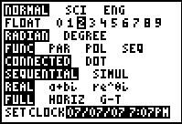  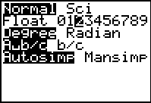
Now from the Home Screen we will select Manual-Fit to have the computer name the line that represents the relationship between the two units of measure of temperature. Press S>:to select 0:Manual-Fit from the CALC screen or on the TI-73 press .  [Note: If you cannot find the Manual-Fit option on your TI-84 you will need to upgrade the OS. See the TI website, TI Connect or call 1-800-TI-CARES.] | 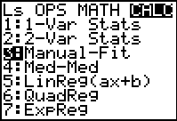
We need to tell the computer where to put this rule. To do this we go to the place the variable names are stored. Press v>11 to select Y₁ from the FUNCTION Menu or on the TI-73 press . | 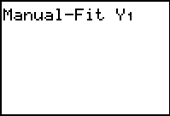
Press  to get to the graph and then move your cursor to get in line with one some of the points on the cool end of the graph. When you think you have it, press  and then with the arrow keys drag a line that marks out the majority of the points. Press  again to lay down the line. | 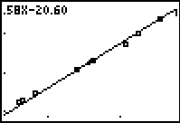
Now we can adjust this line by keying in alternative values for the slope (the number in front of the x) and the y-intercept (the number at the end). Use your arrow to move to the two choices and press  to accept the revisions. Note in this example the y-intercept is negative. You must tell the computer you want negative using the . Press  to dump the formula in Y₁.  [Note: To adjust your line, use your  arrows to change the tilt of the line and the location that it crosses the y-axis. Press when you finish. If you can’t get close enough you may need to start over from the Home Screen after getting more digits in the Mode.] | 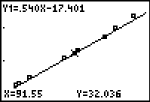
If you press  and then the  arrows you will see your formulas. Do you recognize any of the numbers? Have your teacher explain to you how the two units were created and then give you the True conversion formula. Use the fraction values to avoid rounding. Replace your Y₁ with the Truth. How well doe this line fit the data? What is 5/9 as a decimal? What is 5/9 times 32? Why 5/9? Why 32?  Test out this Truth with what you know. If x = 32, we should get y = 0 for x being degrees Fahrenheit and y being degrees Celsius. | 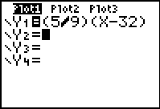
Now let us visit the Table. Before we go to the Table we should set it. Press  and adjust it like this for the Y₁ formula. The Ask option requires you to key in a value and press  to get the values. | 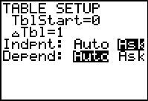
Now go to the TABLE and key in values for x (the Fahrenheit). Our goal is to find “nice” values. Ones that will result in no decimals, like 32 degrees F is 0 degrees C. You only get 7 so you can delete  or just key over for more guesses. Keep guessing until you have found 7 nice pairs. Show your teacher.  [Note: You might want to change your  back to Float.] | 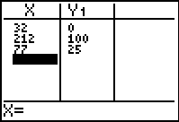
Do you see the pattern? Change the Table Setup like shown. Press. This will start at the nice value of 77 and change by 1 degree Fahrenheit and you move up or down the X column when you press  to return to the Table. Do you see the pattern now? Can you predict the next value? Learn a few and then the conversions between the two units will be easy! | 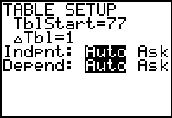  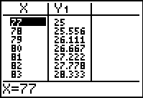
You may repeat this process with Celsius as the X value and Fahrenheit as the Y values. | 