To better understand the limiting agent in a reaction the book provided you with a set of drawings on page 185 in Chapter 9. This investigation is designed to help you parse the sketches.

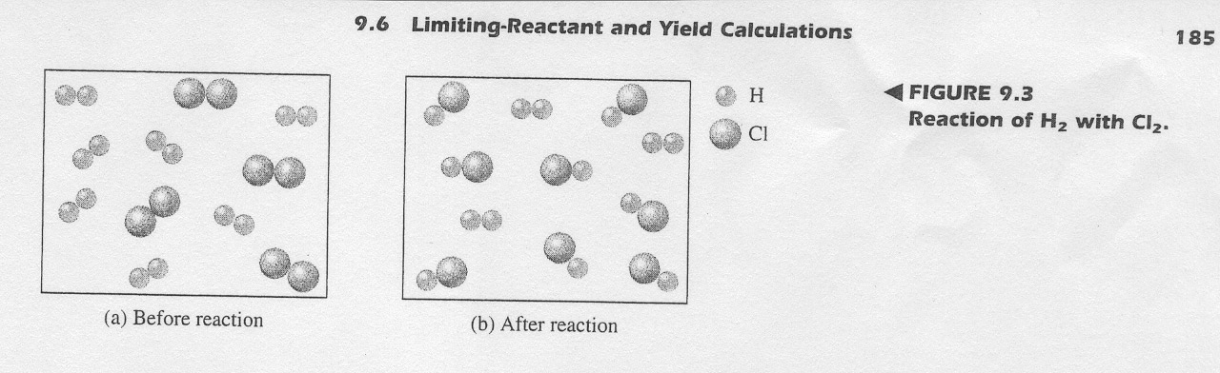

- In Cabri jr. draw the Before image on page 185 in your book. Scale the drawing a needed and label the elements.
- Save this file as BEFORE.
- Now create the After image from the book. Scaling in a consistent manner with the Before.
- Save this file as AFTER.
- In NAVNET send these two APP VARS to Mr. Young.

1. What do the BEFORE and AFTER files have to do with limiting?
2. How did you make the AFTER?
3. Why did I have you draw these images in Cabri Jr?

