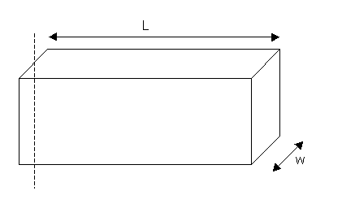
1. Hold the Lead Brick in your hands and estimate how heavy it is.
Estimated Value = ________________
2. Explain the basis of your estimation. How did you come to the reported value?
3. Assuming you are on Earth, you may convert your estimate into another unit such as weight or mass. Give your estimated value in the following units:
Kilograms Grams Slugs
4. Collect the measures needed to calculate the volume of the brick.
l = _______ w = _______ h = _______
5. Calculate the volume of the brick.
6. Report the density of Lead.
7. Using the measured volume and the True density of Lead determine the mass of the Lead Brick.
8. Convert this value into the units used in your estimate [assuming you are still on Earth].
9. Calculate the Error.
10. Reflect on your error.

