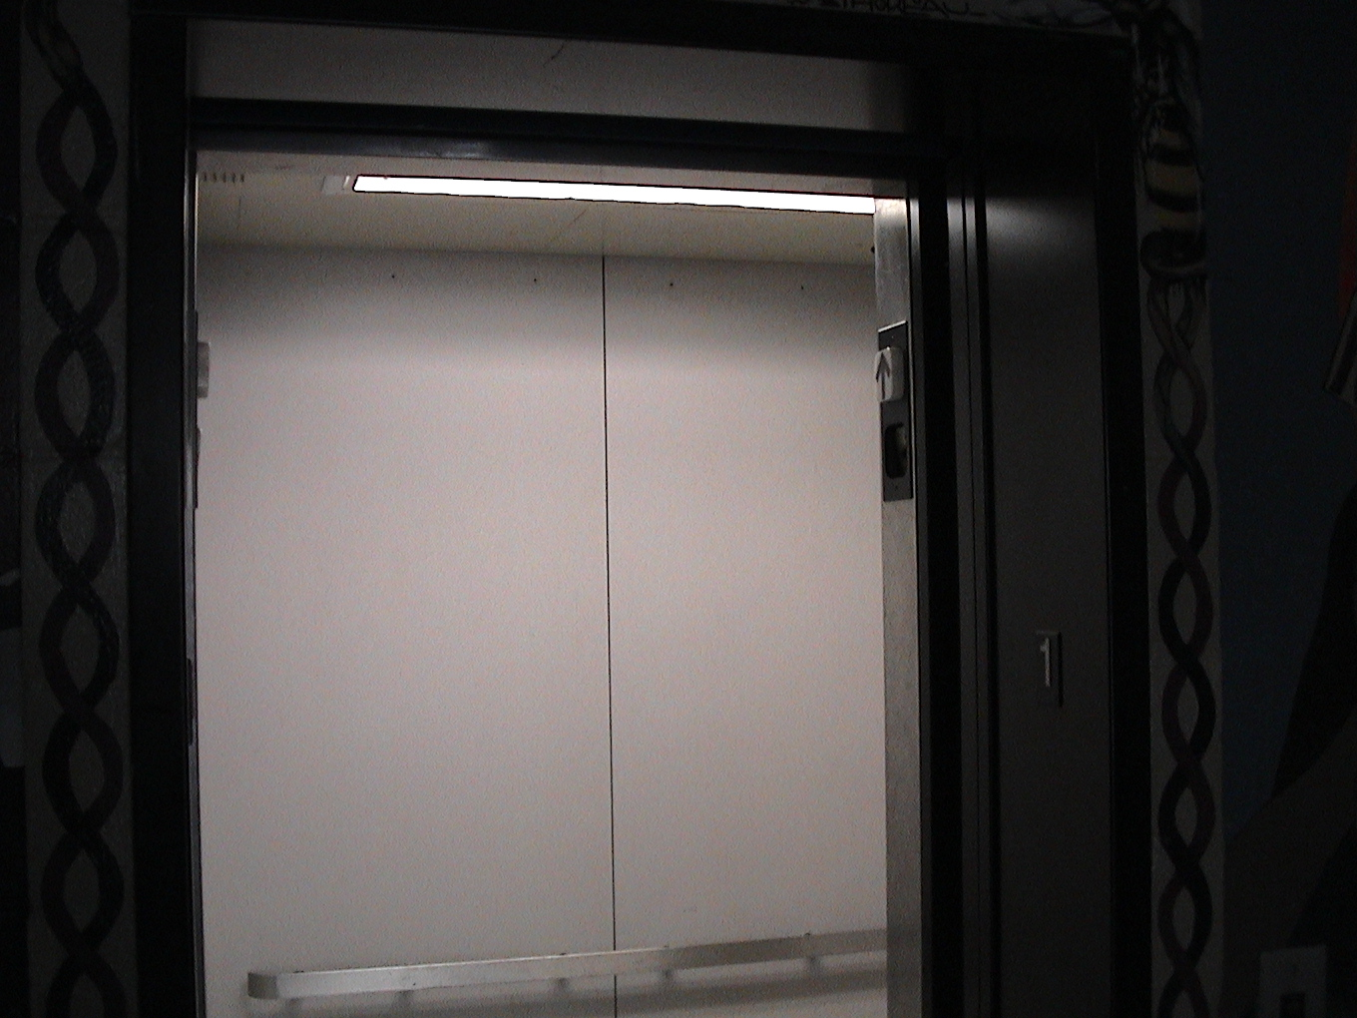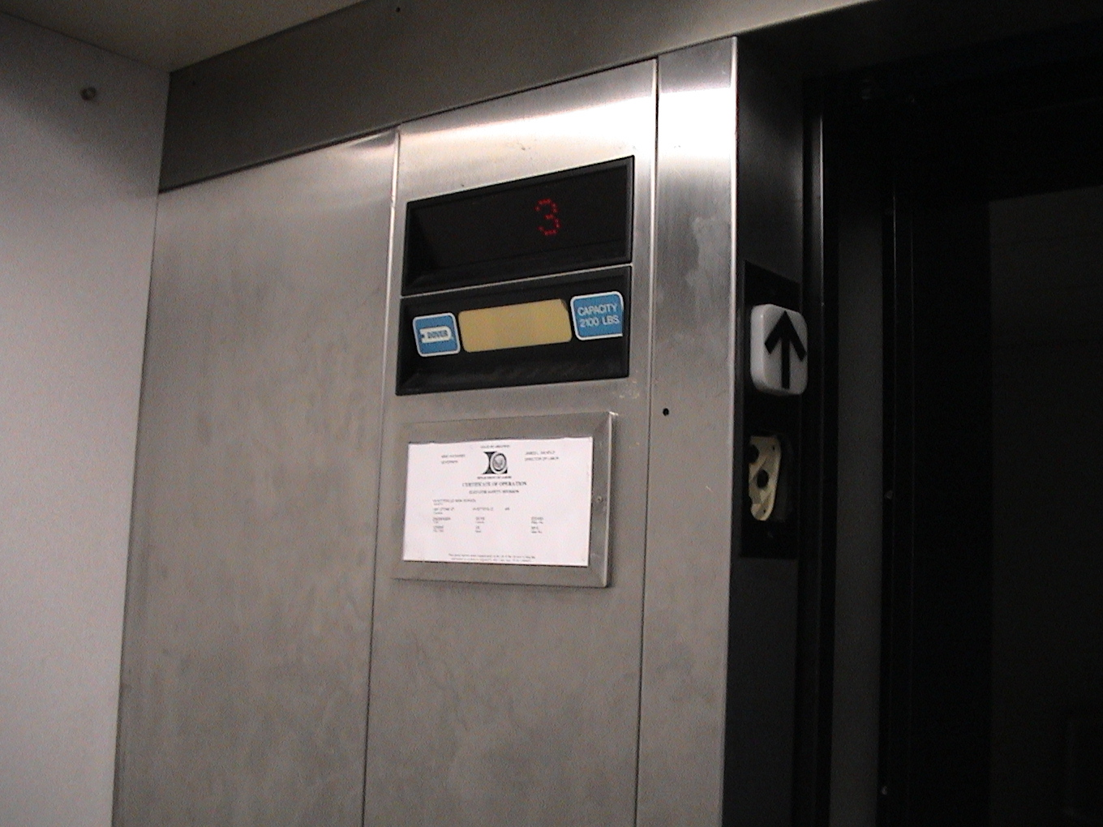

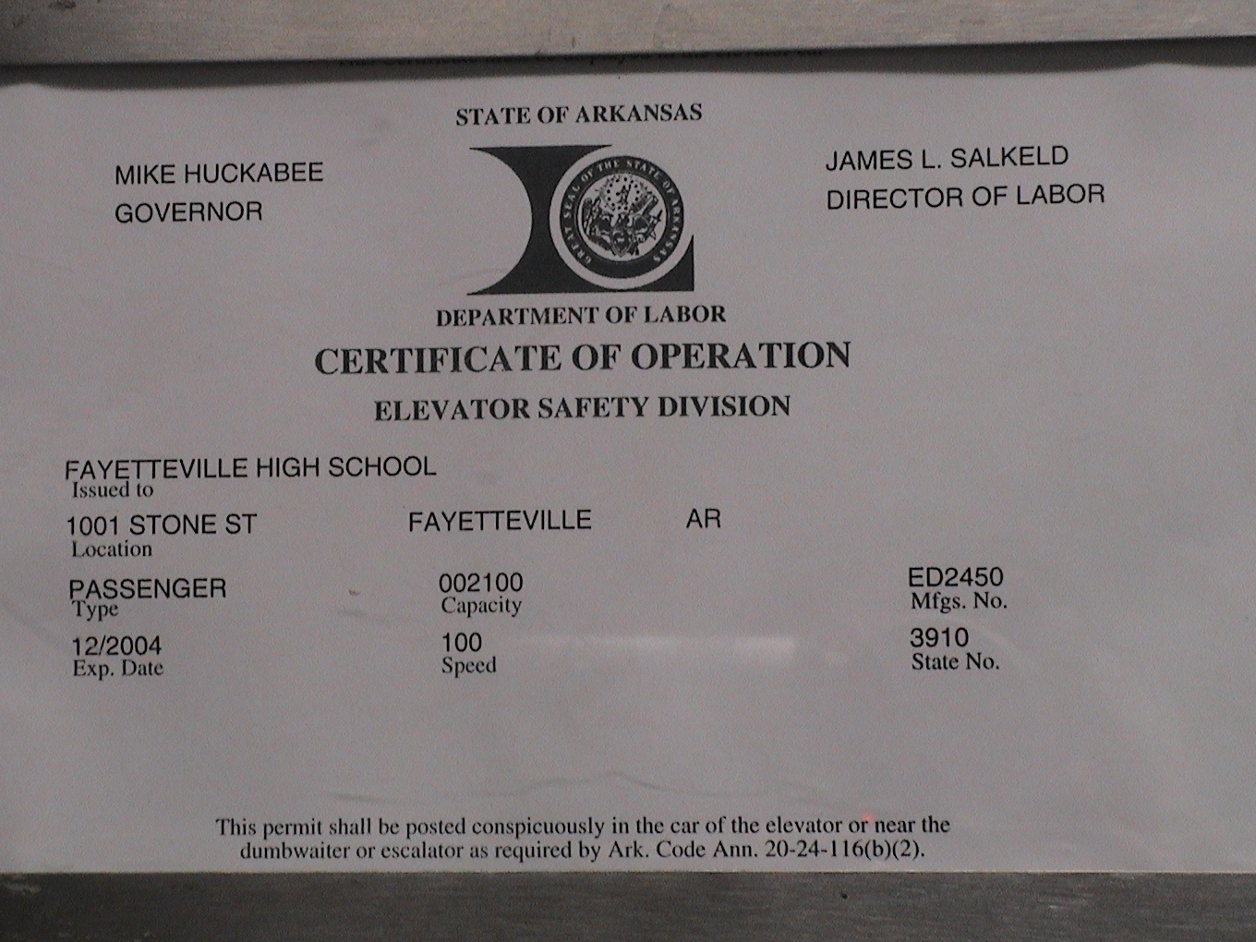
Shown above are photos of the elevator at East Campus. Notice that the Speed of the elevator is 100. Use the Unit Converter in the Science Tools on your calculator and your fence-posts to determine the units of this speed. Once you determine an appropriate unit, explain why you think you have discovered it and how you came to know.

